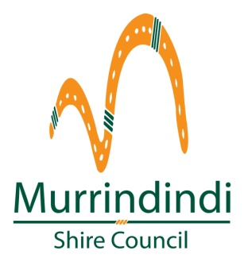
2018 Parent Education Session Dates

Managing Sleep Problems Sessions | Enjoying your terrific Toddler Sessions | St John’s ‘Kids First’ Course (1/2 day)
Wednesday 28th February 10am-12pm  Alexandra Maternal and Child Health Centre | Wednesday 28th February 1pm-3pm  Alexandra Maternal and Child Health Centre | Wednesday 7th March  CEACA, Alexandra  9:30-1:30pm
Thursday 1st March  10am-12pm  Kinglake Ranges Children’s Centre | Thursday 1st March  1pm-3pm  Kinglake Ranges Children’s Centre | Thursday 22nd March  Kinglake Ranges Children’s Centre 9:30-1:30pm
Wednesday 13th June  10am-12pm  Alexandra Maternal and Child Health Centre | Wednesday 13th June  1pm-3pm  Alexandra Maternal and Child Health Centre | Wednesday 7th November  CEACA, Alexandra  9:30-1:30pm
Thursday 21st June  10am-12pm  Kinglake Ranges Children’s Centre | Thursday 21st June  1pm-3pm  Kinglake Ranges Children’s Centre | Thursday 29th November  Kinglake Ranges Children’s Centre 9:30-1:30pm
Wednesday 17th October  10am-12pm  Alexandra Maternal and Child Health Centre | Wednesday 17th October  1pm -3pm  Alexandra Maternal and Child Health Centre
Thursday 25th October  10am-12pm  Kinglake Ranges Children’s Centre | Thursday 25th October  1pm-3pm  Kinglake Ranges Children’s Centre

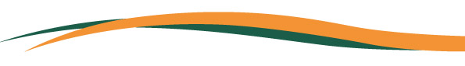

2018 Parent Education Sessions
Venue: The Maternal and Child Health Centre
Cost: Free
Babies and Toddlers welcome to attend.

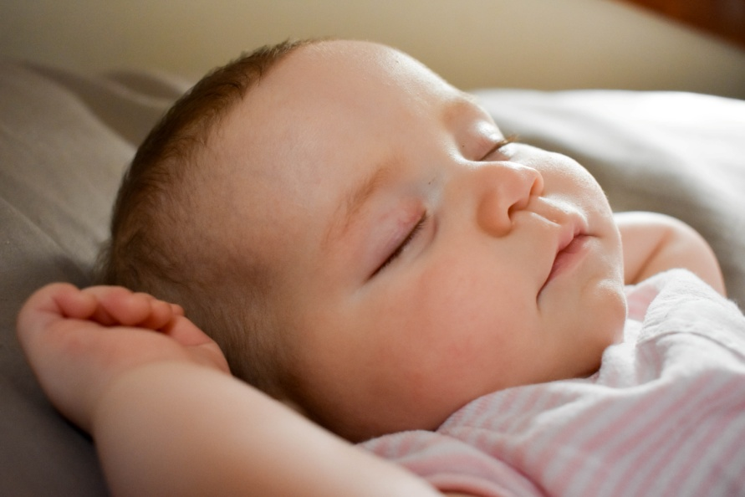
Managing Sleep problems in Babies.

This 2 hour interactive session is for parents of babies aged 6+ months. Topics covered include identifying the causes of sleep issues, eliminating habits that reinforce sleep problems and troubleshooting some of the common sleep problems experienced between 6 months and 2yrs of age.
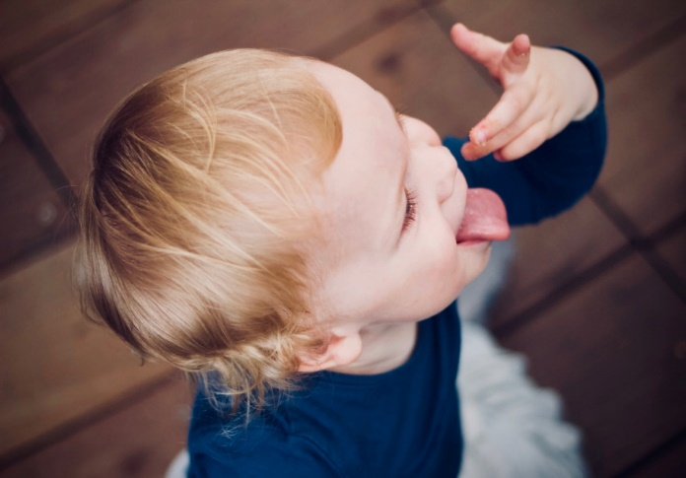
Enjoying Your Terrific Toddler.

This 2 hour interactive session is for parents of children aged between 18 months and 3 years. Topics covered include toilet training, fussy eating and managing difficult behaviours, such as tantrums, sibling rivalry, and aggressive behaviour.

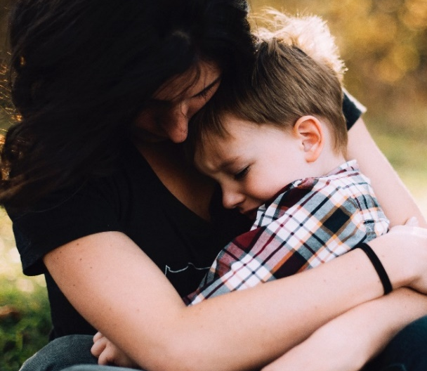
St John’s Ambulance ‘Kids First’ Course

This half day course is run by St John’s Ambulance. St John’s will demonstrate and discuss with participants the skills required for basic first aid, common injuries and emergency care to children. There is a fee of $50 per person for this course, upon completion participants receive a 128 page color book ‘First Aid for Babies and Children’.

