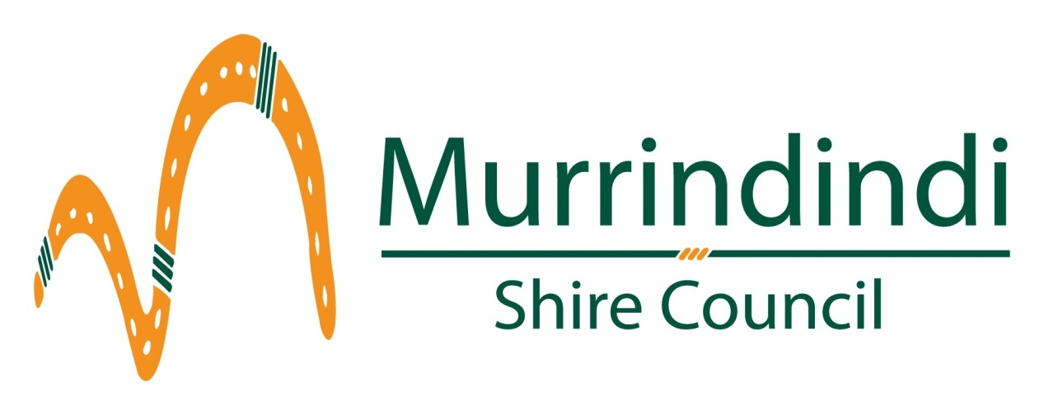

Murrindindi Shire Council

Community Grants Program

Application Form

Contact person at council is Naomi McNamara 5772 0365
nmcnamara@murrindindi.vic.gov.au

Definitions used throughout this application

Project What you would spend the grant funds on – could be an event,
improvement to facilities, equipment upgrade, activity etc

Group Means your group, club, organisation, association etc

In kind Contributions of labour, equipment or expertise provided free to you but which can be given a monetary value in your budget

You need to answer ‘yes’ to all of the following to be eligible to apply for a Community Grant

Application is from a not for profit group YES NO
Application is for a one-off project YES NO
Your group or project is based in the Shire of Murrindindi YES NO
Your project is new YES NO
Application is for a maximum of $5000 YES NO
You have completed a budget for this project YES NO
If your application is for more than $500 you can demonstrate
a significant contribution of cash or ‘in kind’ support. YES NO

You have checked that the project meets council’s aims* YES NO

* To do this go to www.murrindindi.vic.gov.au/Your_Council/Forms_and_Documents and in the alphabetical listing find the Council Plan Incorporating Strategic Resource Plan 2013 – 2017 and the Health and Wellbeing Plan 2013 – 2017.

Please do not apply for a Community Grant if you answer ‘yes’ to any of the following

You are an individual YES NO
Your project has already started or is complete YES NO
Your group has received Community Grant funding
in the last 12 months YES NO

Your group has an outstanding debt with council YES NO
Your application is for wages or ongoing operating costs YES NO
Your group has received a previous grant from council
which is not yet acquitted or finalised YES NO

Office Use

Project is eligible to apply for a Community Grant YES NO

Information about your project and your group

Name of your project

Maximum 10 words

Name of your group

Please provide a brief description of what your group does, who benefits and in what way  Point form is fine | Maximum 100 words

Postal address of group

Name of person authorised to submit the application

Position in the group (eg secretary, president)

Preferred phone number of authorised person

Best time/s to contact you by phone

Email of authorised person

Your group is an Incorporated Association | YES NO  If yes please attach a copy of your Certificate of Incorporation
Your group has an ABN | YES NO  ABN no.
Your group is registered for GST | YES NO
Your group will  manage the grant funds | YES NO  If no please provide the following about the group who will manage your funds:  Name  ABN  GST status

Please describe your project in 50 words?

What would the Community Grant pay for?

Have you spoken to a Murrindindi Shire Council staff member about this project?

YES NO (If no please provide details below for contacting you)
Name of staff member Date of meeting
Outline of discussion
We strongly recommend that you discuss your application with a council staff member before submitting it. Please provide contact details for the person we should phone.

Name Phone

Who will be involved in this project (please tell us which other groups may be involved in the planning of or participation in this project)?

Location of project (street address)

Proposed completion date

What are the benefits for the community of this project?

How does your project fit in with what council wants to achieve for our communities?

Please refer to goals or strategies in our Council Plan or Health and Wellbeing Plan which can be found in the alphabetical listing under Council Plan Incorporating Strategic Resource Plan 2013 – 2017 and the Health and Wellbeing Plan 2013 – 2017 on www.murrindindi.vic.gov.au/Your_Council/Forms_and_Documents

Have you applied for or received any other funding for this project?

YES NO If yes please provide details

Do you intend to apply for any other funding for this project?

YES NO If yes please provide details

Please indicate any funding your group has received from the Community Grant Program in the last three years.

Financial Year | Amount | Project
2011 - 2012
2012 - 2013
2013 - 2014

Will you need any sort of Council permit for this project?

YES NO If yes please be specific, check cost and include in your budget
If your activity involves an event you must have an event management plan. Contact our Events Management Coordinator on 5772 0341 or msc@murrindindi.vic.gov.au

What council services might you need when doing your project?
Examples: permits, waste removal, road closures, signage, cleaning

How will your group recognise Council’s contribution to your project? Examples: a plaque, official opening, media release, use of logo.

Sample project work plan

List of tasks/activities | Who? | When by?

What ‘in kind’ contributions are you counting on for this project?

To work this out please complete the table below and transfer the amount in to your budget. ‘In kind’ work may be anything from professional services to providing machinery or tools to labouring. Cost it at market rates.

In kind (volunteer) work schedule (please add another sheet if needed)

Task to be completed | Who will do this? | Hours | Hourly rate | Total Cost
Transfer total to your budget (next page) |  | Total ‘in kind’ contribution
Project budget

Please provide specific details of the total budget for the project. This may include details on labour costs, materials, equipment, venue hire, etc.

Transfer your ‘in kind’ (volunteer) work or contributions from the table above.

Income and expenditure totals must be equal

Income

Cash contribution from your group | $
In kind or volunteer contributions from your group | $
Amount of Grant sought from Council | $
State Government contribution | $
Federal Government contribution | $
Entry fees | $
Sponsorship/donations | $
Other (please specify) | $
Total Income for the Project | $

Expenditure (Attach copies of quotes where applicable)

Item | Amount
Council permit/s (if required) | $
 | $
 | $
 | $
 | $
 | $
 | $
 | $
 | $
In kind expenditure (should match your in kind contribution) | $
Total expenditure for the project | $

Declaration of authorised applicant

I have read the guidelines relating to the Community Grants Program and certify to the best of my knowledge that the information provided in this application is true and correct.

I have the authority to submit this application on behalf of my group.

I understand that this application may not necessarily result in approval of funding through the Community Grant Program.

If this application is successful I agree that within 12 months of completion of the project I will submit an acquittal of the grant funds (how the money was spent) and a project evaluation report (how well the project went and what my group has learnt from the experience).

Name (please print)
Group
Position
Project name
Signature Date

Applications labeled 'Community Grants Application' can be submitted via:
Post to Manager Community Services, Murrindindi Shire Council, PO Box 138, Alexandra 3714.
Email to msc@murrindindi.vic.gov.au

