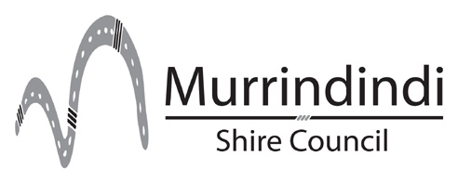
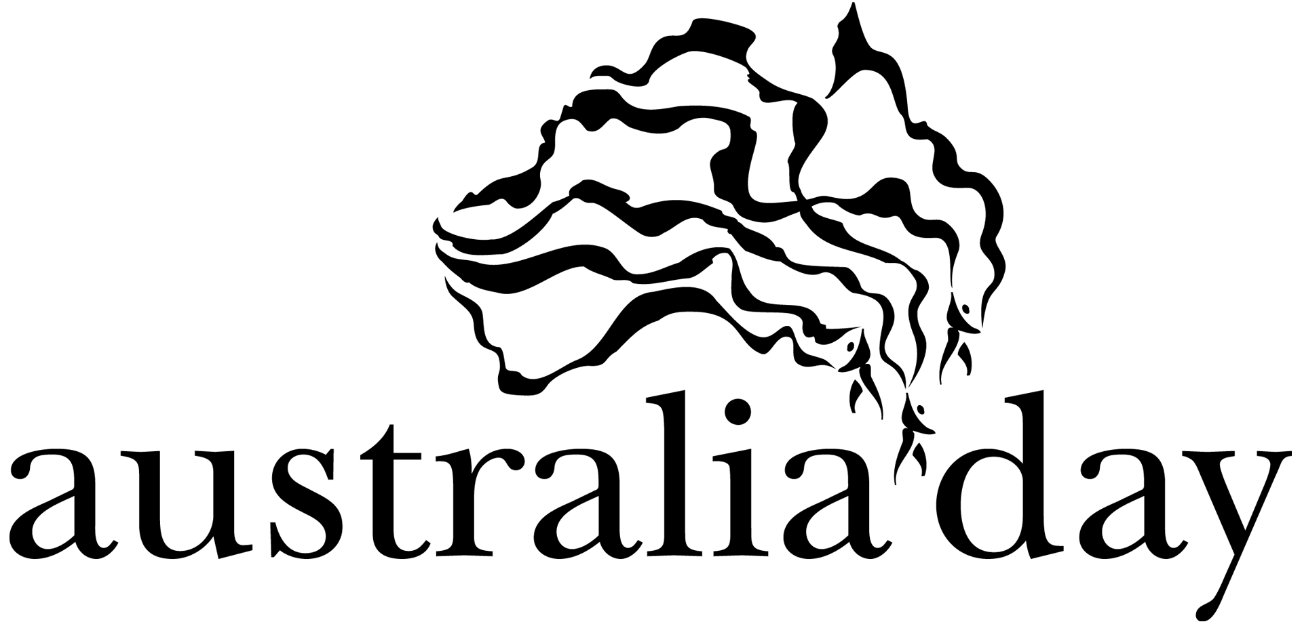

Australia Day Awards 2018 - Nomination Form

The Awards are provided by the Australia Day Committee (Victoria) and are administered by Local Government Authorities throughout Australia on behalf of the Committee.

How to compile a nomination:

- Read the criteria and eligibility section on page 3.
- Written submissions should be between 500 and 2,000 words

Nomination Check list:
- Nominations must be on the official nomination form including:
      - Personal details of nominee
      - Listed details of the contribution(s) they have made to the community,
      - The period of time they have made contributions to the community
      - Other personal achievements and awards
      - Past membership of community, sporting, professional organisations and clubs, etc.
      - Any other background and relevant information
- Supporting documents, such as any newspaper or magazine articles about the nominee and their achievements should be attached
- The name of at least one referee must be supplied.

Nomination for: Murrindindi Shire Citizen of the Year
(please tick one) Murrindindi Shire Young Citizen of the Year
Murrindindi Shire Community Event of the Year

Citizen or Young Citizen of the Year Award

Surname______________________________ Christian names ____________________________________
Address ________________________________________________________________________________
Date of birth ______/______/______ Australian citizen Yes No

Please describe why this person is being nominated for the above award. In 50 words

Please describe in detail how this person has made noteworthy contributions for outstanding service to the local community, including period of contribution and other achievements and awards? In 500-2000 words

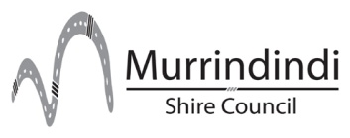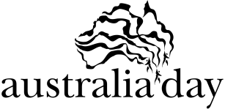

Australia Day Awards 2018 - Nomination Form

Community Event of the Year Award

Community event name____________________________________________________________________
Organised by__________________________________________ Date event held _____________________

Please describe why this event is being nominated for the above award. In 50 words

What benefits did this event provide for the community? In 500-2000 words

Nominated by
Name (person or organisation) _______________________________________________________________
Relationship to nominee ____________________________________________________________________
Address ________________________________________________________________________________
Telephone (h) ______________________ (b) _____________________ (m) __________________________
Email _________________________________________
Signature of person making this nomination ____________________________________________________

Please provide the name and contact details of someone else who is familiar with the achievements listed in this nomination who can act as a referee.

Referee
Name __________________________________________________________________________________
Address ________________________________________________________________________________
Telephone (h) ______________________ (b) _____________________ (m) __________________________

Please note: when the winner of a category is decided you will be contacted to make appropriate arrangements to ensure the winner is able to accept the award at a local Australia Day celebration.

Australia Day Awards 2018 - Nomination Form

Criteria and eligibility

The Australia Day Awards are presented annually to local citizens or groups who have made an outstanding contribution and been a role model to their community, as well as demonstrating excellence in their achievements.

- Murrindindi Shire Citizen of the Year
To be eligible, the person must be 25 years or older on 26 January 2018
- Murrindindi Shire Young Citizen of the Year
To be eligible, the person must be under 25 years of age on 26 January 2018
- Murrindindi Shire Community Event of the Year
Presented to the person or group who has staged the most outstanding community event

The citizen awards are presented to persons who have made a noteworthy contribution for outstanding service to the local community.

The Community Event Award is presented to an individual, organisation or group in recognition of the valuable contribution that a special event has made to its local community.

In the absence of nominations from members of the public, the selection panel may make its own nominations based on local knowledge, experience and/or previous nominations.

Previous unsuccessful nominations may be resubmitted, providing they are updated and entered on the required form.

Presentation of the awards will be made at celebrations held on Australia Day.

The Murrindindi Shire Council must receive all entries no later than 5pm on Friday 10 November 2017
and are to be addressed as follows:

Chief Executive Officer
Murrindindi Shire Council
PO Box 138
ALEXANDRA VIC 3714

Further information may be obtained from the Executive Assistant on Ph: (03) 5772 0337 or eaceo@murrindindi.vic.gov.au.

All nomination information and material submitted remains the property of the Murrindindi Shire Council.
The decision of the Murrindindi Australia Day Awards Selection Panel is final and no correspondence will be entered into in respect of that decision.
Nomination information may be used for publicity and historical purposes.

Sponsored by Australia Day Committee (Victoria).

