Murrindindi Shire Council
Council Plan
2017-2021
(Word version – does not include Strategic Resource Plan)

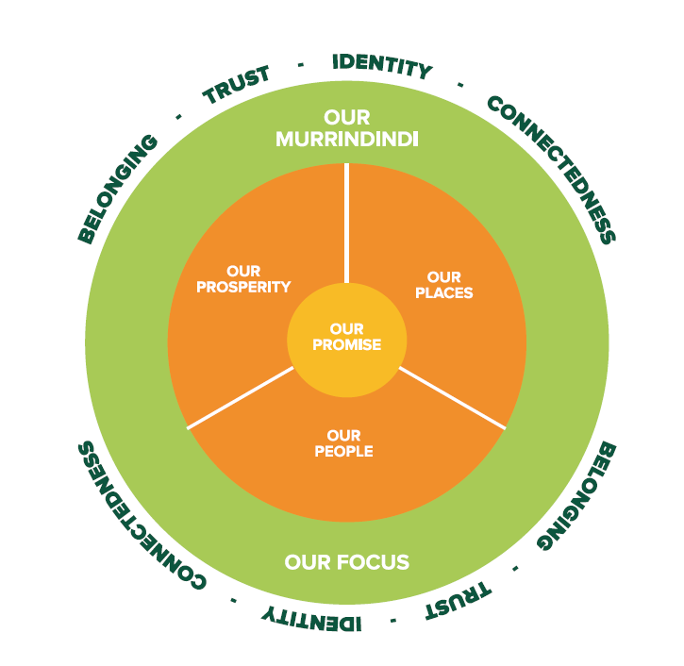
TABLE OF CONTENT

Message from the Mayor and Councillors 4
Message from the CEO 5
About Our Community 7
Murrindindi 2030 Vision 10
Our Commitment 11
Council Plan Framework 14
Our People 15
Our Place 17
Our Prosperity 20
Our Promise 22

Message from the Mayor and Councillors

We are thrilled to present to our community Murrindindi Shire Council’s 2017-2021 Council Plan.

This Plan is the result of collaboration between Council and the communities of Murrindindi Shire. It sets the direction for Council’s work over the next four years.

In February 2017, we invited you to ‘Have Your Say’, Council’s largest ever community engagement project to ensure this Plan reflects the values, needs and aspirations of our communities across the Shire.

We were overwhelmed by the enthusiastic participation as we received over 1,600 responses, including approximately 400 young people across many of our schools.

What we heard was that, in our Shire, you place a lot of value on being part of strong, safe, small and connected communities within a healthy and scenic natural environment, within easy reach of Melbourne.

You also want to see an increased focus on economic activity and business development. Balancing these factors is part of the challenge facing us going forward. We are therefore looking to develop initiatives to support opportunities for our community.

We are committed to preserving and building on what makes this Shire great. Whilst growth and development is very necessary for our future, it should be sensitively planned and not at the expense of our unique way of life, our rural character or the quality of our environment.

As a result of your input we have based our Plan around four main objectives and strategies covering Our People, Our Places, Our Prosperity, and Our Promise to you as your Council.

Over the next four years we need to ensure our work is progressing well in meeting our objectives. To help us assess this, we have included in the Plan ways of measuring our activities which will help us – and our community - gauge our success in achieving our planned outcomes.

We commit to keeping you informed about how we are enacting this Plan. We will report annually on our progress and more regularly on an informal basis as we work collaboratively with our community.

As part of this process we are asking you to stay in touch with us about this Plan. We want you to let us know how you think we are going and if our activities need to be adjusted to ensure we continue to meet the needs of the community over the four year life of the Plan.

We know Murrindindi Shire is already a wonderful place to live, work and play. We look forward to making it even better and to ensuring a prosperous future for us all.

Message from the CEO

This Council Plan will guide the work of both Councillors and Officers in responding to the opportunities and challenges facing the Shire over the next four years. The Plan sets out what the Council wants to achieve and the activities it will carry out during this time. It also lays out how these things will be resourced, measured and assessed.

The Plan is the result of many hours of collecting and considering the vast array of ideas that have come from our community as well as the Councillors reflections on their conversations with you. The Have Your Say community engagement in early 2017 has given us a great understanding of what our community’s needs and priorities for the future of the Shire.

You told us that Murrindindi Shire has a very positive future but it also remains true that we will face some challenges.

We know our community wants rates kept as low as possible. We must balance this with our community’s desire for Council to continue to improve, and possibly even increase, the range of services it offers.

Whilst community expectations grow, local government is also absorbing the effect of decisions by the Federal and State Governments to shift the costs for delivering key services to local government and to cap the grant funding and rates revenue it receives.

We need to make some difficult decisions about how we allocate our resources across our many townships and rural localities.

The Shire is not part of a State Government-identified ‘growth corridor’ and the well-funded transport infrastructure and employment plans that are linked to this. So, while the Shire is within very close proximity to Melbourne, transport options remain limited. This is a barrier to growth and economic development.

Murrindindi is also projected to have a slower population growth than other municipalities of similar distance from Melbourne. On the positive side, this provides an opportunity to carefully plan our growth to ensure we retain the Shire’s rural character and scenic beauty which our community has told us it values highly.

But we do need to consider how we can encourage new business investment and support our existing businesses to grow. We want to retain local talent (including young people) and attract new residents to the Shire. We have heard from our community that economic development and increased business and education opportunities within the Shire are critical.

We also need to think about the effect of demographic changes in the Shire, as the average age of citizens of the Shire continues to rise, compared to other peri-urban municipalities, and the challenges this presents for Council’s service delivery.

Where there are challenges, there is also opportunity. I am confident this Plan – guided by our community’s priorities - will help invigorate Council’s approach to finding innovative solutions to complex service delivery issues.

Council will also advocate on behalf of the community to ensure the concerns of Murrindindi Shire communities are heard by other levels of government.

To ensure our advocacy is informed by community priorities, we commit to communicating with and listening to our community for the life of this Plan. Council will continue to look to ways to better communicate with you, following the launch of its Facebook Page in early 2017. We will use your feedback to improve the way we deliver our services and interact with customers.

Importantly, the range of services and activities identified by our community in this Plan will be delivered within the context of a responsible and sustainable long-term financial plan.

We will continue to drive change and improvement within Council to allow us to deliver the high quality service our community expects; we will examine our own operations to ensure we are operating efficiently and cleverly; we will also look to how we deliver the services we provide to ensure they continue to meet our community’s needs. This will involve service planning which allow us to examine and assess the services we provide to ensure maximum efficiency of those services.

I thank our community for its support in the lead up to development of this Plan and we look forward to working together with you to achieve our shared goals.

About Our Community
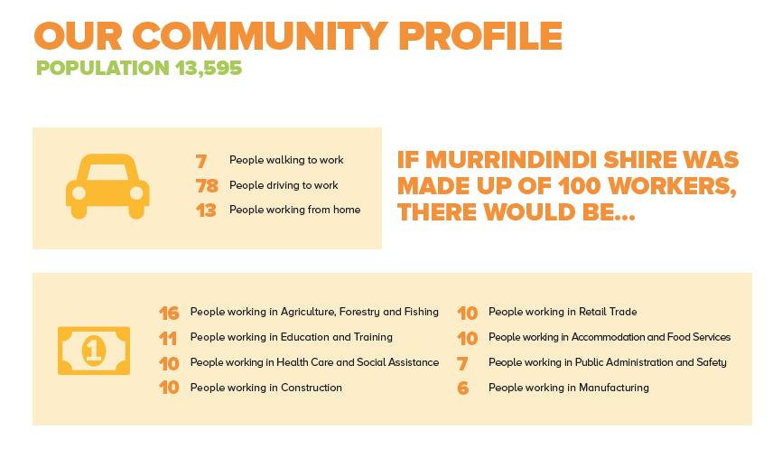

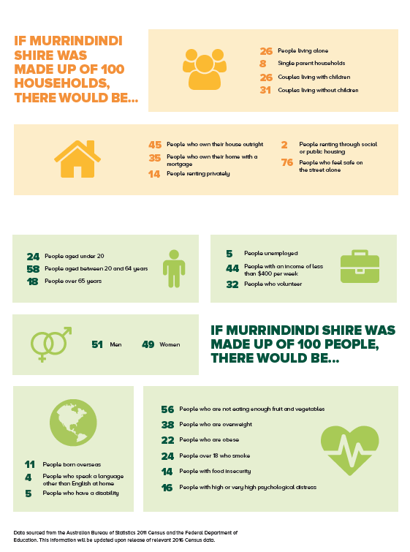
Our Community’s Priorities

This Council Plan 2017– 2021 has been shaped by the views and aspirations of our community. We received over 1,600 responses to our survey and 120 people attended a community workshop to tell us about the things that matter in making the Murrindindi Shire a special place to live, work, visit and recreate. The ‘Have Your Say’ community engagement in early 2017 was both incredibly successful and very informative.

What people told us they most value about the Shire is:

- belonging to a caring, strong, safe and connected community where people look out for each other
- living a rural or country lifestyle, with a small town pace and feel, yet within easy reach of Melbourne
- the scenic beauty and health of the natural environment
- the diverse range of community groups and services that support community life
- having a variety of outdoor recreational opportunities available
- being able to attend local events, community gatherings and attractions

We received many ideas for the future of the Shire and how to make it an even better place to live or visit. Our community wants Council to focus on:

- nurturing, not losing what we have
- improving local employment and business prospects
- growing tourism, visitation and events
- supporting local education and training opportunities
- looking after the natural environment
- increasing recreational opportunities, facilities and spaces
- making sure people can access the services they need at different life stages
- supporting healthy and connected communities
- increasing public transport options
- support, activities and opportunities for young people
- increasing access to waste services
- managed and sustainable growth
- responsible financial management and rates
- looking after community infrastructure (roads, buildings, parks, paths)
- more communication and engagement with the community
- improving Council’s business practices and customer service

In addition around 400 of our young people (primary and secondary school aged) told us they value:

- sport and play activities and facilities
- feeling a sense of belonging
- supportive and safe communities
- the outdoors and natural environment
- creative activities, making and listening to music
- having local food shops and businesses
- jobs for youth, work experiences

Murrindindi 2030 Vision

The Murrindindi 2030 Vision was developed in partnership with our community in 2014. It is an aspirational statement of what our community wants the Murrindindi Shire to be like in 2030.

“In 2030 we are sustainable, vibrant and resilient. We focus on growing our business opportunities. Our communities are safe and connected, enjoying a healthy and productive lifestyle within our wonderful natural environment.”

We feel this vision is still very relevant. It is consistent with the views expressed by our community in the ‘Have Your Say’ community engagement during the development of this Council Plan.

The objectives we have set in this Plan complement this vision and we will use it as a guide for the plans and decisions we make during our term that affect the future of the Murrindindi Shire.

Our Commitment

Our Objectives

We have committed to delivering on four key objectives which will drive the work we do, and the services we deliver over the next four years, in partnership with our community.

We believe these objectives reflect the values, priorities and aspirations of the Murrindindi community as expressed in our ‘Have Your Say’ community engagement.

They address the things about the Murrindindi Shire that our community says are important to support opportunity, quality of life, wellbeing and the liveability of our towns and places.

Our People
Together we will encourage and celebrate diverse, caring and connected communities

One of the factors people value most about living in the Murrindindi Shire is a sense of belonging to a caring and well connected community. We will build on this strength by encouraging collaboration and involvement, whether this is amongst our valued volunteer–based community groups, through supporting cultural, artistic or celebratory events, or ensuring that opportunities and services are available that support inclusion, participation and access for all.

Our Place
We will maintain and enhance places to be attractive, liveable and in harmony with the natural environment

The unique character, history, scenic beauty and ambience of our places and spaces and the health of our natural environment are highly valued by our communities. We will ensure our built environments are well planned to enable sensible growth that does not compromise the natural environment, nor the liveability, accessibility and character of our towns and localities.

Our Prosperity
In partnership with the community we will prioritise and promote a culture in which business and community can evolve and thrive

We recognise that prosperity within our communities is key to supporting individual aspirations and community growth. We will ensure that opportunities to encourage economic development within our Shire are pursued. We will support business development and new investment, promote tourism, facilitate access to training, and advocate for improved infrastructure and services that meet our business and community needs.

Our Promise
We (the Councillors and officers) will work as a team in collaboration with our communities to deliver the best possible outcomes in all that we do

Our Promise reflects the core of what we do as a Council to ensure our community’s needs and priorities are well represented in our actions and services. Our promise is to provide strong advocacy, transparent governance, two-way communication and engagement, stewardship of our community’s resources, and relevant, responsive and efficient service delivery.

Our key objectives are represented in the diagram below. Our Promise will be at the centre of what we do, representing the foundation for us to deliver our objectives for Our People, Our Place and Our Prosperity. It is our intention that the outcomes of our work will help reinforce the Identity of our diverse towns, promote Connectedness and Belonging in the community and build Trust with our community. We want this to be our legacy.

Our Values

As the seven Councillors who serve as the Murrindindi Shire Council, we are committed to working together in the best interests of our community in ways that recognise and acknowledge the traditional custodians of the land, our rich diversity and our shared potential.

We are embarking on our term with a new, energetic and fresh approach based on our desire to be more engaging and to work more collaboratively with our community.

To this end, as reflected in our Code of Conduct, we have committed to carrying out our roles in accordance with the following values:

Collaboration
We will ..
o operate as a cohesive team,
o work together with the community through accessible and inclusive engagement
o strive to build effective working relationships

Stewardship
We will...
o endeavour to make careful and responsible decisions
o strive to make decisions that do not limit the opportunities or aspirations of those who follow in the future

Equity & Fairness
We will ..
o be fair, even-handed and impartial in our decision making and our dealings with others
o consider the merits of each case while upholding legislated requirements and ensuring consistency and justice in our decision making
o strive to ensure all have access to similar opportunities and experiences

Respect
We will ..
o respect the views, contributions, feelings, wishes and rights of others
o actively seek to understand others’ experiences, ideas and perspectives
o embrace and appreciate diversity of origin, viewpoint, experience and lifestyle
o recognise the achievements of others

Accountability & Honesty
We will ..
o make our decisions openly and publicly whenever possible
o take responsibility for our actions and decisions
o honour our commitments
o act with integrity and honesty in all our dealings
o openly report our performance and acknowledge our mistakes

Council Plan Framework

The Murrindindi 2030 vision, developed in partnership with the community sets out the goals, opportunities and aspirations of our community over the longer term. It provides a guide to Council in setting its objectives and strategies for its term.

The Council Plan 2017-2021 sets out what council is undertaking to achieve over its four year term and the resources that are needed to deliver the Plan.

The main components of the Plan include strategic objectives, which describe the overall goals we aim to achieve, the strategies for achieving the objectives, strategic indicators to measure our success in meeting our objectives and a strategic resource plan which sets out the financial resources required.

The development of the Council Plan 2017-2021 has been informed by one of the most extensive community consultation initiatives ever undertaken by the Council. This will ensure our Plan is reflective of our community’s needs.

Each year we prepare an implementation plan and an annual budget that ensures the correct focus and resources are being applied to implement the Council Plan. At the end of each year we publish an annual report which informs our community of Council’s performance and achievements in meeting the Council Plan objectives and our other statutory obligations.

Each year we also review the strategies in the Council Plan to ensure they remain focused on achieving the Plan’s objectives. Our community is invited to make comment on any proposed adjustments before the changes are adopted.

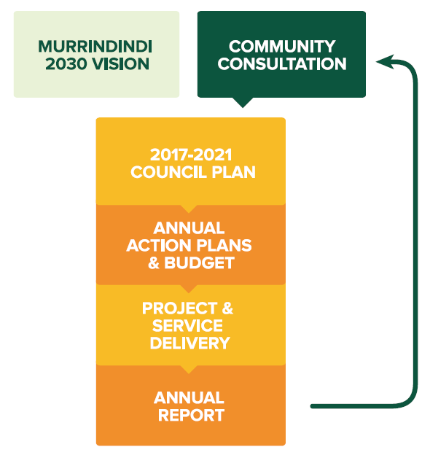
Our People

STRATEGIC OBJECTIVE: Together we will celebrate and encourage diverse, caring and connected communities.
- “Community spirit, most of which is informally generated by members of the community”
- “Support community networking and development initiatives to strengthen communities in the region”
- “More community events to get people together”
- “Supporting community groups to enhance participation in all forms of the community”
What our community said was important: | - More support for community groups  - Make health services accessible  - Connecting and providing services to the elderly  - Strengthen communication with and within the community  - Give the community a reason to gather and celebrate  - Encourage diversity within our communities  - Promote and support volunteerism and participation– especially in young people
What we aim to achieve:  (Strategies) | - Encourage activities and events that celebrate our vibrant, diverse and creative people and communities  - Work with community and groups to connect, collaborate and plan for our future  - Work with our partner agencies to ensure people of all ages can access the health and community services they need  - Create a positive environment that supports our young people to grow, participate and be happy  - Promote opportunities for people of all ages to connect with and be involved in their community
How will we know we are succeeding:  (Strategic indicators) | - Increased community events supported by Council  - Community satisfaction with elderly support services  - Community satisfaction with family support services  - Increased active library members and participation in library and other Council programs  - Increased participation by young people in Council activities and services  - Council’s involvement in collaborative networks, plans and projects
Supporting Council Services: | - Community Services – including Aged and Disability, Youth and Recreation and Children’s Services  - Libraries  - Emergency Recovery
Relevant Strategies / Plans: | - Municipal Public Health and Wellbeing Plan  - Municipal Recovery Plan 2015  - Proposed Recreation Action Plan

Our Place

STRATEGIC OBJECTIVE: We will maintain and enhance places to be attractive, liveable and in harmony with the natural environment.
- “Lifestyle of the country but not too far from the city”
- “The rural atmosphere, the clean air and the nice people I meet”
- “More sustainability of the environment and how we sustain ourselves in a changing climate – small and big changes to make a difference”
- “Transport for vulnerable and older people, and young people”
What our community said was important: | - Preserving the rural lifestyle and village atmosphere  - Protecting and promoting the natural environment  - Access to a range of recreation and entertainment opportunities  - Linking townships with trails and transport  - Innovative solutions to waste management  - Embracing and celebrating the diversity of our townships
What we aim to achieve:  (Strategies) | - Support recreation opportunities for our residents and visitors that encourage participation and community connections  - Improving links and making Murrindindi Shire easier to navigate and its services and destinations easy to find  - Through good land use planning enhance the liveability, prosperity and the rural character of our Shire  - Strengthen the environmental sustainability of our communities, protect our natural environment and reduce resource consumption  - Recognise and embrace the history, culture and identity of our towns and communities  - Maintain a fair and transparent approach to promoting community standards in accordance with our legal requirements, and to support liveability and business investment
How will we know we are succeeding:  (Strategic indicators) | - Reduction in Council’s resource use  - Reduction in waste going to landfill  - Community satisfaction with the appearance of public areas  - Strengthened community engagement in safety planning and preparation  - Community satisfaction with Council’s (land use) Planning Policy  - Maintain our roads and open spaces in good condition
Supporting Council Services: | - Infrastructure Maintenance  - Environmental Programs  - Land Use Planning, Local Law Enforcement, Building Approvals, Environmental Health  - Waste Management and Recycling  - Emergency Response
Relevant Strategies / Plans: | - Municipal Strategic Statement  - Murrindindi Shire Heritage Study  - Waste & Resource Recovery Strategy 2014 - 2019  - Municipal Emergency Management Plan 2015  - Kinglake Ranges, Flowerdale and Toolangi Plan & Design Framework  - Yea Structure Plan 2015  - Eildon Structure Plan 2016  - Domestic Animal Management Plan 2013 – 2017  - Roadside Weed and Pest Animal Control Plan  - Proposed Recreation Action Plan  - Proposed Environment Action Plan

Our Prosperity

STRATEGIC OBJECTIVE: In partnership with the community we will prioritise and promote a culture in which business and community can evolve and thrive.
- “Create a more vibrant town, more business development, increased permanent population and spend locally”
- “Increase tourism, we have so much to offer”
- “Flexibility in town planning for new and existing businesses”
- “Develop opportunities to keep young people in the area”
What our community said was important: | - Supporting existing and attracting new business  - Growth in tourism, including eco-tourism  - Attracting new and innovative industries  - Education and employment opportunities  - Creation of a Murrindindi identity/brand  - Support events and attractions that bring visitors to the area  - Keeping our youth in the area  - Improved telecommunications
What we aim to achieve:  (Strategies) | - Promote Council’s fresh approach to attracting new investment including facilitation of approvals  - Work with our businesses, regional partners and communities to support a diverse visitor experience that promotes our natural assets, and a vibrant range of events  - Support and encourage local businesses to work together, thrive and grow, through networking, start-up assistance, mentoring, and access to the skills  - Advocate for and support high quality opportunities for education and training to meet community and business needs  - Advocate for improved infrastructure and access to public land to realise social and economic opportunities
How will we know we are succeeding:  (Strategic indicators) | - Increasing reach of our business support activities  - Increased business investment  - Growth in new dwelling approvals  - Increased visitation to the Shire  - Implementation of our strategic land use plans
Supporting Council Services: | - Economic Development  - Tourism and events  - Land Use Planning Policy and Approvals  - Building approvals
Relevant Strategies / Plans: | - Saleyards 10 Year Strategy 2014 - 2024  - Proposed Economic Development Action Plan  - Yea Structure Plan 2015  - Eildon Structure Plan 2016  - Kinglake Ranges, Flowerdale and Toolangi Plan & Design Framework
Our Promise

STRATEGIC OBJECTIVE: We (the Councillors and officers) will work as a team in collaboration with our communities to deliver the best possible outcomes in all that we do.
- “Moving forward, innovation, involvement, accountability, smart planning of spaces and development, planning for the future, make leaps”
- “Working with communities to assist them to plan together for their future”
- “The Council can work with community to build their capacity and support the many individual and groups who have bright and innovative ideas”
What our community said was important: | - Providing a customer focus  - Innovation in Council services  - Value for rates paid  - Fair and equitable facilities and services for all communities  - A Council that is transparent and accountable  - Better communication and consultation with the community  - Advocating for community needs and priorities  - Empowering communities to plan for the future
What we aim to achieve:  (Strategies) | - Represent and advocate for our community in a transparent and equitable way  - Ensure our culture, systems and technologies encourage and enable innovation in our business practices and service delivery  - Ensure the range of services we provide and the way we provide them are best aligned with community priorities and council’s resources  - Commit to developing a stronger customer-focused culture that makes us easier to deal with  - Expand our communication and two-way engagement with the community  - Maintain Council’s financial sustainability through sound financial and asset management  - Support a skilled, engaged and flexible workforce that can respond to changing needs
How will we know we are succeeding:  (Strategic indicators) | - Community satisfaction with our consultation and engagement  - Community satisfaction with our lobbying on behalf of the community  - Community satisfaction with our customer service  - Positive trends in the Victorian Auditor General’s ratings of Council’s financial sustainability  - Increased workforce engagement  - Innovation opportunities identified and implemented
Supporting Council Services: | - Governance  - Finance  - Human Resources  - Risk Management and Procurement  - Communications  - Customer Service  - Infrastructure Assets
Relevant Strategies / Plans: | - Rating Strategy 2015 – 2019  - Enterprise Risk Management Guidelines 2016  - IT Strategic Plan 2014  - Business Continuity Plan 2015

