MUNICIPAL PUBLIC HEALTH AND WELLBEING PLAN 2017-2021
FINAL VERSION ADOPTED 22 NOVEMBER 2017
(WORD VERSION)

Table of Contents

Introduction 3

Celebrating where we live 4

Our challenges 4

What the data tell us about Murrindindi Shire 5

Health and Wellbeing Plan Framework 7

How we developed our plan 9

Our health and wellbeing partners 11

Our Objectives, Strategies and Actions 12

Implementation, Review and Evaluation 20

Introduction

We are delighted to present to our community the Municipal Public Health and Wellbeing Plan 2017-2021 (Health and Wellbeing Plan). This plan has been developed in collaboration between Council, our health and wellbeing partners and the community. It provides a strategic direction to support the health and wellbeing of our community.

The Health and Wellbeing Plan incorporates several key strategic planning areas that contribute to building strong, healthy and connected communities including:

• Recreation and Open Space
• Positive ageing
• Access and Inclusion
• Early Years
• Youth
• Environmental sustainability, and
• Economic Development.

To elevate our commitment to health and wellbeing we have aligned the Health and Wellbeing Plan to the Council Plan strategies and actions. This integration drives a focus on health and wellbeing across our organisation and strengthens the mandate for health and wellbeing action.

Celebrating where we live

During the development of the Council Plan and Health and Wellbeing Plan, the community told us what they value most about living in Murrindindi Shire including:

• belonging to a caring, strong, safe and connected community where people look out for each other
• living a rural country lifestyle, with a small town pace and feel, yet within easy reach of Melbourne
• the scenic beauty and health of the natural environment
• the diverse range of community groups and services that support community life
• having a variety of outdoor recreational opportunities available
• being able to attend local events, community gatherings and attractions.

We have strong communities where people care, feel safe, volunteer, and help each other out – that’s why Murrindindi Shire is a great place to live.

Our challenges

Our population of 13,732 is spread thinly across our many townships and rural localities with no single major town. Our southern and western boundaries are only an hour from Melbourne yet many of our regionally based services are located in regional centres further away than the City.

Public transport is a challenge for Murrindindi residents with restricted transport means. Therefore we tend to rely on private vehicles and the help of community networks to get us where we need to go.

Murrindindi Shire is projected to have a slower population growth than other municipalities at a similar distance from Melbourne. This provides an opportunity to carefully plan our growth to ensure we retain the Shire’s rural character and scenic beauty that our community highly values.

We have an ageing population with a higher percentage than the State average of people over 65 years and this will continue to increase in the future, presenting both challenges and opportunities.

During the community conversation process we heard that the following areas are priorities for Murrindindi’s diverse communities:

• nurturing the natural environment and rural character
• improving local employment, education, business prospects and tourism
• supporting people to access health services at all life stages
• increasing access to waste services and public transport
• maintaining and planning for community infrastructure (roads, buildings, parks, recreation facilities, paths)
• engaging with and connecting communities
• supporting activities and opportunities for young people.

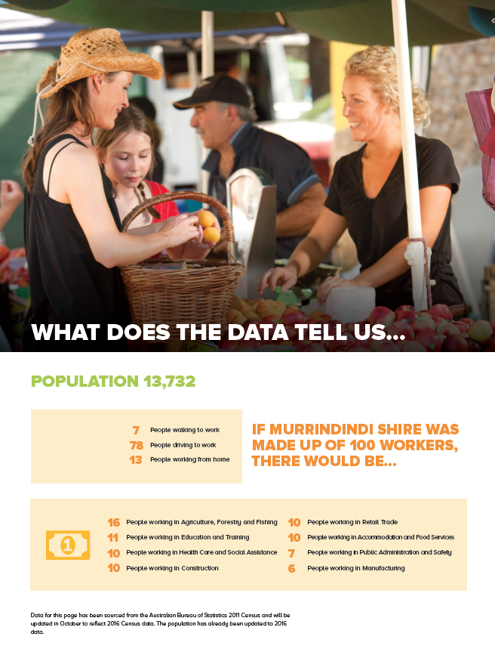

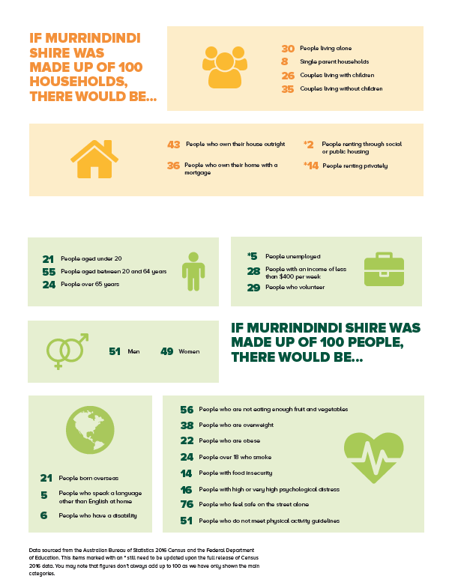

- Municipal Health and Wellbeing Plan Framework

The main components of the Health and Wellbeing Plan are:

- strategic objectives which describe the overall goals we aim to achieve
- strategies and actions for achieving the objectives
- strategic indicators to measure our success in meeting our objectives

The Health and Wellbeing Plan strategic objectives, strategies and actions are aligned with the Council Plan 2017-2021.

The strategic direction developed by the Victorian Health and Wellbeing Plan 2015-2019 have been considered and has helped to guide the overall direction of the Health and Wellbeing Plan.

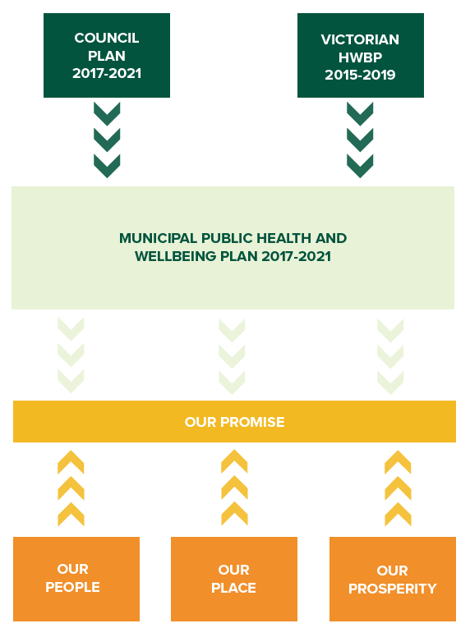

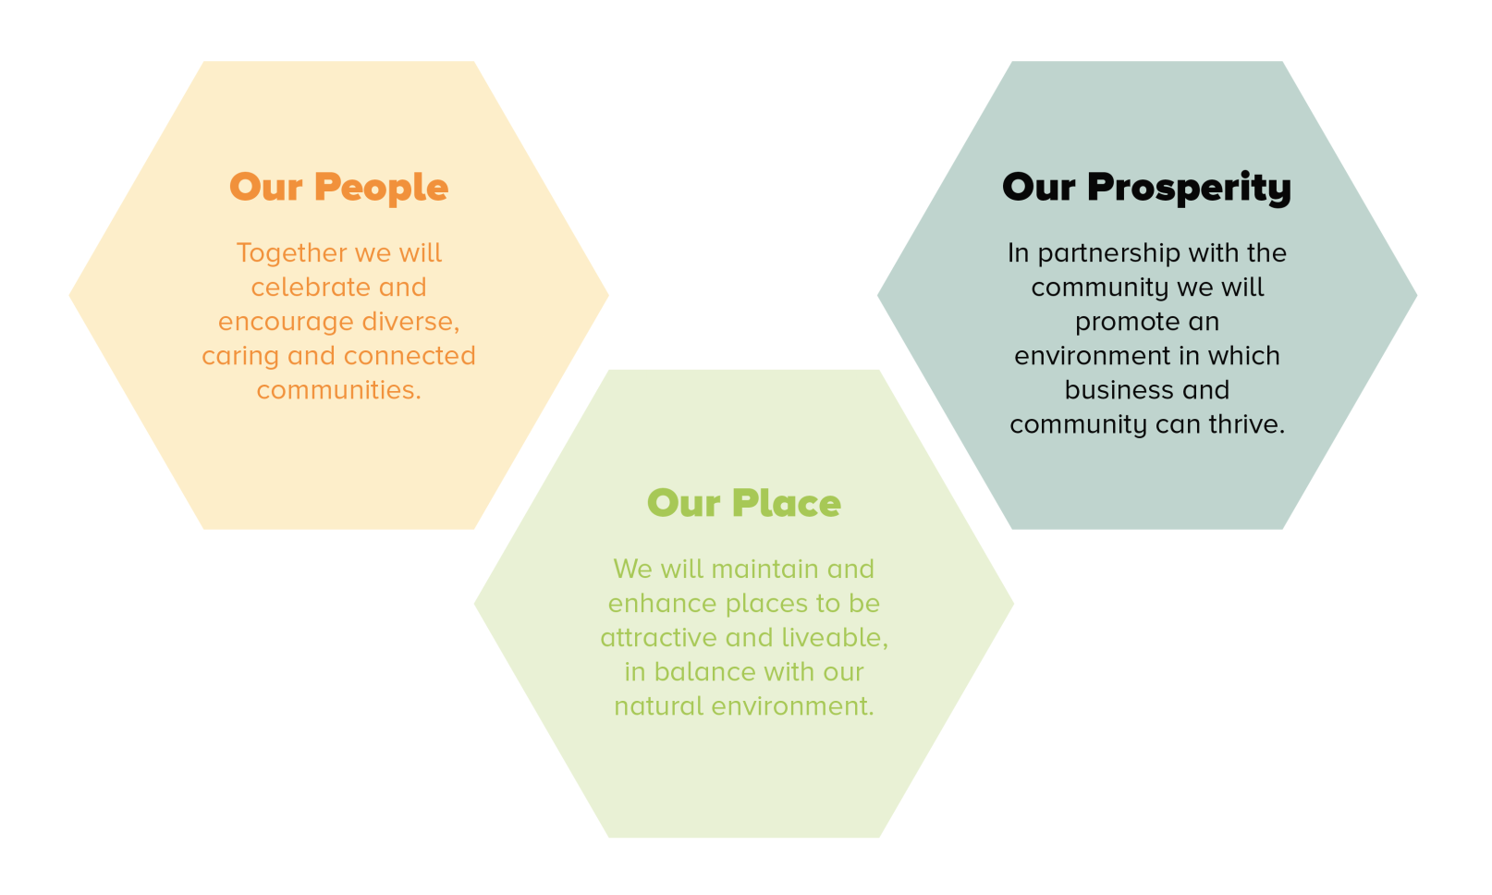
The strategic objectives which form the basis for our Health and Wellbeing Plan strategies and actions are Our People, Our Place and Our Prosperity.

How we developed our plan

The Health and Wellbeing Plan has been shaped by a number of consultations which took place during 2017:

- ‘Have Your Say’ Community Survey and Workshops
- Workshops with Partner Agencies
- Sport and Recreation Conversations

Have Your Say Community Survey and Workshops

In February 2017 Council undertook our largest ever community engagement project to ensure that the Council Plan 2017-2021 and associated plans including the Health and Wellbeing Plan reflected the values, needs and aspirations of the community.

We received over 1,600 responses to our survey and 120 people attended community workshops to tell us about the things that matter in making Murrindindi Shire a special place to live, work, visit and play.

Workshops with Partner Agencies

In July 2017 Council held a number of workshops with key partners to develop the Health and Wellbeing Plan. Collaboration between Council, partner agencies and the community is critical in developing and implementing the Health and Wellbeing Plan.

The workshops provided an opportunity to identify health and wellbeing priorities and opportunities to assist with the development of the plan.

Fourteen agencies were represented at these workshops and a number of health and wellbeing priorities were identified in the workshops including:

• Community capacity building
• Reducing harm caused by alcohol and other drugs
• Supporting vulnerable Children and families
• Food access and security
• Promoting healthy living and healthy eating
• Improved access to services including mental health services and advocating for short term crisis housing
• Improved promotion, development and access to lifelong learning opportunities
• Working together to develop innovative approaches

Sport and Recreation Conversations

In July 2017 Council organised four sport and recreation conversations around the Shire held in Alexandra, Kinglake, Marysville and Yea to bring groups together to discuss key contributors to a successful club.

A total of 57 clubs and associations participated in the conversations from across the Shire.

The following key issues were raised:

• Capacity building for clubs and groups including strategic planning, governance, grants, sponsorship, succession planning, volunteer engagement and promotion.
• Collaboration opportunities including mentoring between clubs and membership partnerships.
• Female participation including the need for female friendly programs and facilities.
• Challenges in keeping young people involved in sport.
• Events and celebrations with an active and healthy focus including ‘come and try’ open days and volunteer acknowledgments/awards.
• The need for cycle friendly safe roads.
• Improved marketing and communication with a focus on online and social media including promotion of unstructured activities and natural assets, i.e. tracks and trails.
• Long term planning to ensure assets meet need and capacity.
• Maintenance planning and agreements including fair and equitable facility hire costs.

Our Health and Wellbeing Partners

We have worked with our partner agencies in the development of the Health and Wellbeing Plan and will work collectively to implement its actions. We would like to thank our health and wellbeing partners for their time and expertise. We look forward to working together to support and encourage active and healthy communities in Murrindindi Shire.

These agencies include:
- Alexandra District Health
- Yea and District Memorial Hospital
- Nexus Primary Health
- Lower Hume Primary Care Partnership
- Dame Pattie Menzies Centre Inc.
- Family Care
- Berry Street
- Rural Housing Network
- CEACA
- Yea Community House
- Flowerdale Community House
- Kinglake Ranges Neighbourhood House
- Toolangi Castella Community House
- Ellimatta Youth
- Kellock Lodge
- Darlingford Nursing Home
- Pre-schools, Primary and Secondary Schools
- Taungurung Clans Aboriginal Corporation
- Valley Sport
- Victoria Police

Our objectives, strategies, actions:

OUR PROMISE

Our Promise comprises a set of guiding values that will direct the work of partner agencies as we work collectively to support the health and wellbeing of the communities and residents in Murrindindi Shire.

As partners to the Health and Wellbeing plan we commit to:
- Collaborate: Work together and coordinate our efforts to improve health and wellbeing with the community.

- Innovate: Develop and trial new ideas and create innovative solutions to health and wellbeing priorities.

- Communicate: Ensure our communities are aware of and involved in creating and supporting programs that meet their needs.

- Participate: Commit to delivering and monitoring the actions in the Health and Wellbeing Plan 2017-2021.

OUR PEOPLE - Together we will celebrate and encourage diverse, caring and connected communities

People value the sense of belonging to a caring and well connected community in Murrindindi Shire. We will build on this strength by encouraging collaboration and involvement, whether among our valued volunteer-based community groups, through supporting cultural, artistic or celebratory events, or ensuring that opportunities and services are available that support inclusion, participation and access for all.

  - Encourage activities and events that celebrate our vibrant, diverse and creative people and communities.

Action | Key focus areas include
Promote more community celebrations | - Support and deliver events that celebrate our diverse communities.  - Review, support and promote the Community Grants Program as a means to encourage more events.
Lead and support creative and cultural activities | - Support artists and groups to connect and showcase our artistic and creative people.  - Actively link young people to performing arts.  - Promote and enhance opportunities for community involvement in arts and cultural activities.
Strengthen our relationship with local Aboriginal communities | - Recognise and include Aboriginal culture as part of community events and initiatives.  - Celebrate Aboriginal stories and history.  - Strengthen our relationship with Taungurung Clans Aboriginal Corporation through joint initiatives.

  - Work with community and groups to connect, collaborate and plan for our future.

Action |  | Key focus areas
Help local communities plan for their future. | - Design a Community Planning Framework in partnership with the community.  - Support communities to plan for the 10 year anniversary of 2009 bushfires.
Strengthen community, sport and recreation groups. | - Collaborate with government, sporting assemblies and peak bodies to improve sporting and recreation opportunities and facilities.  - Improve coordination and collaboration of Council support to all community groups.
Promote and encourage volunteering. | - Investigate collaborative approaches to volunteer recruitment, engagement and training.  - Coordinate volunteer celebration and acknowledgment events.  - Introduce new volunteer opportunities to support delivery of Council’s Community Services.  - Support and promote volunteer activities that help to protect and sustain the natural environment.

  - Work with our partner agencies to ensure people of all ages can access the health and community services they need.

Action | Key focus areas
Encourage provision of services that meet community needs. | - Explore and deliver innovative ways to let people know where to access the services and information they need.  - Advocate for flexible and equitable delivery of services, including specialist medical services, mental health, family violence and other support services.  - Continue to improve the planning and coordination of services and explore new ways to deliver.  - Ensure services are inclusive, welcoming and accessible to all people.
Strengthen local aged and disability services. | - Work together to implement Aged and Disability Service reforms.  - Identify opportunities to strengthen and sustain local and accessible service delivery.
Promote programs that encourage active lifestyle and access to healthy food. | - Work together to improve access to affordable healthy food.  - Promote active and healthy life choices through health and wellbeing programs.  - Support and deliver events and programs focusing on active living and healthy eating.  - Minimise harm to the community caused by alcohol, smoking and other drugs.
Support healthy and happy children and families. | - Support the delivery of high quality, flexible child care and children’s services across Murrindindi.  - Deliver services and initiatives that strengthen and support families.  - Work with key partners to prevent family violence.

  - Create a positive environment that supports our young people to grow, participate and be happy.

Action | Key focus areas
Encourage young people to participate and lead. | - Collaborate with young people to design and deliver local initiatives and programs.  - Build youth resilience through leadership development groups.
Improve access to the support young people need. | - Plan local community initiatives to address existing and emerging issues, e.g. Alcohol and other drugs/mental health forums, youth engagement and participation programs.  - Advocate for the delivery of flexible youth services.

  - Promote opportunities for people of all ages to connect with and be involved in their community.

Action | Key focus areas
Inspire people to be engaged and active. | - Deliver Library programs and events, which engage, inform, inspire and help connect communities.  - Recognise the valuable role Community and Neighbourhood Houses play in fostering social inclusion and community participation and work collaboratively with them to support their delivery of health and wellbeing, social, recreational, educational, training and volunteering opportunities.
Remove barriers that restrict people’s participation in the community. | - Deliver initiatives that will make our communities more age friendly.  - Identify and address disability access issues in conjunction with the Access and Inclusion Committee.  - Promote the inclusion of all people regardless of age, disability, gender identity, sexuality, cultural and/or religious background.

OUR PLACE - We will maintain and enhance places to be attractive and liveable, in balance with our natural environment

The unique character, history, scenic beauty and ambience of our places and spaces and the health of our natural environment are highly valued by our communities. We will ensure our built environments are well planned to enable sensible growth that does not compromise the natural environment, nor the liveability, accessibility and character of our towns and localities.

2.1 Support recreation opportunities for our residents and visitors that encourage participation and community connections.

Action | Key focus areas
Plan for an appropriate mix of sport and recreation assets to meet community needs. | - Review recreation and open space assets to identify community requirements.  - Facilitate community conversations to support maintenance, service planning and collaboration.
Explore innovative approaches to promote tracks, trails and sport and recreational opportunities. | - Support the marketing and promotion of local sport and recreation opportunities.  - Explore partnerships with key stakeholders to promote use of our natural assets.

2.2 Improve links and make Murrindindi Shire easier to navigate and its services and destinations easier to find.

Action | Key focus areas
Improve pathway links for pedestrians, cyclists, horse riders and business | - Deliver new and improved pathways  - Prioritise opportunities for new or improved links  - Explore and address road and pedestrian safety issues  - Improve signage to indicate key cycling routes
Identify and upgrade road links for key attractions and business. | - Review and prioritise road links.  - Seek funding to support road upgrades.  - Advocate for improved east-west links
Improve information and directional signage | - Seek funding to continue implementation of the Great Victorian Rail Trail signage plan.  - Promote online information and explore new ways to inform the community.  - Prioritise opportunities to improve signage and advocate where action is required by VicRoads.

2.3 Through good land use planning enhance the liveability, prosperity and the rural character of our Shire.

Action | Key focus areas
Maintain a proactive Strategic Planning program | - Work with community to improve our streetscapes.  - Continually assess the Murrindindi Planning Scheme to ensure the needs of the community are met while minimising the impact on the natural environment.
Implement priority actions from existing strategic plans. | - Review existing strategic land-use plans to support the liveability of our communities.

2.4 Strengthen the environmental sustainability of our communities, protect our natural environment and reduce resource consumption.

Action | Key focus areas
Reduce Council’s impact on the environment. | - Establish a Green House Gas emission target and implement actions to reduce emissions.  - Promote the use of recycled products.  - Minimise disturbance of the natural environment when undertaking land management operational activities such as road maintenance and weed control.
Support our communities to live, and our businesses to operate, more sustainably. | - Support community action on reducing waste.  - Provide opportunities to educate business and the community.  - Support community initiatives that care for our environment.
Introduce new waste management and recycling services and progressively improve existing services | - Open a Reuse Shop  - Evaluate opportunities for new services including organics collection and processing and recycling of soft plastics.  - Develop a new strategic plan for waste services  - Sustainably manage landfill.

2.5 Recognise and embrace the history, culture and identity of our towns and communities.

Action | Key focus areas
Understand township identities and showcase the individual nature of our towns, villages and localities. | - Use community planning process to better understand township identities for those townships where community planning is piloted.
Tell the stories of Aboriginal and European history and the stories of today’s communities and businesses. | - Engage relevant Aboriginal community groups to determine the best way to identify and tell stories.  - Tell stories about award winning businesses and key community activities in Council’s media and social media program.
2.6 Enhance community safety, resilience and liveability through improved planning, community engagement, and a fair and transparent approach to compliance.

Action | Key focus areas
Plan for emergency response and recovery and promote community resilience. | - Work with communities and agencies to plan for emergency situations.  - Work with emergency response agencies to improve community awareness, preparedness and access to information.
Provide information and support for community action in fire season preparation. | - Promote Council risk reduction activities such as road side slashing  - Promote the community’s role in managing fuel on their own land.  - Encourage businesses to prepare and plan for emergencies through promotion of PlanSmart.
Promote awareness of the community’s standards which support an enjoyable and sustainable lifestyle for all. | - Review the Domestic Animal Management Plan.  - Promote responsible domestic animal ownership.  - Prepare and implement the Domestic Wastewater Management Plan.

OUR PROSPERITY - In partnership with the community we will promote an environment in which business and community can thrive

We recognise that prosperity within our communities is key to supporting individual aspirations and community growth. We will ensure that opportunities to encourage economic development within our Shire are pursued. We will support business development and new investment, promote tourism, facilitate access to training, and advocate for improved infrastructure and services that meet our business and community needs.

3.1 Use a fresh approach to attract new and existing business investment

Action | Key focus areas
Provide a seamless service for businesses and investors | - Develop and promote the Development Assessment Team as a means to encourage investment in the Shire.  - Explore opportunities for investment grants.
Use social media and established marketing documentation as well as networks and connections to promote our Shire as a great place to invest and do business. | - Enhance existing promotion activities and explore new ways to promote our Shire as a great place to invest and do business.  - Continually improve Visitor Information Services

3.2 Work with our businesses, regional partners and communities to support a diverse visitor experience that promotes our natural assets, and a vibrant range of events

Action | Key focus areas
Partner with regional and local stakeholders to enhance the economic benefit of the tourism sector | - Review council’s role in supporting the function and effectiveness of local business and tourism associations and Murrindindi Inc.  - Build partnerships with all neighbouring tourism boards to identify opportunities to work together to develop our tourism sector  - Establish a Cycle Tourism Plan that harnesses the benefits of the cycling offer available in the Shire
Leverage our natural assets to build on the tourism offer | - Identify key natural assets and showcase in the Tourism and Events Plan  - Work with Goulburn Murray Water to enhance recreation opportunities of Lake Eildon.
Support tourism experiences, eventdevelopment and delivery | - Develop a Tourism and Events Plan and investigate resources for delivery  - Attract and deliver events that enhance community connectedness and support increased visitation to the Shire.  - Investigate the feasibility of the Giant Trees Trail and action follow up tasks accordingly

3.3 Support and encourage local businesses to work together, thrive and grow, through networking, start-up assistance, mentoring, and access to skills

Action | Key focus areas
Improve business-to-business and business-to-community networking | - Provide avenues to showcase high performing businesses  - Ensure there are opportunities for businesses to network and learn together  - Support and encourage gender equity in business networks.
Ensure businesses have access to the information and support they need to improve their viability | - Streamline access to information and programs that assist businesses to grow, prosper and support their workforce.  - Create a mentoring program for new businesses  - Deliver the Doing Business Better Project including:  - Update marketing materials  - Professional development program

3.4 Advocate for and support high quality opportunities for education and training to meet community and business needs

Action | Key focus areas
Assist with the development of a local, skilled workforce | - Advocate for and promote life-long learning and industry driven training opportunities which support our community, employers, or small businesses  - Encourage initiatives that support and grow key industry sectors (including aged care and child care)  - Support initiatives developed by employment and education networks that link young people to work, post secondary education or training opportunities

3.5 Advocate for improved infrastructure and access to public land to realise social and economic opportunities

Action | Key focus areas
Realise social and economic opportunities from our Public Land | - Prioritise and deliver infrastructure works that positively affect the local economy and improve the liveability of our community.  - Advocate to the state and federal government as appropriate
Continue to support the roll out of technology and telecommunications | - Continue to advocate to the state and federal government as appropriate to improve access.  - Support outcomes through a responsive and coordinated service approach.

Implementation, Review and Evaluation

Each year Council and our partner agencies will review the strategies and actions in the Health and Wellbeing Plan to ensure they remain focused on achieving our objectives.
An annual implementation plan will be developed to support the delivery of Health and Wellbeing actions. The implementation plan will detail activities, timeframes, responsibilities and measures of success.

Short, medium and long term outcomes reflect the changes we wish to see as a result of working together to support improved health and wellbeing outcomes for our community. Data will be sourced from State, Federal and local sources to help monitor our progress. Some measures of success can be obtained annually while others are only accessible every three or four years. The annual measures of success will be collated and reported in the annual implementation plan.

