Marysville Community Planning

Project Idea Template

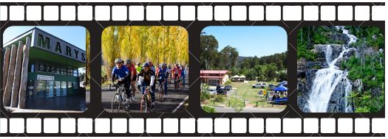

This worksheet is designed to help groups and individuals think through a project idea they would like to see included in the Marysville Community Plan, as per the suggestions from community members at the Marysville Community Planning meeting on 27 June, 2019.

Please complete and drop it off at MiRa or email it to communityplanning@murrindindi.vic.gov.au.

Names and contact details of people who have helped complete this form: ___________________________________________________________________________________________________________________________________________________________________________

What is the project idea? (Describe in one sentence)
____________________________________________________________________________________________________________________________________________________________________________________________________________________________________

Describe a little bit more about the idea:
_______________________________________________________________________________________________________________________________________________________________________________________________________________________________________________________________________________________________________________________________________________________________________________________________________________

Timeframe of project: (and indicate whether short, medium or long-term)

___________________________________________________________________________________________________________________________________________________________________________

What time and volunteer input is going to be needed? Do you think people are willing?

____________________________________________________________________________________________________________________________________________________________________________________________________________________________________

What is the community benefit? (Think how broad and how deep.)
Cultural Children/youth Tourism Environment Sport/Rec
Assets Infrastructure/assets Partnerships Services
Economic development Other

____________________________________________________________________________________________________________________________________________________________________________________________________________________________________

Who should be involved in this project? Are there partnerships involved? Please list any community groups who support this project idea.
_____________________________________________________________________________________________________________________________________________________________________________________________________________________________________________________________________________________________

Are there people who might not support this project to happen? What is their perspective? Is there a way to work them?
____________________________________________________________________________________________________________________________________________________________________________________________________________________________________

Project budget: How much will it cost? Give as much detail as you can.
______________________________________________________________________________________________________________________________________________________________________________________________________________________________________________________________________________________________________________________________________________________

Where do you think this money might come from? [Short term & long term if applicable]
____________________________________________________________________________________________________________________________________________________________________________________________________________________________________

Sustainability: does it require ongoing funding? (Eg. Running costs and maintenance, and human resources.)
___________________________________________________________________________________________________________________________________________________________________________

Date this form was completed:
_________________________________________________________

