Aboriginal Family Health and Community Service
Lower Hume (Murrindindi and Mitchell Shire)
2016
Compiled by Glynis Vickery

INTRODUCTION
This Aboriginal Family Health and Community Service resource booklet was created for Aboriginal Families within the community to know how and where to access services in their area. Both Rebecca and I feel that this resource is very important to us both as we feel the families out there do not know some of the services that they could be accessing and thought this would be a great way for them to navigate the systems. If you find any information in the booklet incorrect could you please contact the following:
- Rebecca Welsh
- Lisa Arnold
- Glynis Vickery

AKNOWLEDGEMENT
I would like to express my very great appreciation to Rebecca Welsh from Lower Hume Aboriginal Health and Wellbeing Project and would like to offer my special thanks to her for the advice she has given while putting this resource together, the assistance she has given has been a great help and very much appreciated.

Contents
INTRODUCTION 2
AKNOWLEDGEMENT 2
PARENTLINE VICTORIA 5
KIDS HELPLINE 6
FAMILYCARE SERVICES 6
BERRY STREET 7
VICTORIAN ABORIGINAL LEGAL SERVICE 7
REGIONAL INFORMATION & ADVOCACY (RIAC) 8
COMMUNITY LINKS 9
NEXUS PRIMARY HEALTH 10
PLENTY VALLEY COMMUNITY HEALTH 11
EASTERN HEALTH 12
VICTORIAN ABORIGINAL HEALTH SERVICE (VAHS) 13
RUMBALARA ABORIGINAL HEALTH SERVICE 14
HOSPITALS 15
ROYAL CHILDREN’s HOSPITAL 15
THE NORTHERN HOSPITAL 16
MERCY HOSPITAL 17
DENTAL HEALTH SERVICES 18
OPTOMETTRY (Eye Health) 18
PLAYGROUP 19
MURRINDINDI SHIRE - Playgroup 19
MITCHELL SHIRE – Playgroup 20
KINDERGARTEN - Mitchell Shire 21
KINDERGARTEN - Murrindindi Shire 22
SEXUAL ASSAULT 23
COMMUNITY TRANSPORT 23
FOOD BANK 23
FAMILY VIOLENCE 23
KOORIE ENGAGEMENT SUPPORT OFFICER (KESO) 24
CATHOLIC EDUCATION (Koorie Officers) 24
MATERNAL and CHILD HEALTH SERVICES (MCH) 25
MCH - Murrindindi Shire 25
MCH - Mitchell Shire 26
EARLY CHILKDHOOD SERVICES AND SCHOOLS 26
CENTRELINK 27
YOUTH SERVICES 28
ABORIGINAL COMMUNITY ELDERLY SERVICES (ACES) 28
ABORIGNAL and TORRES STRAIT ISLANDERS CENTER FOR MALES 29
HOUSING 30
ABORIGINAL HOUSING – Narradjeri House 30
DHHS – Rural Housing 30
SEYMOUR DIRECTORY 31
MITCHELL SHIRE COUNCIL COMMUNITY DIRECTORY 31
MURRINDINDI SHIRE COUNCIL COMMUNITY DIECTORY 31
POST and ANTENATAL DEPRESSION ASSOCIATION (PANDA) 32
DISABILITIES 32
AMAZE (Autism Victoria) 32
ABORIGINAL HEALTH AND WELLBEING PROJECTS 33
ABORIGINAL HEALTH TRANSITION OFFICERS 33
MURRAY PRIMARY HEALTH NETWORK 33
ACADEMY OF SPORT HEALTH AND EDUCATION (ASHE) 34
SEYMOUR LOCAL ABORIGINAL NETWORK (LAN) GROUP 34

PARENTLINE VICTORIA
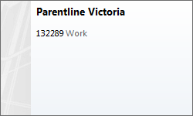
- Parentline provides a statewide telephone counselling service to parents and carers of children aged from birth to eighteen years
- Professional counsellors are able to explore a variety of issues that impact on parenting and relationships
- Parentline can provide contact details for community services
- Parentline respects the confidentiality and right to privacy of callers
"I often lack confidence in what I am doing so being able to talk with someone was really great for me. I did not feel put down or judged..."
"I felt a connection with the counsellor. They tailored (the call) to my situation."

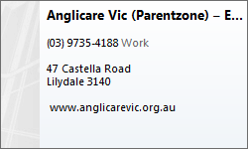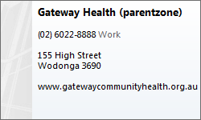
Parent education is an integral component of Anglicare's work with families. Parentzone, Parent Resource Centres, provide support to parents on a wide-range of parenting issues, including building self-esteem and dealing with conflict.
Parentzone gives support to parents through information and group work including:
- a variety of parenting programs offered at no cost
- a quarterly newsletter containing information about groups and events, support groups, family supports and professional development
- a resource library of books, videos and articles about parenting
- resources for professionals who offer parenting programs
- training and consultancy for professionals in facilitating parent programs
- information about other family support agencies.

KIDS HELPLINE
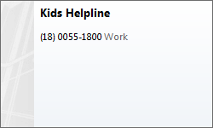
Kids Helpline is Australia's only free, private and confidential, telephone and online counselling service specifically for young people aged between 5 and 25.

FAMILYCARE SERVICES
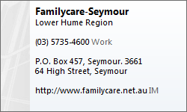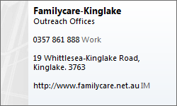
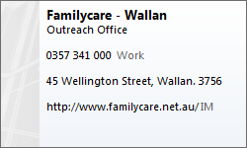
Provides relevant support and services to families. The various programs and activities that are offered under this umbrella are designed to enhance parent to child, partner to partner & sibling to sibling interactions.

All Family Care programs and services are free and confidential.

BERRY STREET
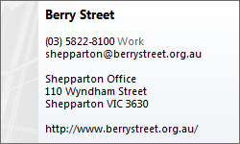

VICTORIAN ABORIGINAL LEGAL SERVICE
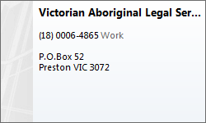
VALS provides free legal advice and representation for the Koorie community.
The services VALS provides are as follows:
- Information, initial legal advice, minor assistance and referral;
- Duty lawyer assistance;
- Legal casework services including representation and assistance, covering Criminal Law, Civil Law and Family Law matters.
Information
Each of the VALS’ offices can provide basic legal information.
Initial Legal Advice
Initial legal advice is the provision of legal advice or information that is not provided as part of duty lawyer work or casework. It includes referrals, preliminary assistance, the writing of short letters and completion of forms.
Minor assistance
Minor assistance is helping with phone calls or letters and advocacy in dealing with other services.
Referral
A VALS’ staff member will use his or her professional judgement in making an appropriate referral having reference to the lists of appropriate sources of referral and assistance maintained by VALS.
Duty Lawyer assistance
Duty Lawyers provide advice and/or representation in urgent matters to people who have not been able to arrange legal representation. For instance, all applications (i.e. for bail or adjournments) are performed on a Duty Lawyer basis where the matter is completed in one day. A matter not completed on the same day is called a Casework matter.
Legal Casework
Legal Casework is legal representation and assistance, covering criminal, civil and family law matters. It is matters where VALS provides ongoing legal services (i.e. assistance continues after the first day of contact) to a client in relation to a particular legal problem.

REGIONAL INFORMATION & ADVOCACY (RIAC)
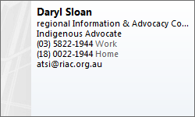
Who is RIAC for?
People with all types of disabilities, their families and carers, the aged and Cultural & Linguistically Diverse (CALD)
What do Advocates do?
An Advocate is someone who will support you to make decisions or have your opinion heard, so that you are treated fairly. An Advocate might speak on your behalf, or write letters or simply sit beside you in meetings to support you in the decisions you need to make.

COMMUNITY LINKS
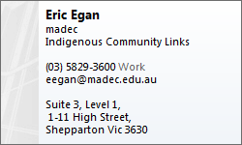
Indigenous community links is for Aboriginal and Torres Strait Islander people and their families. There are services across Australia in many urban regional areas.
Indigenous community links can help if you need information about other services in your area.
The staff can give you advice about what you expect from other services and support you to make an appointment to get a referral.
If you need help or advice drop in and have a yarn with our friendly staff.

NEXUS PRIMARY HEALTH
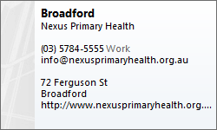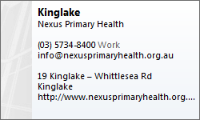
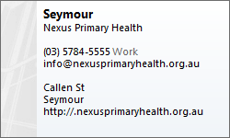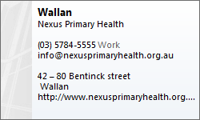
Nexus Primary Health offers the following services:
- Allied Health
- Community Support
- Alcohol, Tobacco & other Drugs
- Counselling
- Financial Counselling
- Family Violence Support
- Personal Helpers & Mentors Program
- Disability Case Management
- Community Aged Care Packages
- Planned Activity & Wanderers Group
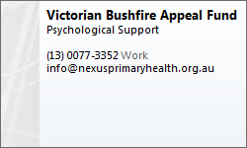
Nexus Primary Health has offices located at:
- Broadford, Kinglake, Wallan, Seymour, Euroa

PLENTY VALLEY COMMUNITY HEALTH
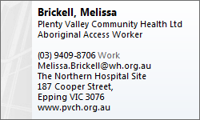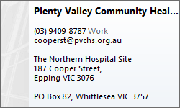
Aboriginal Health
A Plenty Valley Aboriginal Access Worker may be able to assist and support access to the following Plenty Valley Community Health Services:
- Counselling
- Community Midwifery and Women's Health
- Dental Services
- Diabetes Education
- Dietetics
- Drug and Alcohol Services
- Endocrinology
- Housing Services
- Occupational Therapy
- Physiotherapy
- Podiatry
- Speech Pathology
- Optometry
- Renal / Nephrology
- Psychiatrist
- Respiratory

EASTERN HEALTH
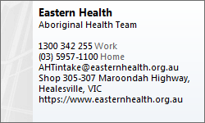
The Aboriginal Health Team is a community-based health service located in Healesville that is accessible by Aboriginal people and their families living anywhere in Eastern Health’s catchment. The service adopts a holistic approach in line with cultural best-practice and as such provides a broad range of services which are available both on-site in Healesville and through home visits and outreach including:
Primary Health Care:
- Aboriginal and Torres Strait Islander Health Checks (all ages)
- Nursing support including chronic disease management and maternal-child health
- Health information and education
- Visiting specialists
Case Management and Advocacy:
- Care-planning
- Referral & advocacy to other services including transport to medical appointments where appropriate
- Case management
Social and Emotional Well-Being
- Social & Emotional Well-Being Counselling
- Drug and Alcohol Counselling
- Psychological & Psychiatric support services
- School-based programs and educational support
- Bringing Them Home services for Aboriginal people impacted on by Government forced removal policies
Home and Community Care
- Domestic assistance and cleaning
- Property maintenance
- Social events and outings including Men’s and Women’s Group and Planned Activity Groups

VICTORIAN ABORIGINAL HEALTH SERVICE (VAHS)
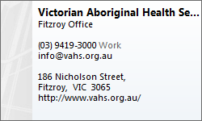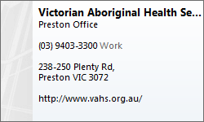
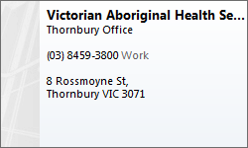
Visiting Medical Specialists:
The VAHS continues to have a range of Visiting Medical Specialists – Cardiologist, Gynaecologist, Geriatrician, Ophthalmologist, General Surgeon and Ear Nose & Throat Surgeon – to provide services to patients instead of having to attend out-patient clinics in hospitals. These sessions are well attended by community members.
The VAHS will again review our list of Visiting Medical Specialists to ensure that they meet the needs of the community and the service. Some of the specialists that we are considering include; a Dermatologist (commenced December 2013); an Endocrinologist (Diabetes specialist); and a Liver specialist.

RUMBALARA ABORIGINAL HEALTH SERVICE
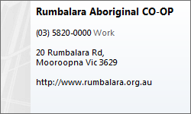
Rumbalara operates in a culturally appropriate and sensitive Community Controlled environment that maintains a Holistic approach to service provision and emphasize the importance of Family and Community.
Services they provide:
- Aged Care & Disability Services
- Family Services
- Housing
- Health
- Dental
- Justice

HOSPITALS
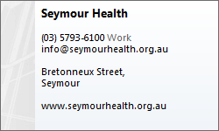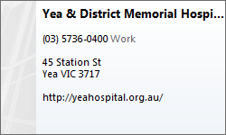
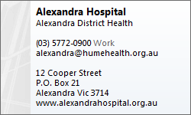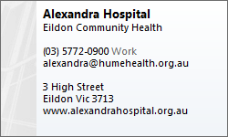
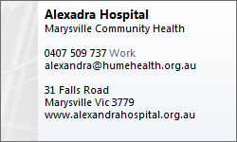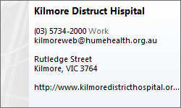

ROYAL CHILDREN’s HOSPITAL
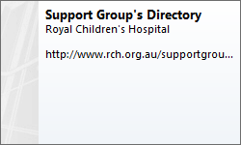

THE NORTHERN HOSPITAL
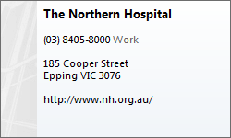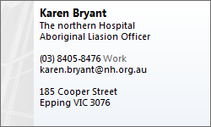
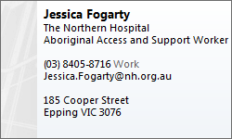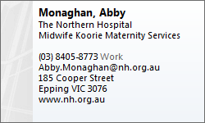

Aboriginal Liaison Program
Northern Health has a committed Aboriginal Liaison Program in place with a number of objectives, including:
- Development of relationships with the Aboriginal community
- Providing or coordinating cross-cultural training for hospital staff
- Implementation of policies to improve services for Aboriginal culture
- Development of initiatives that examine and improve the discharge planning and primary care referral of Aboriginal patients to ongoing care.
The Program provides information to the Aboriginal community on the types of services available at Northern Health and offers support in accessing these services.
Driven by the Northern Health Aboriginal Liaison Officer (AHLO), the Program also places an emphasis on raising the cultural awareness of health professionals to the distinct needs of Aboriginal patients.

MERCY HOSPITAL
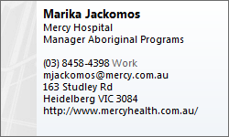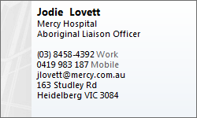
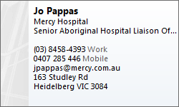
Aboriginal Health at Mercy Public Hospitals
Mercy Hospital is committed to improving the health and wellbeing of Aboriginal and Torres Strait Islander people.
Mercy Hospital for Women and Werribee Mercy Hospital seek to provide health services that are culturally safe, appropriate and welcoming for Aboriginal and Torres Strait Islander patients, families and visitors.
This includes:
- Providing direct support to patients and families
reviewing hospital policies and procedures to improve access to services and quality of care
- Enhancing the cultural appropriateness of care through providing information, education, and consultation to hospital staff regarding the needs of Aboriginal patients
- Maintaining a positive relationship with the Aboriginal community, including Aboriginal organisations.
Mercy Hospital for Women (Heidelberg)
- Aboriginal Hospital Liaison
- Nangnak Baban Murrup Aboriginal antenatal clinic
- Nangnak Wan Myeek postnatal support (New Directions Program)

DENTAL HEALTH SERVICES
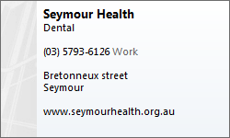
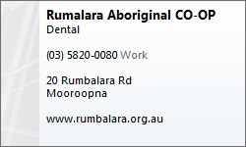

OPTOMETTRY (Eye Health)
The Victorian Aboriginal and Torres Strait Islander $10 Spectacle Subsidy Scheme is available at this optometrist.

PLAYGROUP
Playgroup provides parents and care givers with the opportunity to meet new people, gain support and exchange parenting ideas. They allow babies, toddlers and pre-schoolers to socialise as they play and learn together. All playgroups are different but the emphasis is on fun and friendship.
For more information
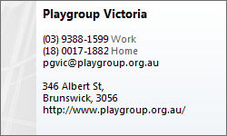

MURRINDINDI SHIRE - Playgroup
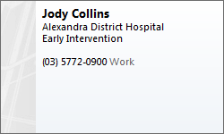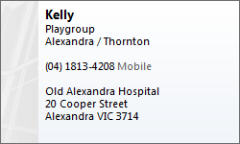
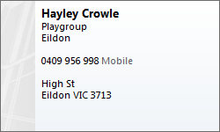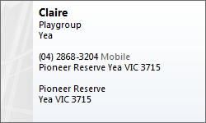
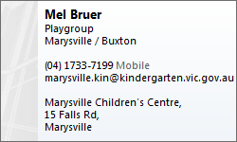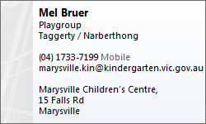
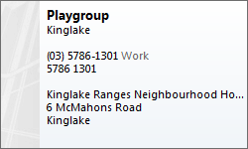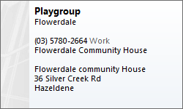

MITCHELL SHIRE – Playgroup
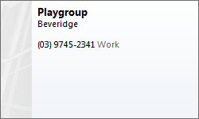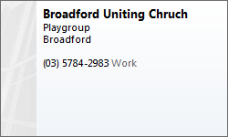
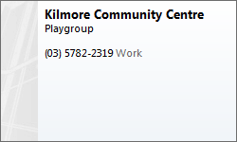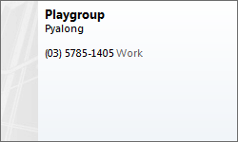
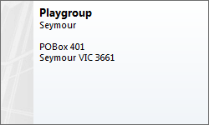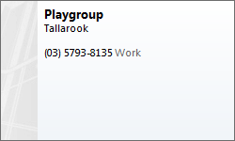
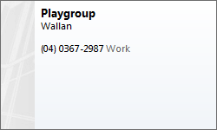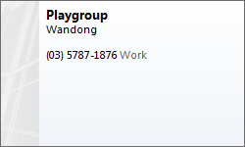

KINDERGARTEN - Mitchell Shire
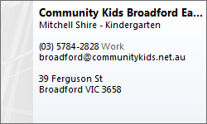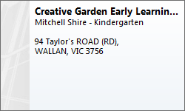
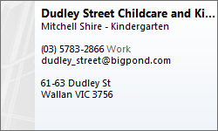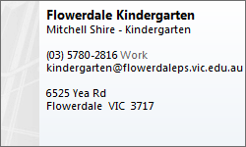
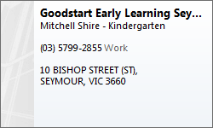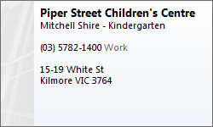
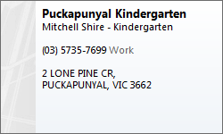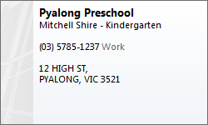
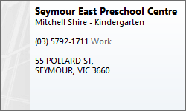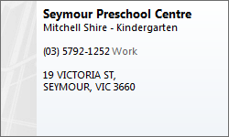
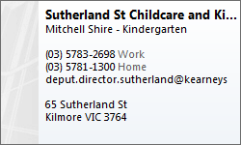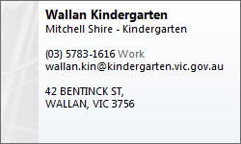
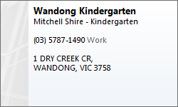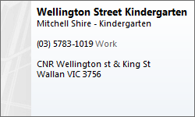

KINDERGARTEN - Murrindindi Shire
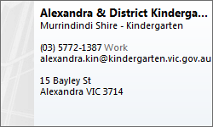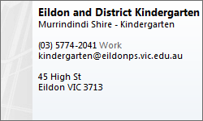
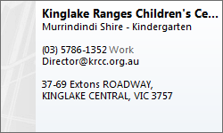
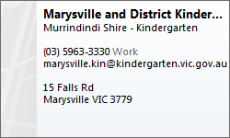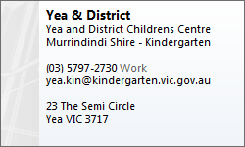

SEXUAL ASSAULT
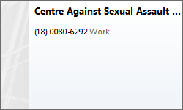

COMMUNITY TRANSPORT
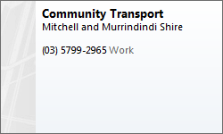

FOOD BANK
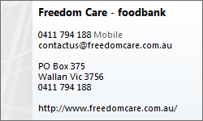

FAMILY VIOLENCE
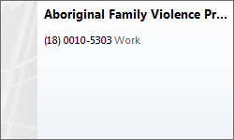

KOORIE ENGAGEMENT SUPPORT OFFICER (KESO)
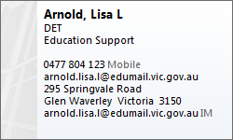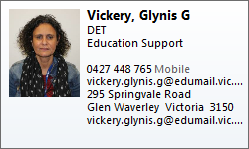
Koorie engagement support officers are employed in each Department of Education and Training regional office to work in partnership with the Koorie education coordinator in each region to support the implementation of the regional plan for the Koorie Education Strategy for Koorie students and early childhood initiatives to improve the health, wellbeing and educational outcomes for Koorie children and young people. Duties may include: coordinating the implementation of targeted educational and early childhood initiatives for Koorie children and young people; providing expert advice to early childhood services and school communities about models of effective support for Koorie children and young people; advising school staff in respect to the education of Koorie children and young people and the Koorie community as a whole; interpreting and analyzing data; liaising with early childhoods services, schools and regional officers to identify and access support mechanisms, programs and initiatives aimed at improving attendance and implementing strategies to increase the engagement of Koorie families in their child's learning.

CATHOLIC EDUCATION (Koorie Officers)
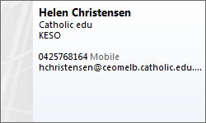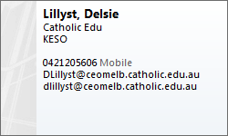
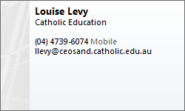

MATERNAL and CHILD HEALTH SERVICES (MCH)

MCH - Murrindindi Shire
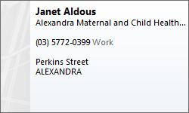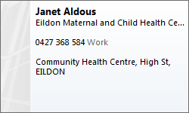
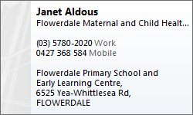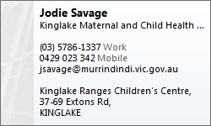
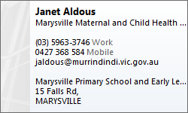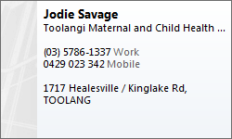
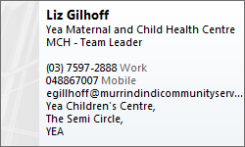

MCH - Mitchell Shire
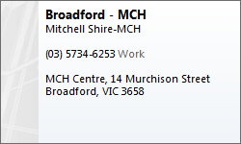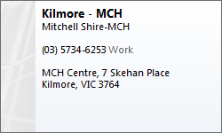
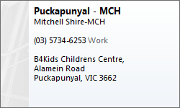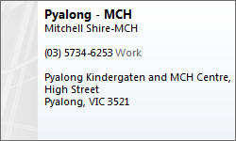
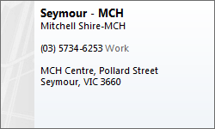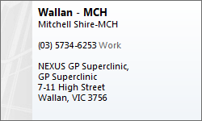
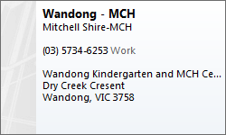

EARLY CHILKDHOOD SERVICES AND SCHOOLS
To find details of government schools and early childhood services in your area, see: http://www.education.vic.gov.au/findaservice/Home.aspx
For a list of all schools in Victoria, see: https://www.data.vic.gov.au/data/dataset/school-locations

CENTRELINK
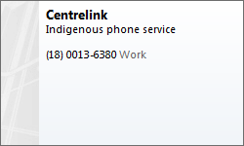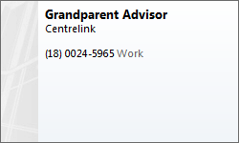
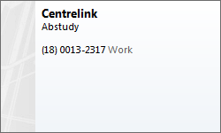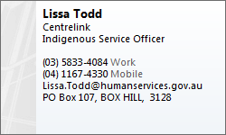
For transport issues – I would encourage the person to contact the Abstudy line 1800 132 317
Eligibility for ABSTUDY
To be eligible for ABSTUDY you must be:
- An Aboriginal or Torres Strait islander Australian
- Able to meet residence requirements
- Enrolled in an approved course or undertaking a full-time Australian Apprenticeship, and
- Not receiving any other government assistance to study or complete your apprenticeship

What ABSTUDY covers
If you are studying at a secondary school or college, TAFE (a technical and further education college), university or other approved tertiary institution, or in a full-time Australian Apprenticeship, ABSTUDY can help with your costs for:
- Education
- Accommodation
- Living
- Fares to travel to your place of study each term or semester if you need to study away from home
- Prescription medicine
If you qualify for ABSTUDY, you may be entitled to other payments and benefits too.
Murrindindi Shire (Alexandra) – nearest Centrelink Office is Lilydale, then Greensborough.

YOUTH SERVICES
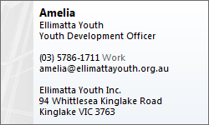

ABORIGINAL COMMUNITY ELDERLY SERVICES (ACES)
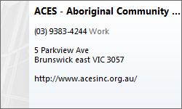
Programs
The Aboriginal Community Elders Services (ACES) is the only Aboriginal & Torres Strait Islander community controlled organisation in an urban setting which provides all three aged care programs:
- Residential Care Services
- Community Aged Care (also known as Koori Community Aged Care Program or KCACP)
- Home and Community Care (HACC) Planned Activity Groups (also known as PAG)

ABORIGNAL and TORRES STRAIT ISLANDERS CENTER FOR MALES
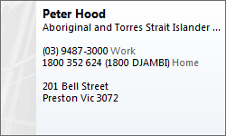
The Aboriginal and Torres Strait Islander centre for males, situated in Preston, Victoria, is run by the Victorian Aboriginal Community Services Association Limited (VACSAL) and the Victorian Aboriginal Health Services (VAHS). This program provides a safe and welcoming environment for Aboriginal and Torres Strait Islander males dealing with complex issues, including family violence. Men are referred to this program through various community services. They receive support and counselling through the program, and their progress and attendance is monitored. This process involves the husband/father, wife/mother, and the children. Services are available to the whole family.
The main aim of the Aboriginal and Torres Strait Islander centre for males is to culturally strengthen the family, bring awareness and responsibility to the male for their actions and their role as a father/husband, and to keep the family together.
Abstract adapted from the Victorian Aboriginal Community Services Association Limited

HOUSING

ABORIGINAL HOUSING – Narradjeri House
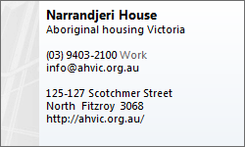
Business Overview
Aboriginal Housing Victoria is a state-wide Aboriginal community organisation that manages the Victorian Aboriginal rental housing program. The program includes over 1,500 properties state-wide, providing safe, secure and affordable housing. AHV empowers the Aboriginal and Torres Strait Islander community not only by providing safe and affordable housing but also by increasing the spiritual, political, social, educational and economic strength of individuals and communities. Through empowerment, AHV is playing our part in closing the gap.

Products / Services
Victorian Aboriginal rental housing program. Social housing program providing long term housing and assistance.

DHHS – Rural Housing
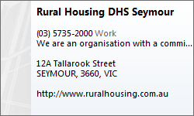
We are an organisation with a commitment to addressing housing affordability, tackling homelessness, and fostering housing stability, known for our progressive and compassionate approach to working with people experiencing homelessness and housing disadvantage. We are the largest social and community housing organisation within the Hume region of Victoria providing services to over 6000 people on an annual basis.

SEYMOUR DIRECTORY
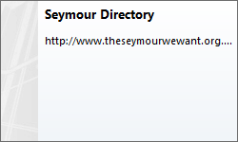

MITCHELL SHIRE COUNCIL COMMUNITY DIRECTORY
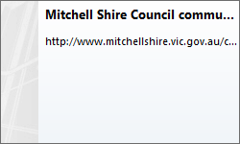

MURRINDINDI SHIRE COUNCIL COMMUNITY DIECTORY
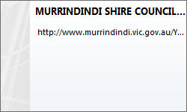

POST and ANTENATAL DEPRESSION ASSOCIATION (PANDA)
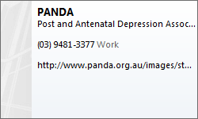

DISABILITIES
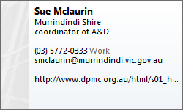

AMAZE (Autism Victoria)
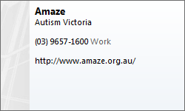

ABORIGINAL HEALTH AND WELLBEING PROJECTS
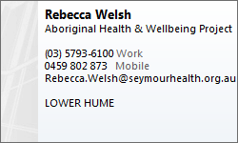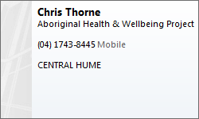

ABORIGINAL HEALTH TRANSITION OFFICERS
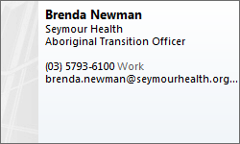

MURRAY PRIMARY HEALTH NETWORK
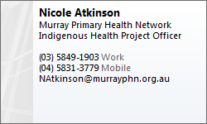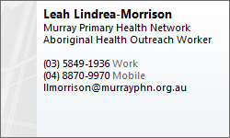

ACADEMY OF SPORT HEALTH AND EDUCATION (ASHE)
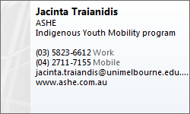

SEYMOUR LOCAL ABORIGINAL NETWORK (LAN) GROUP
