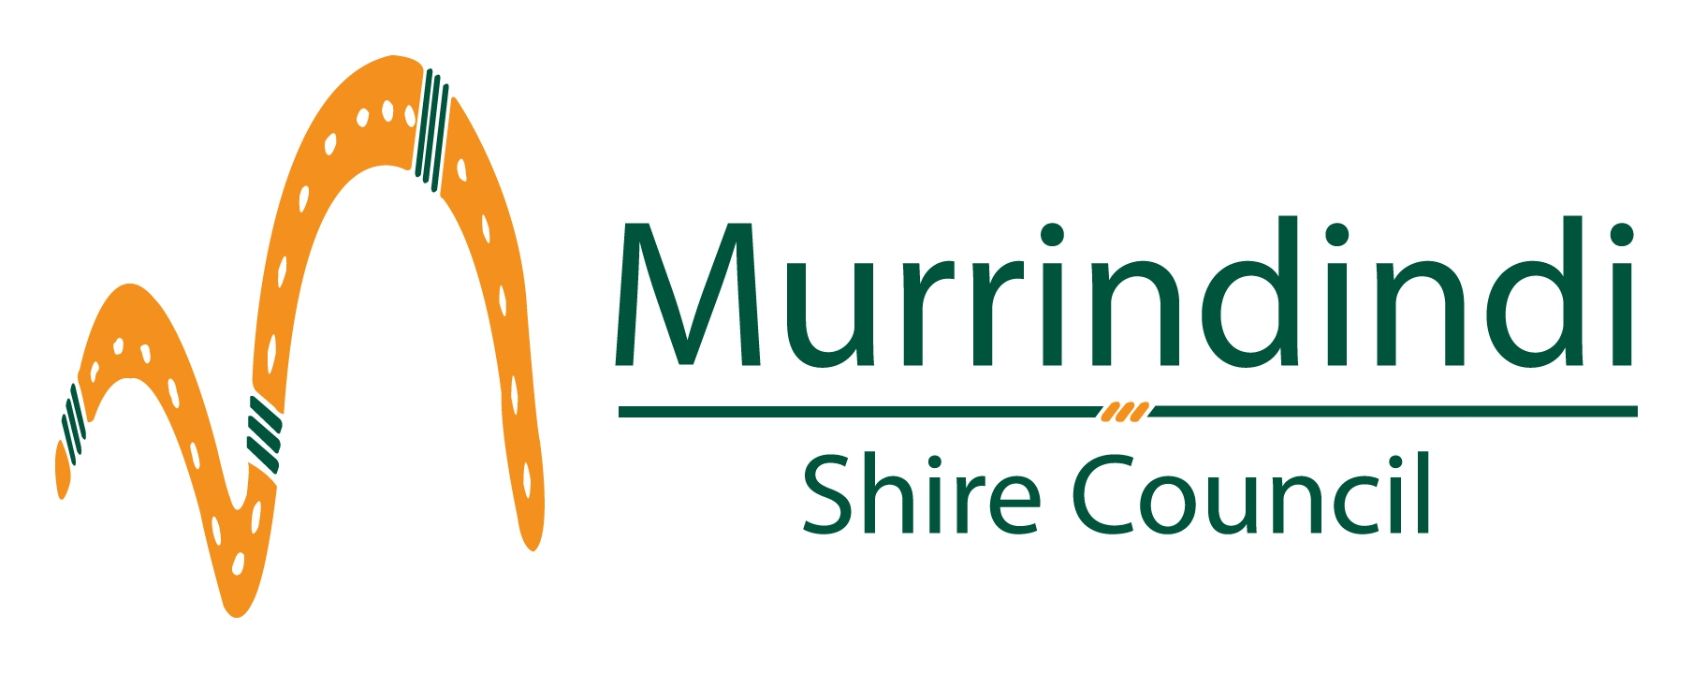
Office use only:

Public Liability Insurance
Hirers of Council Facilities

Council can offer limited liability cover to ‘Casual’ Hirers of Council Owned and Controlled Facilities. Liability Cover $10 million.

This policy is for casual ‘one-off’ hiring’s and is not for regular users or hirers.
Eg: Hire of Hall for Private Function

Note: Should there be a claim, the hirer will be responsible for excess

Name of Hirer:

Address:

Email Address:

Facility being Hired:

Purpose of Hire:

Date(s)

Signed:

Insurance Fee (Premium) is $35.00 incl. GST

Date Paid / / Receipt No:

Receipt to 50120.5145.1001 – Public Liability Insurance (Inc GST)

Return to: Murrindindi Shire Council
PO Box 138
Alexandra 3714

