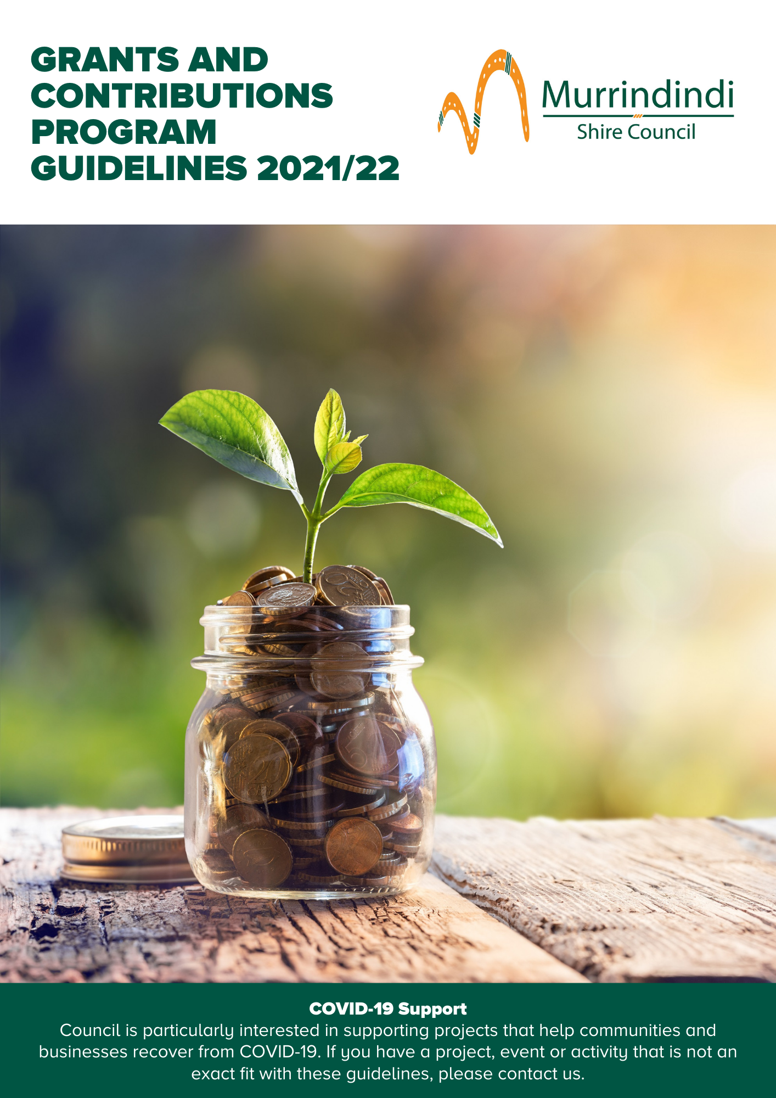

Contents

Contents 2
An Overview 3
Who is eligible to apply? 4
5
What won’t be funded 5
When is the funding available? 6
How do I apply? 7
Fee Reductions 8
Quick Response Grants 10
Governance, Skills & Capacity Building 11
Business Plan Support 13
Community Grants 15
Sponsorships 15
Community Projects and Events 17
Events Support 19
Small or New Tourism Events 19
Events of State Significance 21

Further information
Information on the Murrindindi Shire Council Grants and Contributions Program (MSCGCP) is made available through Council libraries and customer service centres, as well as on Council’s website and social media pages.
Support and guidance for applicants who may require assistance to access application forms is available through Council’s Community Wellbeing Department.
You can find more information about Council’s Contributions and Grants Program on Council’s website at www.murrindindi.vic.gov.au/grants
To contact us, please call 03 5772 0333 or email
grants@murrindindi.vic.gov.au

Information sessions
Council offers information sessions and individual appointments for potential applicants.
Information session times and dates are published on Council’s website and promoted through Council’s Facebook page.

An Overview

The Murrindindi Shire Council Grants and Contributions Program (MSCGCP) aligns with Council’s objectives outlined in the Murrindindi Shire Council Plan 2017-2021 and listed below.
- Our people – Together we will celebrate and encourage diverse, caring and connected communities.
- Our place – We will maintain and enhance places to be attractive and liveable, in balance with our natural environment.
- Our prosperity – In partnership with the community we will promote an environment in which business and community can thrive.
- Our promise – We will all work in collaboration with our community to deliver the best possible outcomes in all that we do.
It also aligns with other key strategic plans including the Murrindindi 2030 Vision and Municipal Public Health & Wellbeing Plan 2017-2021.

We value partnerships
We recognise the value of the resources and skills applicants contribute to deliver projects and run events and activities.
This is why we want to work collaboratively with applicants and we encourage you to get in touch with us if your project, event or activity is not an exact fit with these guidelines.
Applications that demonstrate community contributions to the proposed project or activity are considered favourably. Resources can be in the form of cash, volunteer time, donated materials, other grant sources, and funds raised through crowd funding platforms. Skills can include donated skilled and unskilled labour.

Good governance is important
Good governance is important in the daily operations of all organisations, community groups and businesses.
Council’s online grant application and management system improves the governance and transparency of our contributions and grants. It’s also a place for you to keep your grant applications and reports.
We are committed to making grants as easy as possible while still meeting our governance requirements. So, we have made application and reporting requirements proportionate to the size of the funds awarded and the expected outcomes.
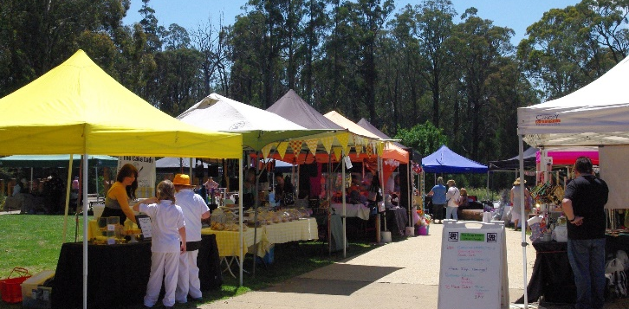

What will it fund?
The Program brings together Council’s previous contributions and grants programs and includes the following funding streams:
Fee Reductions (waivers by exception)
Quick Response Grants
Governance, Skills and Capacity Building
Sponsorships
Community Projects and Events
Business Plan Support
Small and New Tourism Events
Events of State Significance

Who is eligible to apply?

Who can apply
The Murrindindi Shire Grants and Contributions Program (MSCGCP) is available to not-for-profit community groups and organisations, social enterprises and businesses that:
- are a legal entity with an ABN, ACN or are incorporated, or have an auspice that is a legal entity
- are based within the Murrindindi Shire and/or are able to demonstrate the proposed activity will benefit the communities of Murrindindi Shire
- have acquitted all previous Council grants
- have no outstanding debts to Council
- demonstrate the contribution or grant will be used for a purpose in accordance with Council’s objectives as stated in the Council Plan, Health and Wellbeing Plan and other strategic plans
- demonstrate they are capable of delivering the proposed activity
- show they have considered the environmental impacts of their activity
- are able to contribute cash, in-kind or both to the activity, as specified in the program guidelines

Grant / Contribution |  | Individuals auspiced by a not-for-profit | Not-for-profit community groups and organisations | Social Enterprises | Businesses
Fee Reductions |  |  |  |  | 
Quick Response Grants |  |  |  |  | 
Governance, Skills and Capacity Building |  |  |  |  | 
Business Plan Support |  |  |  |  | 
Community  Grants | Sponsorships |  |  |  | 
 | Community Projects and events |  |  |  | 
Events  Support | Small and New Tourism Events |  |  |  | 
 | Events of State Significance |  |  |  | 

Auspices
If your group or organisation is ineligible to apply, you may enter into an agreement with an eligible not-for-profit community group or organisation to auspice the grant. Individuals seeking sponsorships require an auspice to apply.
If the application is successful, the auspice must enter into an agreement with Council and is
responsible for managing the grant funds. The auspice is legally accountable for the funds and must make sure the funds are spent as outlined in the agreement with Council. The auspice will be required to meet any reporting requirements and meet all the eligibility conditions of the grant.
If an auspice is required, written evidence of an auspice agreement must be submitted at the time of application.
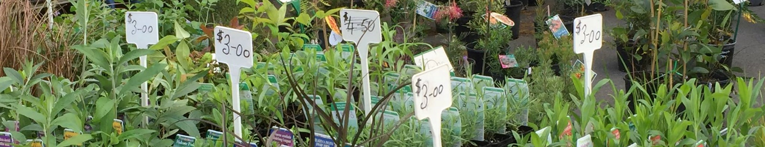

What won’t be funded

Council encourages applications from not-for-profit community groups and organisations, social enterprises, businesses and individuals located in Murrindindi Shire. We support projects that represent good value for the amount of money or in-kind support requested.
Council does not provide grants for projects that do not align with Council’s objectives or do not meet the relevant grant category funding criteria.
Eligible projects must be:
- a new, one off project or activity
- ready to commence
Contributions and grants are not available for:
- projects that have started (that is, no retrospective funding)
- projects that do not strengthen Murrindindi Shire communities
- activities that do not align with the strategic objectives of the Council Plan or other key strategic plans
- activities that duplicate existing services or programs
- permanent staffing costs or ongoing operational costs
- the payment of bonds
- programs or activities considered the responsibility of Local, State and Federal Government
- projects that directly contravene Council policy
- general donations to charities (however, Council may provide grants to specific projects run by charities where they meet the criteria)
- activities that could be perceived as benefiting a political party or party political campaign
- overtly religious activities that could be perceived as divisive within the community
- activities that inhibit basic human rights, discriminate or encourage discriminatory behaviour
- projects that are harmful to our residents or communities
- projects that unnecessarily destroy or waste non-recurring natural resources, pollute land, air or water
- market, promote or advertise products or services in a misleading or deceitful manner
- statutory fees and other statutory charges collected on behalf of state government or other authorities including development applications, health inspection fees, health approvals, street closures and other approvals

When is the funding available?
The Program has nine funding categories. The categories and round information are outlined below. Round and information session times and dates are published on Council’s website at www.murrindindi.vic.gov.au/grants and promoted through Council’s Facebook page.

Grant / Contribution |  | Funds | Timing
Fee Reductions |  | Up to 50% of the fee  Request for full waivers will be considered in exceptional circumstances* | Applications are assessed and awarded monthly
Quick Response Grants |  | Up to $1,000 | Applications are assessed and awarded monthly
Governance, Skills and Capacity Building |  | Up to $2,000 | Applications are assessed and awarded in March, July and November
Business Plan Support |  | Up to $5,000 | Applications are assessed and awarded in March, July and November
Community Grants | Sponsorships | Up to $1000 for individual sponsorships | Applications are assessed and awarded monthly
 |  | Up to $5,000 | Applications are assessed and awarded in March, July and November
 | Community Projects and events | Up to $5,000 | Applications are assessed and awarded in March, July and November
Events Support | Small and New Tourism Events | Up to $5,000 | Applications are assessed and awarded in March, July and November
 | Events of State Significance | Up to $20,000 | Applications are assessed and awarded in March, July and November
*Exceptional circumstances may apply if the applicant has limited capacity to generate an income.

How do I apply?

Application process
Application forms are available on Council’s website at www.murrindindi.vic.gov.au/grants
The only exception is the Quick Response Grants where application forms are provided once your project has been discussed with Council’s Manager Community Wellbeing.
Aim to upload your documents and submit your application well before the due date and time. The time needed to upload documents will vary according to the size of the document, your internet speed and how many other applicants are uploading documents. Applications commenced but not submitted will not be assessed by Council. Council does not accept submissions after the grant round has closed.
Council completes eligibility checks after applications are submitted. If Council advises an applicant their application may be better suited to a different grant category and the applicant agrees, additional time will be provided (if required) for the applicant to complete a new online application.

Application support and information sessions
Funding for contributions and grants is limited and it is important that applications provide a well-thought out response to each question. Applications also need to provide the requested supporting documentation.
All applicants are strongly encouraged to speak to the grants team to obtain advice and assistance before commencing their application.
To learn more about Council’s Contributions and Grants Program, including how to prepare a strong application you can:
- attend an information session
- contact Council’s Grants team on
03 5772 0333 or by email at grants@murrindindi.vic.gov.au

Agreements
All successful applicants are required to enter into an agreement with Council.
Agreements vary according to the size of the contribution or grant. Smaller contributions require the acceptance of terms and conditions and larger contributions require a more formal grant agreement.
The grant agreement outlines the reporting, monitoring and acquittal requirements for the grant. It also outlines the dates and times of payments, as well as the deliverables required for each payment.

Fee Reductions

Fee reductions provide financial relief to not-for-profit community groups and organisations, social enterprises and businesses which can demonstrate financial hardship as a result of undertaking projects or activities for community benefit.
Where a community group/organisation or business is seeking a fee reduction and another grant, the fee reduction will be considered as part of the grant application. This means that the combined value won’t exceed the maximum amount allowable for the grant.
Full fee waivers may be considered where significant hardship or need can be demonstrated.
Max project duration | 12 months
Max grant amount | No defined limit
Round frequency | Applications are open throughout the year and are assessed monthly
Eligible applicants | Not-for-profit community groups and organisations  Social enterprises  Businesses
Important information | Please contact Council to discuss your project before you apply. Request for full fee waivers will be considered in exceptional circumstances where applicants can demonstrate financial hardship as the result of undertaking activities for community benefit
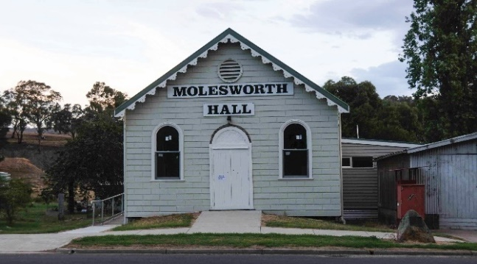

Typical reductions
Fee reductions for projects or activities that deliver a community benefit, such as:
- planning or building fees
- waste services including waste disposal and event bins
- community bus hire for community activities
- venue hire of halls, meeting spaces and building

Expected outcomes
Projects are expected to deliver the following outcomes:
- support social enterprises, not-for-profit community groups, business and organisations undertaking activities for community benefit.
- support social enterprises, businesses or business groups undertaking activities for broad community benefit.

Supporting documents
Applicants need to submit the following documents with their application:
Assessment Criteria
Applications will be assessed against the following criteria:
Financial hardship or risk the fee will create for the applicant. Applicants need to describe how the fee will create financial hardship or risk. Applicants will need to provide evidence of their financial status by means of bank statements, proof of loss, recent copy of financial accounts or letter of current standing from a financial accounts.
Applicant’s capacity to generate an income. Applicants will need to describe how they generate income for their business, social enterprise, community group or organisation, and outline their annual income value and expenditure. .
Community benefit. Applicants will need to describe the benefit that the overall project or activity will have on the broader community.
evidence of current financial status outlining financial loss or hardship other documents relevant to the proposed project or activity

Quick Response Grants

Quick Response Grants provide essential, urgent support to social enterprises and not-for-profit community groups and organisations who can demonstrate financial hardship as a result of unforeseen situations.
These grants do not provide funds to supplement other grant income or address the impact of foreseeable events.
Max project duration | 3 months
Max grant amount | Up to $1000.
Round frequency | Applications are assessed as they are received
Eligible applicants | Not-for-profit community groups and organisations  Social enterprises
Important information | Please contact Council to discuss your project before you apply

Typical projects
Projects or activities that address an urgent, critical need and that are not covered by insurance, such as:
• activities that address the impact of urgent, unforeseen financial impacts
- replacement of essential equipment
- essential and urgent repairs
Assessment Criteria
Applications will be assessed against the following criteria:
Impact on the normal operations of the applicant. Applicants need to show evidence of how the event occurred and its detrimental effect on normal operations.
Financial hardship or risk the fee will create for the applicant. Applicants need to describe how the fee will create financial hardship or risk. Applicants will need to provide evidence of their financial status by means of bank statements, proof of loss, recent copy of financial accounts or letter of current standing from a financial accounts.
How the community will be impacted if normal operations are interrupted. Applicants need to describe how their normal services/activities help their local community
Expected outcomes
Projects are expected to deliver one or more of the following outcomes:
- reduce financial impact of emergency and unforeseen events
- Enable social enterprises, not-for-profit community groups and organisations to continue to operate or quickly return to normal operations

Supporting documents
Applicants need to submit the following documents with their application:
quotes
evidence of current financial status
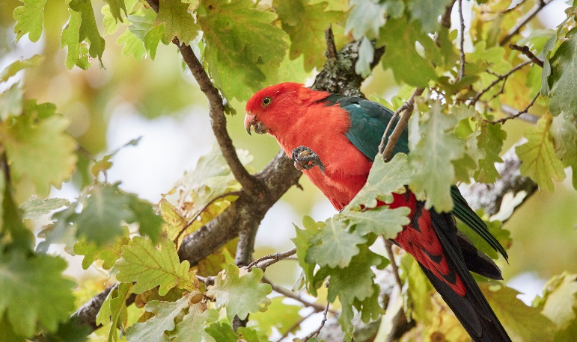
other documents relevant to the proposed project or activity

Governance, Skills & Capacity Building

The Governance, Skills and Capacity Building category supports not-for-profit community groups and organisations, social enterprises and individuals to meet their governance requirements, develop new skills and build their capacity.
This includes activities that improve the ability to operate effectively, undertake future planning and support the sustainability of the group or organisation.

Typical projects
Projects or activities that build the applicants capacity to operate and plan for the future, such as:
- activities that improve knowledge, skills and resources required to operate effectively
- training and education programs
- mentoring programs
- networking opportunities
- best practice resources and guides
- technology and systems
- development of governance strategies and plans
- strategic, business and financial planning activities (e.g. business plans, mentoring, program development, marketing, fundraising, membership)
- policy development (e.g. Working with Children, volunteers, OH&S)
Projects and activities not eligible for this grant include:
- projects that have already been funded by Council
- capital expenditure that is not for IT/computing related equipment or systems
- marketing, promotion or advertising products
- permanent staffing costs or ongoing operational costs

Expected outcomes
Projects are expected to deliver one or more of the following outcomes:
- improved resilience and sustainability of social enterprises, not-for-profit community groups and organisations and Committees of Management
- communities confident to plan, take action, solve problems and lead in the community
- not for profit community groups and organisations are sustainable
- reduced ongoing reliance on Council resources by not-for-profit community groups and organisations.

Supporting documents
Applicants need to submit the following documents with their application:
quotes
other documents relevant to the proposed project or activity

Max project duration | 12 months
Max grant amount | Up to $2000
Round frequency | Applications are open throughout the year and are assessed in March, July, and November
Eligible applicants | Social enterprises  Not-for-profit community groups/organisations  Committees of Management
Important information | Please contact Council to discuss your project before you apply

Assessment Criteria
Applications will be assessed against the following criteria:
Need to build the resilience, sustainability, knowledge, skills and resources. Applicants need to describe how the activity will support resilience, meet identified knowledge or skills gap, or support future sustainability and growth.
Improvements to operational activities. Applicants need to describe how the activity will improve their normal operational activities and how it will assist in ensuring that the social enterprise, community group or organisation is operating at best practise standard for their sector.
Reduce reliance on external funding. Applicants need to show how this project will reduce their reliance on external funds and support their long term financial sustainability.

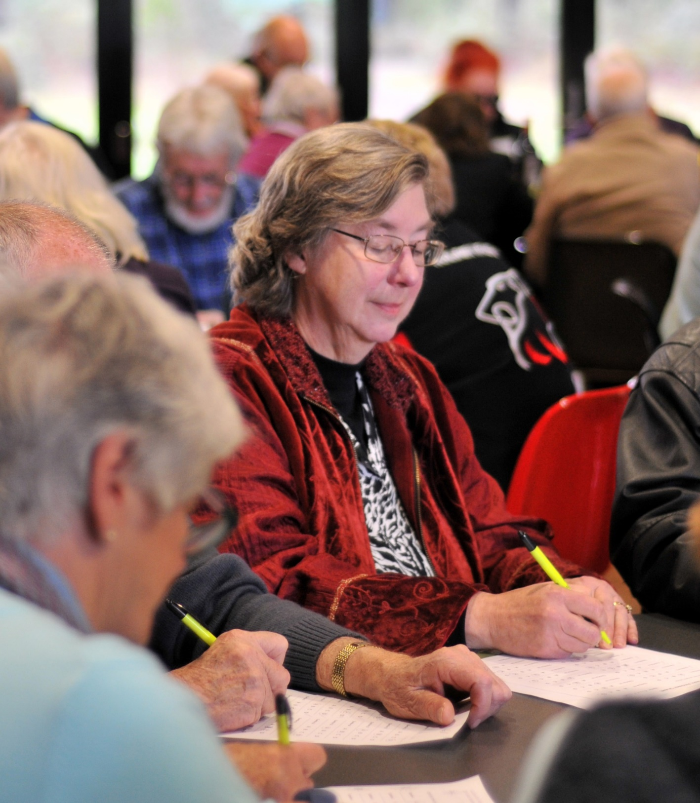

Business Plan Support
The Business Plan Support Grant assists businesses and social enterprises to plan for a viable and sustainable future. This includes activities that improve the ability to operate effectively, and support the sustainability of the social enterprise or business.

Typical projects
Projects or activities that:
- involve strategic, business and financial planning activities (e.g., business plans, program development, marketing, fundraising, membership)

Expected outcomes
Projects are expected to deliver one or more of the following outcomes:
- improved resilience and sustainability of businesses and social enterprises
- businesses confident to plan, take action, solve problems and lead in the community
- sustainable and viable businesses and social enterprises
- increased proportion of new social enterprises and businesses trading and viable after three years

Supporting documents
Applicants need to submit the following documents with their application:
quotes
other documents relevant to the proposed project or activity

Max project duration | 12 months
Max grant amount | Up to $5,000
Min applicant contribution | 50% of the project cost
Round frequency | Applications are open throughout the year and are assessed monthly
Eligible applicants | Businesses  Social enterprises
Important information | Please contact Council to discuss your project before you apply

Assessment Criteria
Applications will be assessed against the following criteria:
Improved resilience and sustainability. Applicants need to describe how the project will improve the resilience and sustainability of their business or social enterprise into the future.
Business confidence. Applicants need to describe how the project will establish or improve how the business operates, enable it to take action or to resolve identified challenges, provide growth opportunities that would not be possible without the grant, and how it will assist in planning for the future and becoming financially and environmentally sustainable.
Capacity to deliver the project. Applicants will need to demonstrate they have, or have access to, the skills and experience required to deliver their project.
Sustainable and viable businesses and social enterprises. Applicants will need to explain how the project will enable them to increase their -sustainability and viability over the next 3 years.
Strategic Activities. Applicants will need to demonstrate why the project is a strategic business or financial planning activity.
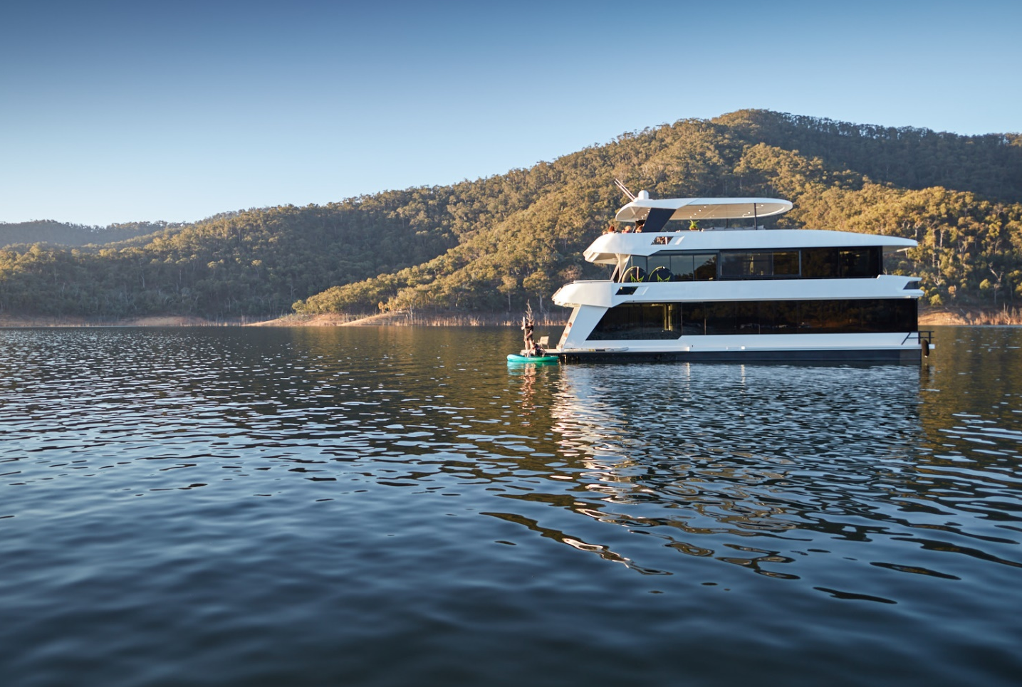

Community Grants

Community Grants are provided for projects that support our communities to improve the liveability of our towns and places, build connections, create opportunities for participation in community and civic life, improve personal and community health and wellbeing, protect our natural environment and assist communities to plan for the future.
There are two categories of community grants
- sponsorships
- community projects & events
Projects that have a partnership approach are encouraged.
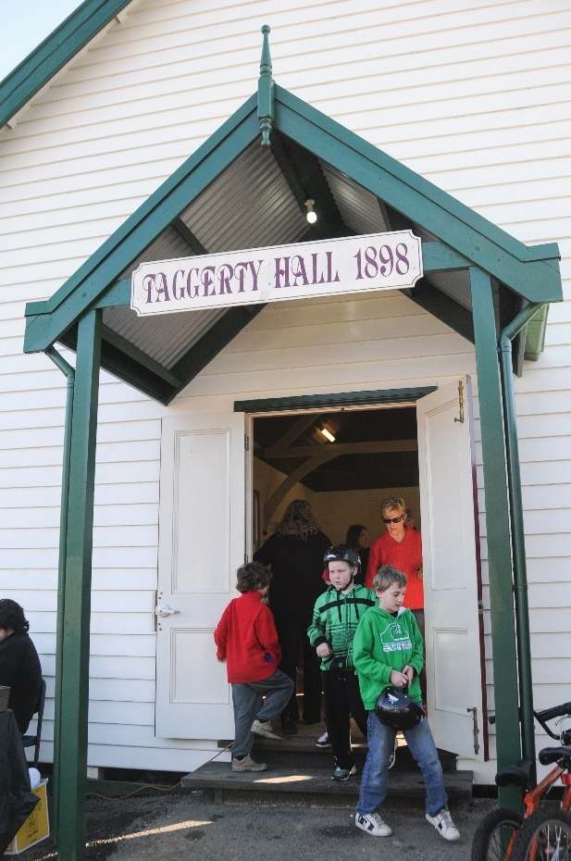
Max project duration | up to 36 months
Max grant amount | Up to $1000 for individuals  Up to $5000 for not-for-profit community groups/organisations
Round frequency | Up to $1000 - Applications are open throughout the year and are assessed monthly Up to $5000 - applications are open throughout the year and are assessed in March, July, and November
Eligible applicants | Individuals  Not-for-profit community groups/organisations  Committees of Management  Social Enterprises
Important information | Please contact Council to discuss your project before you apply  May include Fee Reductions as a component of a grant package

Sponsorships
Sponsorship provides financial or in-kind support to eligible individuals, social enterprises, groups and organisations and promotes the role of Council. Sponsorship is a transaction in which Council provides a financial or non-financial contribution for an event, projects, service or activity, in return for agreed promotional benefits. Individuals are able to apply for a Community Sponsorship if they:
- are participating in an official cultural, sporting or recreation event
- have an incorporated auspice for the activity or event
- are based in Murrindindi Shire
- are able to contribute cash, in-kind or both to the project
- Not-for-profit community groups and organisations, and Committees of Management are able to apply for single or multi-year funding. (The total amount of funding in a multi-year arrangement will not exceed $5000.)

Typical projects
Projects or activities that:
- enhance Council's public image through association with a sponsored activity and:
- delivers a community benefit
- provides a value for money promotion opportunity
- aligns with the Murrindindi Shire Council Plan 2017-2021 Strategic Objectives
- uses traditional and/or online media to promote Council’s contribution
- acknowledges Council's contribution at events and in speeches/interviews
- invites Council to participate in the event in a meaningful way
- includes Council materials in information packs or on static displays
- offers Council naming rights for awards and prizes for the term of the sponsorship
- foster civic pride by highlighting the things Murrindindi Shire is known for:
- showcase the character of our rural towns and communities
- showcase our natural environment and landscapes
- Showcase our diverse range of community, recreation and visitor opportunities and experiences.

Expected outcomes
Projects are expected to deliver one or more of the following outcomes:
- increased visibility of Council contributions to community
greater community awareness of the role of Council
- increased opportunities for Council to distribute or gather information
- raised awareness of activities that align with Council values and strategic objectives

- greater community awareness of the role of Council
- increased opportunities for Council to distribute or gather information
- raised awareness of activities that align with Council values and strategic objectives
- increased awareness and civic pride of rural towns, communities and the things Murrindindi Shire is known for

Supporting documents
Applicants need to submit the following documents with their application:
quotes
evidence of current financial status (Auspices, social enterprises, community groups and organisations only)
evidence of an invitation to participate in a professional, educational, cultural, sporting or recreational activity or event (Individuals only)
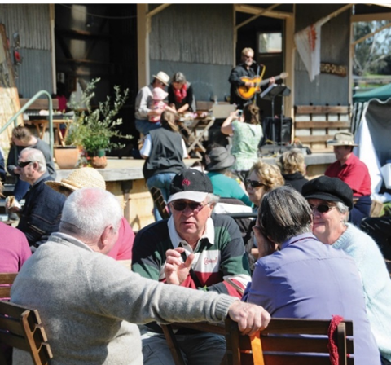
other documents relevant to the proposed project or activity

Assessment Criteria
Applications will be assessed against the following criteria:
Benefit the proposed activity or event will provide to the community. Applicants need to show the benefit their activity or event will bring to the local community. Social and economic benefits should be highlighted.
Benefit Council will receive as a sponsor of this activity or event. Applicants should clearly state the opportunities Council will be offered to provide or distribute information, speak, be interviewed, have prize/award naming rights or any other means to participate in a meaningful way.
Showcase the things Murrindindi Shire is known for. Applicants needs to describe how the activity or event will showcase our rural towns or communities, natural environments/landscapes or the diverse community, recreation and visitor experiences on offer in Murrindindi Shire.

Community Projects and Events
The Community Projects & Events Grant supports social enterprises, not-for-profit community groups and organisations, and businesses to undertake activities that have a broad community benefit. This includes activities with a focus on health & wellbeing, building resilience and reducing social isolation, looking after our built and natural environments and providing arts and cultural opportunities.

Typical projects
Projects or activities that have a broad community benefit and:
- improve community health & wellbeing by
- promoting active and healthy life choices
- increasing opportunities for formal and informal recreation
- improving access to services
- addressing existing and emerging issues.
- connect people and encourage participation in community and civic life by
- providing opportunities for people to connect and build social networks
- reducing social isolation
- building youth resilience through leadership development groups
- maintain and enhance our built and natural environment by
- promoting use of our built and natural assets
Max project duration | 12 months
Max grant amount | Up to $5000
Min applicant contribution | In-kind contributions for grants under $1000  $500 cash or in-kind for grants over $1000
Round frequency | Applications are open throughout the year and are assessed in March, July, and November
Eligible applicants | Businesses  Social enterprises  Not-for-profit community groups/organisations
Important information | Please contact Council to discuss your project before you apply  May include Fee Reductions as a component of a grant package
- caring for our built and natural environment and preserving out historically important buildings and natural environments
- provide opportunities for arts and cultural activities by
- delivering arts or cultural events or projects
- celebrating the history, culture and character of our communities, towns and places
- linking young people to performing arts
- supporting arts and cultural groups

Expected outcomes
Projects are expected to deliver one or more of the following outcomes:
- more activities that promote personal and community health and wellbeing (e.g. arts and culture, recreation, build social connections)
- more opportunities for people to come together, participate and celebrate in community and civic life
- enhanced and increased use of our built and natural environment
- built and natural environment is preserved

Supporting documents
Applicants need to submit the following documents with their application:
quotes
evidence of current financial status
- Other documents relevant to the proposed project or activity

Assessment Criteria
Applications will be assessed against the following criteria:
Need the project or activity will address. Applicants need to describe how the project or activity will address a new or existing community need.
Benefit the project will bring to the community. Applicants need to describe how the project or activity will:
- Improve community health and wellbeing
- Connect people and encourage participation in community and civic life
- Maintain and enhance our built and natural environment
- Provide opportunities for arts and cultural events
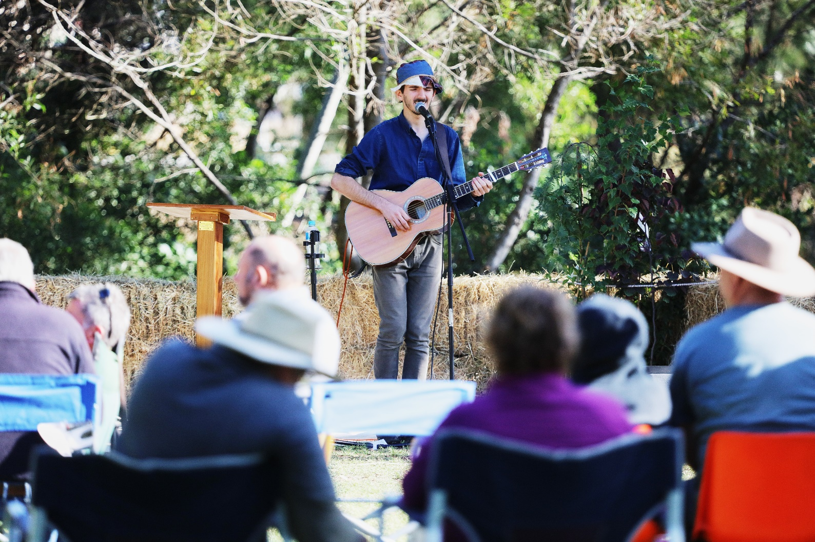

Events Support

Events Support is provided to foster growth in the tourism sector by supporting the development of sustainable events that increase visitor numbers, encourage repeat visitation and promote our rural towns and beautiful natural assets.

There are two levels of Events Support grants:
- Small or New Tourism Events which support the development of small or new events that attract local and regional visitors.
- Events of State Significance which support events that attract state-wide visitors and encourage overnight stays.

Small or New Tourism Events
This category supports tourism events to establish and grow. It can be accessed to start new events or grow niche events looking to improve sustainability.

Typical events
Events that attract local and regional visitors, and:
- generate visitation
- are working to become more sustainable
- align with Murrindindi Shire’s key products, experiences or marketing strengths

Expected outcomes
- Events are expected to deliver one or more of the following outcomes:
have projected attendance of no less than 100 visitors
- increased visitor yield for Murrindindi businesses
- increased opportunities for Council to distribute or gather information
raised awareness of activities that align with Council values and strategic objectives
increased awareness of our rural towns and the things Murrindindi Shire is known for

Max project duration | 12 months
Max grant amount | Up to $5000
Min applicant contribution | Cash and/or in-kind contribution of 30% of total grant value*
Round frequency | Applications are open throughout the year and are assessed in March, July, and November
Eligible applicants | Businesses  Social enterprises  Not-for-profit community groups/organisations
Important information | Please contact Council to discuss your project before you apply  May include Fee Reductions as a component of a grant package  *Minimum applicant contribution may be varied as assessed by Council

Supporting documents
Applicants need to submit the following documents with their application:
quotes
evidence of current financial status
Other documents relevant to the proposed project or activity

Assessment Criteria
Applications will be assessed against the following criteria:
Visitation generated to the town or Shire as a result of the event. Applicants will need to show how the event will attract visitation from both within and outside the Shire and/or attract repeat visitation post-event.
Potential to grow into a sustainable annual event. Applicants will need to outline their plans to make the event sustainable within 3-5 years.
Alignment to Murrindindi Shire’s strengths. Applicants will need to explain how the event aligns with Murrindindi Shire’s key products, experiences or marketing strengths and aligns with Council values and strategic objectives
Provide opportunities for businesses in Murrindindi Shire. Applicants will need to outline how the event will work with, or provide benefit to, businesses in Murrindindi Shire.
Capacity to deliver event. Applicants will need to demonstrate they have, or have access to, the skills and experience required to deliver their event.
Benefit to Council. Applicants will need to outline any opportunities the event will provide to Council to gather or distribute information and how Council’s contribution to the event will be recognised

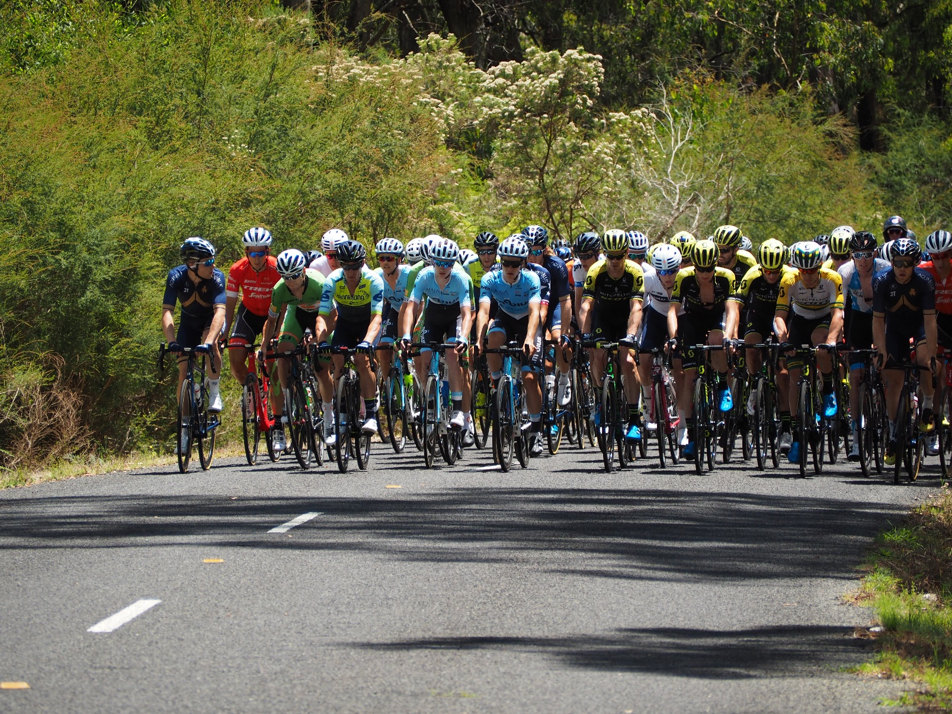

Events of State Significance
Events of State Significance Grants support the delivery of large events that are significant in terms of visitation, length of stay and yield to local businesses and communities.

Typical event costs
Funding will be allocated to marketing and other associated event costs that attract a large number of state-wide visitors, such as:
- events that are part of a recognised event series (e.g. A Day on the Green)
- marquee events that have a major sponsor/promoter associated with them
- nationally recognised competitive events
- significant State or National trade shows/expos
- multi-day events

Expected outcomes
Events are expected to deliver one or more of the following outcomes:
- generate visitation from across the state
- projected attendance of 1000 persons or more
- generate additional overnight stays and maximise repeat visitation
- align with Murrindindi Shire’s key products, experiences or marketing strengths

Supporting documents
Applicants need to submit the following documents with their application:
quotes
marketing plan and products
event management plan
guidelines for other grants if seeking funding for leveraging purposes
evidence of current financial status
- other documents relevant to the proposed project or activity

Max project duration | 24 months
Max grant amount | Up to $20,000
Min applicant contribution | 50% of the event cost
Round frequency | Applications are open throughout the year and are assessed in March, July, and November
Eligible applicants | Businesses  Social enterprises  Not-for-profit community groups/organisations
Important information | Please contact Council to discuss your project before you apply  May include Fee Reductions as a component of a grant package

Assessment Criteria
Applications will be assessed against the following criteria:
Visitation generated to the town or Shire as a result of the event. Applicants will need to demonstrate how the event will attract visitation from across the state and interstate and explain the basis for their projected attendance figure.
Potential for growth into a sustainable annual event. Applicants will need to outline their plans to make the event sustainable within 3-5 years.
Capacity to deliver event. Applicants will need to demonstrate they have, or have access to, the skills and experience required to deliver their event.
Potential to attract State or Federal government grant funding. Applicants will need to outline the alignment of their event to available State or Federal government grant programs and provide evidence of correspondence with the funder. Leveraging opportunities are viewed favourably.
Potential to generate visitor spend, overnight stays or return visitation. Applicants will need to demonstrate how their event will stimulate increased visitor spend, overnight stays or return visitations.
Benefit to the community. Applicants will need to describe the benefit to the community as a result of this event.

Alignment to Murrindindi Shire’s strengths. Applicants will need to explain how the event aligns with Murrindindi Shire’s key products, experiences or marketing strengths and aligns with Council values and strategic objectives
Provide opportunities for businesses in Murrindindi Shire. Applicants will need to outline how the event will work with, or provide benefit to, businesses in Murrindindi Shire.

Benefit to Council. Applicants will need to outline any opportunities the event will provide to Council to gather or distribute information and how Council’s contribution to the event will be recognised

