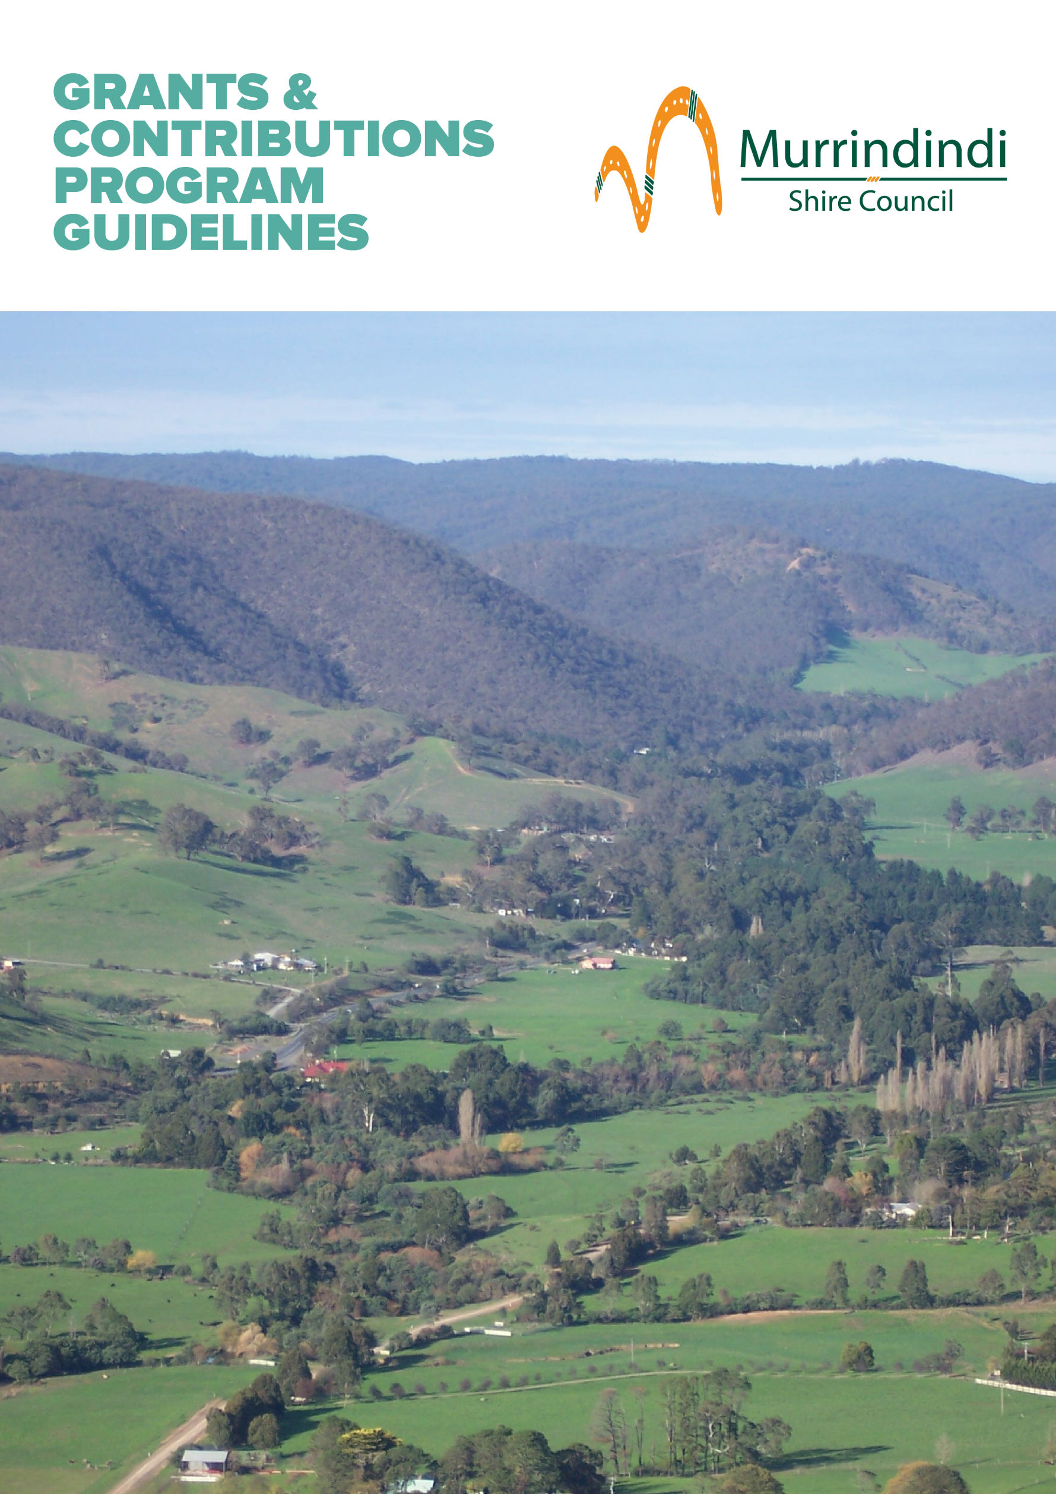

Contents

Contents 2
An Overview 3
Who is eligible to apply? 4
What won’t be funded 5
When is the funding available? 6
How do I apply? 7
Fee Reductions 8
Quick Response Grants 10
Governance, Skills & Capacity Building 11
Community Grants 13
Sponsorships 13
Community Projects and Events 14
Events Support 16
Small or New Tourism Events 16
Events of State Significance 18
Business and Innovation Grants 19
Business Growth or Establishment 19
Industry and Economy Growth 21

Further information
Information on the Murrindindi Shire Council Grants and Contributions Program (MSCGCP) is made available through Council libraries and customer service centres, as well as on Council’s website and social media pages.
Support and guidance for applicants who may require assistance to access application forms is available through Council’s Community Wellbeing Department.
You can find more information about Council’s Contributions and Grants Program on Council’s website at www.murrindindi.vic.gov.au/grants
To contact us, please call 03 5772 0333 or email
grants@murrindindi.vic.gov.au

Information sessions
Council offers information sessions and individual appointments for potential applicants.
Information session times and dates are published on Council’s website and promoted through Council’s Facebook page.

An Overview

The Murrindindi Shire Council Grants and Contributions Program (MSCGCP) aligns with Council’s objectives outlined in the Murrindindi Shire Council Plan 2017-2021 and listed below.
- Our people – Together we will celebrate and encourage diverse, caring and connected communities.
- Our place – We will maintain and enhance places to be attractive and liveable, in balance with our natural environment.
- Our prosperity – In partnership with the community we will promote an environment in which business and community can thrive.
- Our promise – We will all work in collaboration with our community to deliver the best possible outcomes in all that we do.
It also aligns with other key strategic plans including the Murrindindi 2030 Vision and Municipal Public Health & Wellbeing Plan 2017-2021.

We value partnerships
This Program allows us to work collaboratively with and in the best interests of our community in a funding partnership based on mutual respect and transparency.
We recognise the value of the resources and skills applicants contribute to deliver projects and run activities. Applications that can demonstrate community contributions to the proposed project or activity are considered favourably. Resources can be in the form of cash, volunteer time, donated materials, other grant sources, and funds raised through crowd funding platforms. Skills can include donated skilled and unskilled labour.

Good governance is important
Good governance is important in the daily operations of all organisations, community groups and businesses.
As such, Council has shifted to an online grant application and management system to improve the governance and transparency of our contributions and grants.
We are committed to equitable and transparent decision making, and effective and efficient grant and contribution management processes. So, we have made application and reporting requirements proportionate to the size of the funds awarded and the expected outcome.
The system also assists us to obtain the best mix of grants to meet the needs of the community and maximises outcomes for Murrindindi Shire. It minimises the administration costs of the program and allows us to evaluate the impact and delivery of the grants in order to ensure relevance and continuous improvement.
Through this new online grant system, applicants will be asked to evaluate their funded activities in a way that that helps them to continuously improve.
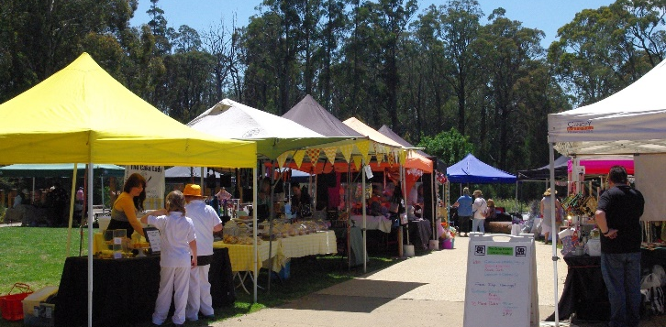

What will it fund?
The Program brings together Council’s previous contributions and grants programs and includes the following funding streams:
- Fee Reductions (waivers by exception)
- Quick Response Grants
- Sponsorships
- Governance, Skills and Capacity Building
- Community Projects and Events
- Small and New Tourism Events
- Events of State Significance
- Business Growth or Establishment
- Industry or Economy Growth

Who is eligible to apply?

Who can apply
The Murrindindi Shire Grants and Contributions Program (MSCGCP) is available to not for profit community groups and organisations and businesses that:
- are a legal entity with an ABN, ACN or are incorporated or have an auspice that is a legal entity
- are based within the Murrindindi Shire and/or are able to demonstrate the proposed activity will benefit the communities of Murrindindi Shire
- have acquitted all previous Council grants and have no outstanding debts to Council

- demonstrate the contribution or grant will be used for a purpose in accordance with Council’s objectives as stated in the Council Plan, Health and Wellbeing Plan and other strategic plans
- demonstrate they are capable of delivering the proposed activity
- show they have considered the environmental impacts of their activity
- are able to contribute cash, in-kind or both to the activity, as specified in the program guidelines

Grant / Contribution |  | Individuals auspiced by a not-for-profit | Not-for-profit community groups and organisations | Businesses
Fee Reductions
Quick Response Grants
Governance, Skills and Capacity Building
Community  Grants | Sponsorships
 | Community Projects and events
Events  Support | Small and New Tourism Events
 | Events of State Significance
Business &  Innovations  Grants | Business Growth or Establishment
 | Industry or Economy Growth

Auspices
If your group or organisation is ineligible to apply, you may enter into an agreement with an eligible not-for-profit community group or organisation to auspice the grant. Individuals seeking sponsorships require an auspice to apply.
If the application is successful, the auspice must enter into an agreement with Council and is

responsible for managing the grant funds. The auspice is legally accountable for the funds and must make sure the funds are spent as outlined in the agreement with Council. An auspice will be required to meet any reporting requirements and meet all the eligibility conditions of the grant.
If an auspice is required, written evidence of an auspice agreement must be submitted at the time of application.
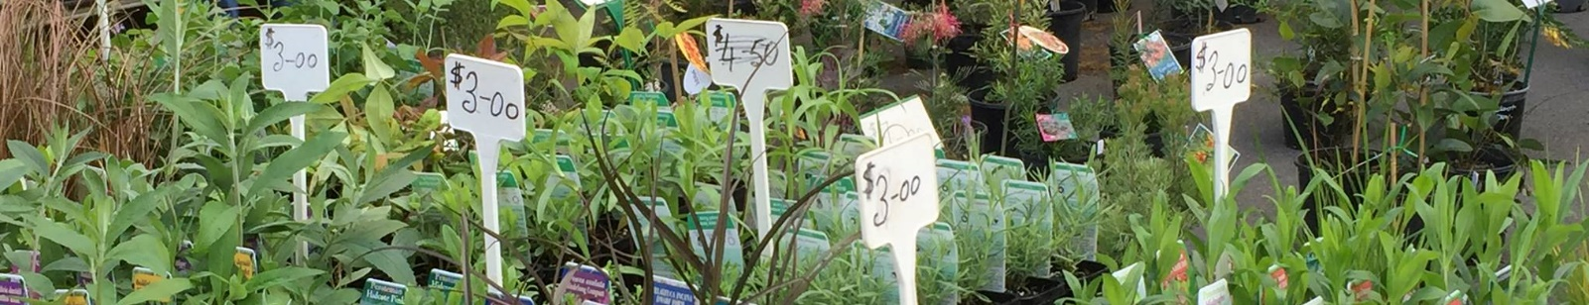

What won’t be funded

Council encourages applications from not for profit community groups and organisations, social enterprises, businesses and individuals located in Murrindindi Shire. We support projects that represent good value for the amount of money or in-kind support requested.
Council does not provide grants for projects that do not align with Council’s objectives or do not meet the relevant grant category funding criteria.
Eligible projects must be:
- a new, one off project or activity
- ready to commence
Contributions and grants are not available for:
- projects that have started (that is, no retrospective funding)
- projects that do not strengthen Murrindindi Shire communities
- activities that do not align with the strategic objectives of the Council Plan or other key strategic plans
- activities that duplicate existing services or programs
- permanent staffing costs or ongoing operational costs
- the payment of bonds
- programs or activities considered the responsibility of Local, State and Federal Government
- projects that directly contravene Council policy
- general donations to charities (however, Council may provide grants to specific projects run by charities where they meet the criteria)
- activities that could be perceived as benefiting a political party or party political campaign
- overtly religious activities that could be perceived as divisive within the community
- activities that inhibit basic human rights, discriminate or encourage discriminatory behaviour
- projects that are harmful to our residents or communities
- projects that unnecessarily destroy or waste non-recurring natural resources, pollute land, air or water
- market, promote or advertise products or services in a misleading or deceitful manner
- statutory fees and other statutory charges collected on behalf of state government or other authorities including development applications, health inspection fees, health approvals, street closures and other approvals

When is the funding available?
The Program has nine funding categories. The categories and round information are outlined below. Round and information session times and dates are published on Council’s website at www.murrindindi.vic.gov.au/Our-Services/Grants/Murrindindi-Shire-Council-Grants-and-Contributions-Program and promoted through Council’s Facebook page.

Grant / Contribution |  | Funds | Timing
Fee Reductions |  | Up to 50% of the fee  Request for full waivers will be considered in exceptional circumstances* | Applications received all year around.  Assessed as received.
Quick Response Grants |  | Up to $1000** | Applications received all year around.  Assessed as received.
Governance, Skills and Capacity Building |  | Up to $2000 | Applications received all year around.  Assessed monthly.
Community Grants | Sponsorships | Up to $1000 for individual sponsorships | Applications received all year around.  Assessed monthly.
 |  | Up to $5000 for community sponsorships.  Multi-year funding available | Assessed monthly.
 | Community Projects and events | Up to $5000
Events Support | Small and New Tourism Events | Up to $5000 | Assessed monthly.
 | Events of State Significance | Up to $20,000
Business &  Innovations Grants | Business Growth or Establishment | Up to $20,000 | Applications received all year around.  Assessed 6 monthly in April and October***
 | Industry or Economy Growth | Up to $50,000
*Exceptional circumstances may apply if the applicant has limited capacity to generate an income.**Limit may be varied in extraordinary circumstances as assessed by Council.*** Please contact Council if your project does not fit within assessment timeframes indicated.

How do I apply?

Application process
Application forms are available on Council’s website at www.murrindindi.vic.gov.au/grants
When applying for a Quick Response Grant we encourage you to discuss your requirements with Council’s Manager Community Wellbeing.
Please allow sufficient time to upload supporting documents to your applications. The time needed to upload documents will vary according to the size of the document, your internet speed and how many other applicants are uploading documents. So aim to upload your documents and submit your application well before the due date and time. Applications commenced but not submitted will not be assessed by Council. Council does not accept submissions after the grant round has closed.
Council completes eligibility checks after applications are submitted. If Council advises an applicant their application may be better suited to a different grant category and the applicant agrees, additional time will be provided (if required) for the applicant to complete a new online application.

Application support and information sessions
Funding for contributions and grants is limited and it is important that applications provide a well-thought out response to each question. Applications also need to provide the requested supporting documentation.
All applicants are strongly encouraged to speak to the grants team to obtain advice and assistance before commencing their application.
To learn more about Council’s Contributions and Grants Program, including how to prepare a strong application you can:
- attend an information session
- contact Council’s Grants team on
03 5772 0333 or by email at grants@murrindindi.vic.gov.au

Agreements
All successful applicants are required to enter into an agreement with Council.
Agreements vary according to the size of the contribution or grant. Smaller contributions require the acceptance of terms and conditions and larger contributions require a more formal grant agreement.
The grant agreement outlines the reporting, monitoring and acquittal requirements for the grant. It also outlines the dates and times of payments, as well as the deliverables required for each payment.

Fee Reductions

Fee reductions provide financial support to community groups, business and organisations which are undertaking projects or activities for community benefit.
Where a community group or business is seeking a fee reduction and a Community Projects and Events Grant, the fee reduction will be considered as part of the grant application. This means that the combined value can’t exceed the maximum amount allowable for a Community Projects and Events Grant.
Full fee waivers may be considered where significant hardship or need can be demonstrated.
Max project duration | 12 months
Max grant amount | Up to 50% of the fee*
Round frequency | Applications are assessed as they are received
Eligible applicants | Not-for-profit community groups and organisations, businesses
Important information | *Request for full fee waivers will be considered in exceptional circumstances

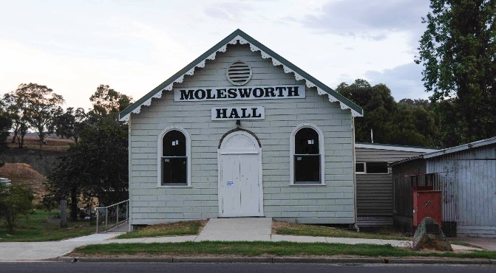

Typical reductions
Fee reductions for projects or activities that deliver a community benefit, such as:
- planning or building fees for community events and projects
- waste services including waste disposal and event bins
- community bus hire for community activities
- venue hire of halls, meeting spaces and building

Expected outcomes
Projects are expected to deliver the following outcomes:
- lower the financial hardship or risk for community groups, businesses and organisations undertaking events, projects or other activities

Supporting documents
Applicants need to submit the following documents with their application:
evidence of current financial status*
other documents relevant to the proposed project or activity
- * Note:- Not required for Community not-for-profit organisations

Assessment Criteria
Applications will be assessed against the following criteria:
How the fee waiver will assist support an activity for community benefit. Applicants need to describe how the fee reduction will assist the applicant to deliver an activity that will provide benefit to the community. Applicants will need to provide evidence of their financial status.
Applicant’s capacity to generate an income. Applicants will need to describe how they raise funds for their group or organisation. Applicants (with the exception of Community not-for-profit organisations) will also need to outline the value of their annual income and expenditure.

Quick Response Grants

Quick Response Grants provide essential, urgent support to not-for-profit community groups and organisations who can demonstrate financial hardship as a result of an emergency or unforeseen events.
These grants do not provide funds to supplement other grant income or address the impact of foreseeable events.

Typical projects
Projects or activities that address an urgent, critical need and that are not covered by insurance, such as:
- replacement of essential equipment
- essential and urgent repairs
- activities that address the impact of urgent, emergency or unforeseen events

Expected outcomes
Projects are expected to deliver one or more of the following outcomes:
- reduce financial impact of emergency and unforeseen events
- enable not-for-profit community groups and organisations to continue to operate or quickly return to normal operations following damage as the result of emergency and unforeseen events
Max project duration | 3 months
Max grant amount | Up to $1000.  Additional funding may be granted in extraordinary circumstances
Round frequency | Applications are assessed as they are received
Eligible applicants | Not-for-profit community groups and organisations
Important information | Please contact Council to discuss your project before you apply

Supporting documents
Applicants need to submit the following documents with their application:
quotes
evidence of current financial status
other documents relevant to the proposed project or activity
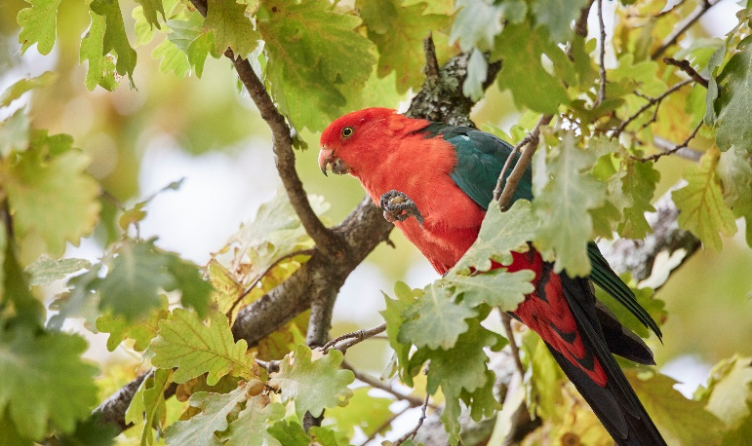

Assessment Criteria
Applications will be assessed against the following criteria:
Impact on the normal operations of the applicant. Applicants need to show evidence of how the event occurred and its detrimental effect on normal operations.
Financial hardship the applicant will experience. Applicants need to show how the emergency or unforeseen event has created financial hardship and provide evidence of their financial status.
How the community will be impacted if normal operations are interrupted. Applicants need to describe how their normal services/activities help their local community

Governance, Skills & Capacity Building

The Governance, Skills and Capacity Building category supports businesses, not-for-profit community groups and organisations, and Committees of Management to meet their governance requirements, develop new skills and build their capacity. This includes activities that improve the ability to operate effectively, undertake future planning and support sustainability.

Typical projects
Projects or activities that build the applicants capacity to operate and plan for the future, such as:
- training and education programs
- mentoring programs and business coaching
- networking opportunities
- funding application assistance
- best practice resources and guides
- technology and systems
- development of governance strategies and plans
- strategic, business and financial planning activities (e.g. business plans, program development, marketing, fundraising, membership)
- policy development (e.g. Working with Children, volunteers, OH&S)

Projects and activities not eligible for this grant include:
- projects that have already been funded by Council
- capital expenditure that is not for IT/computing related equipment or systems
- marketing, promotion or advertising products
- permanent staffing costs or ongoing operational costs

Expected outcomes
Projects are expected to deliver one or more of the following outcomes:
- communities confident to plan, take action, solve problems and lead in the community
- not for profit community groups and organisations are sustainable
- reduced ongoing reliance on Council resources by not-for-profit community groups and organisations. increased proportion of new businesses trading and viable after 3 years
- improved resilience of businesses, not-for-profit community groups and organisations and Committees of Management

Max project duration | 12 months
Max grant amount | Up to $2000
Round frequency | Monthly
Eligible applicants | Businesses  Not-for-profit community groups/organisations  Committees of Management
Important information | Please contact Council to discuss your project before you apply

Supporting documents
Applicants need to submit the following documents with their application:
quotes
other documents relevant to the proposed project or activity
Assessment Criteria
Applications will be assessed against the following criteria:
Need to build the knowledge, skills, networks and resources of applicants. Applicants need to show the activity will meet an identified knowledge or skills gap, or enable them to obtain resources to fill those gaps.
Improvements to operational activities. Applicants need to describe how the activity will improve their normal operational activities.
Ability to plan for the future and respond to change. Applicants need to describe how the activity will support planning and improve their ability to respond to sudden or incremental changes around them.
Reduce reliance on external funding. Applicants need to show how this project will reduce their reliance on external funds and support their long term financial sustainability.
Support applicants to operate at best practice standard for their sector.
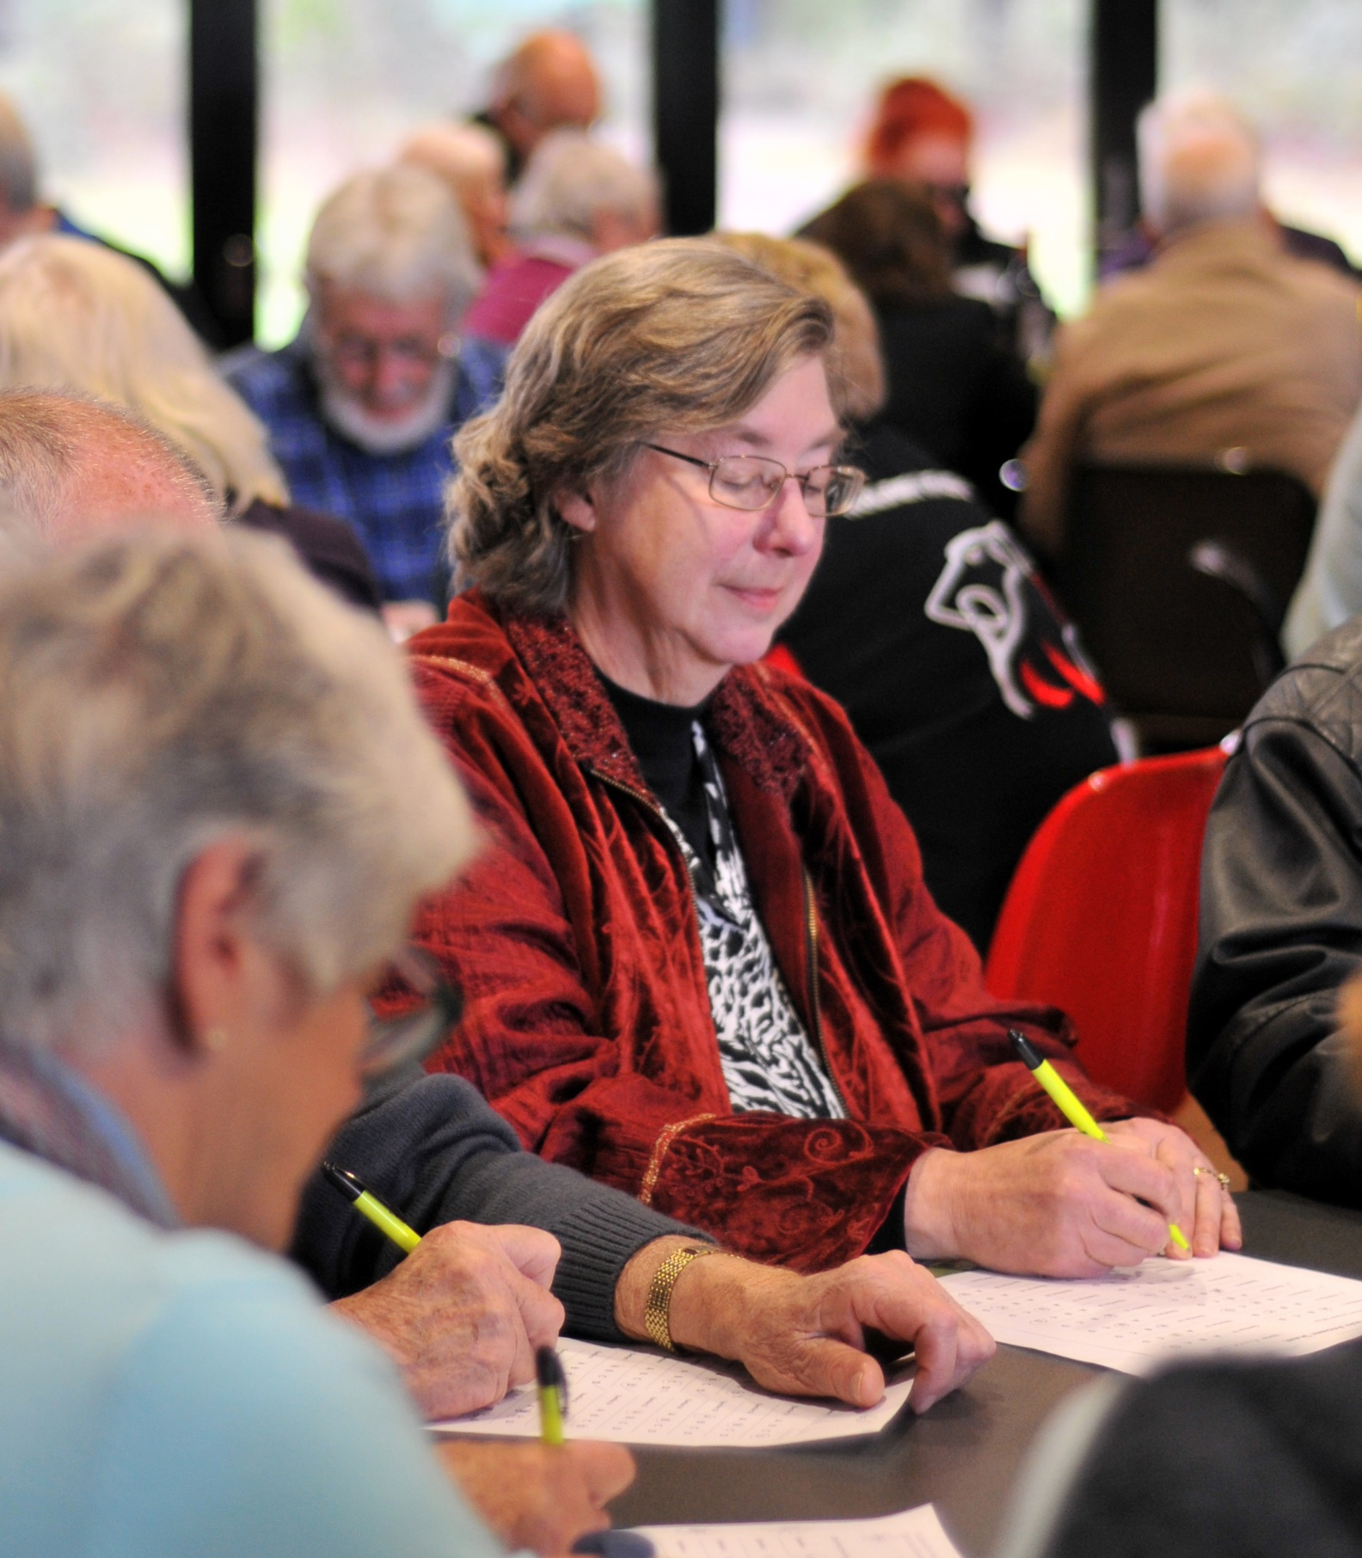

Community Grants

Community Grants are provided for projects that support our communities to improve the liveability of our towns and places, build connections, create opportunities for participation in community and civic life, improve personal and community health and wellbeing, protect our natural environment and assist communities to plan for the future.
There are two categories of community grants
- sponsorships
- community projects & events
These grants are available to not-for-profit community groups and organisations located in the Murrindindi Shire or delivering a project or event within the Shire.
Projects that have a partnership approach are encouraged.
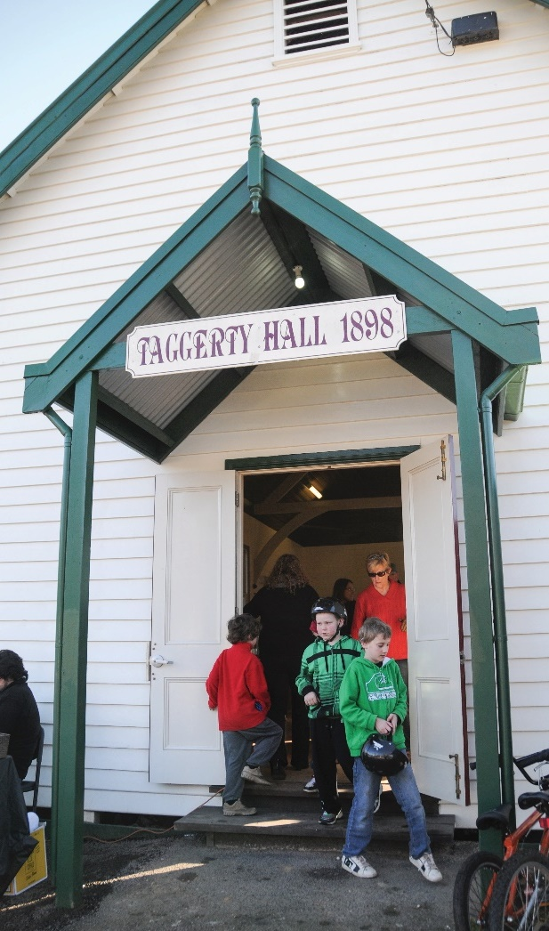

Sponsorships
Council sponsorships provide financial or in-kind support to eligible individuals, groups and organisations. The Sponsorships program provides community with support to plan and run community activities or events.
Individuals are able to apply for a Community Sponsorship if they:
- are participating in an official cultural, sporting or recreation event
- have an incorporated auspice for the activity or event
- are based in Murrindindi Shire
- are able to contribute cash, in-kind or both to the project
Not-for-profit community groups and organisations, and Committees of Management are able to apply for single or multi-year funding. (The total amount of funding in a multi-year arrangement will not exceed $5000.)
Max project duration | Up to 36 months
Max grant amount | Up to $1000 for individuals  Up to $5000 is available to not-for-profit community groups/organisations
Round frequency | Monthly
Eligible applicants | Individuals  Not-for-profit community groups/organisations  Committees of Management
Important information | Please contact Council to discuss your project before you apply  May include Fee Reductions as a component of a grant package

Typical projects
Projects or activities that promote the diverse range of opportunities and experiences on offer in Murrindindi Shire such as:
- cultural, artistic, recreational or tourism events or activities
- arts and cultural events and activities
- recreational and sporting events
- individuals participating in an official cultural, sporting or recreation event

Expected outcomes
Projects are expected to deliver one or more of the following outcomes:
- increased awareness and civic pride of rural towns, communities and the things Murrindindi Shire is known for
- increased visibility of Council contributions to community
- greater community awareness of the role of Council
- increased opportunities for Council to distribute or gather information
- raised awareness of activities that align with Council values and strategic objectives

Supporting documents
Applicants need to submit the following documents with their application:
quotes
evidence of current financial status (Auspices, community groups and organisations only)
evidence of an invitation to participate in a professional, educational, cultural, sporting or recreational activity or event (Individuals only)
other documents relevant to the proposed project or activity

Assessment Criteria
Applications will be assessed against the following criteria:
Benefit the proposed activity or event will provide to the community. The applicant needs to show the benefit their activity or event will bring to the local community. Social and economic benefits should be highlighted.
Benefit Council will receive as a sponsor of this activity or event. Applicants should clearly state the opportunities Council will be offered to provide or distribute information, speak, be interviewed, have prize/award naming rights or any other means to participate in a meaningful way.
Showcase the things Murrindindi Shire is known for. The applicant needs to describe how the activity or event will showcase our rural towns or communities, natural environments/landscapes or the diverse community, recreation and visitor experiences on offer in Murrindindi Shire.

Community Projects and Events
Community Projects & Events grants support not-for-profit community groups and organisations to undertake activities that have a broad community benefit. This includes activities with a focus on health & wellbeing, building resilience and reducing social isolation, looking after our built and natural environments and providing arts and cultural opportunities.

Typical projects
Projects or activities that have a broad community benefit and:
- promote health & wellbeing by
- promoting active and healthy life choices
- increasing opportunities for formal and informal recreation
- improving access to services
- addressing existing and emerging issues.
- connect people and encourage participation in community and civic life by
- providing opportunities for people to connect and build social networks
- reduce social isolation
- build youth resilience through leadership development groups
- maintain and enhance our built and natural environment by
- promoting use of our built and natural assets
- caring for our built and natural environment and
- preserving our historically important buildings
- preserving our natural environments
- provide opportunities for arts and cultural activities by
- delivering arts or cultural events or projects
- celebrating the history, culture and character of our communities, towns and places
- linking young people to performing arts
- supporting arts and cultural groups

Expected outcomes
Projects are expected to deliver one or more of the following outcomes:
- more activities that promote personal and community health and wellbeing (e.g. arts and culture, recreation, build social connections)
- more opportunities for people to come together, participate and celebrate in community and civic life
- enhanced and increased use of our built and natural environment
- built and natural environment is preserved

Supporting documents
Applicants need to submit the following documents with their application:
quotes
evidence of current financial status
Other documents relevant to the proposed project or activity

Max project duration | 12 months
Max grant amount | Up to $5000
Min applicant contribution | In-kind contributions for grants under $1000  $500 cash or in-kind for grants over $1000
Round frequency | Monthly
Eligible applicants | Not-for-profit community groups/organisations
Important information | Please contact Council to discuss your project before you apply  May include Fee Reductions as a component of a grant package

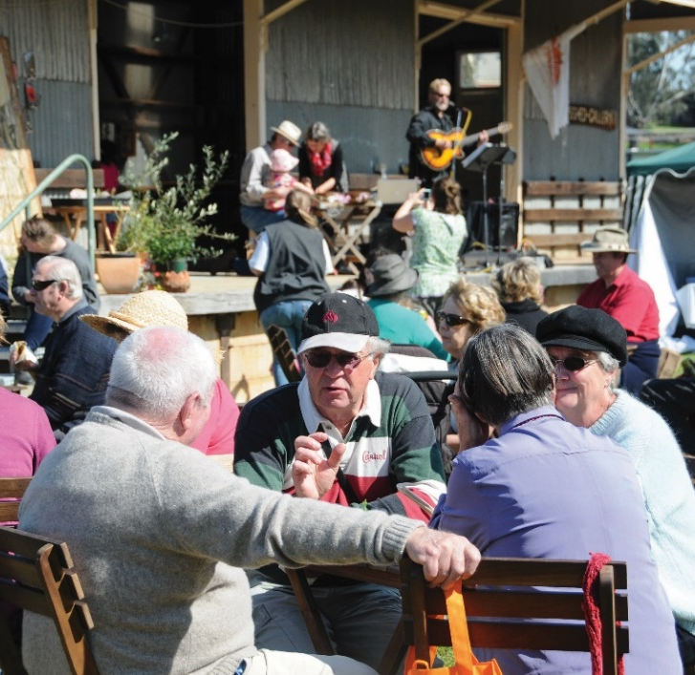

Assessment Criteria
Applications will be assessed against the following criteria:
Need the project or activity will address. The applicant needs to show the project or activity will address an emerging or existing community need.
Benefit the project will bring to the community. The applicant needs to describe how the project or activity will
- Improve community health and wellbeing
- Connect people and encourage participation in community and civic life
- Maintain and enhance our built and natural environment
- Provide opportunities for arts and cultural events

Events Support

Events Support grants provide financial support to businesses and community groups and organisations to develop sustainable events that grow tourism within Murrindindi Shire and grow employment in the tourism sector.
There are two levels of Events Support grants:
- Small or New Tourism Events which support the development of small or new events that attract local or regional visitors.
- Events of State Significance which support events that attract state-wide visitors and encourage overnight stays.

Small or New Tourism Events
This category supports small community and tourism events to establish and grow. It can be accessed to start new events or grow niche events looking to improve sustainability.

Typical events
Events that attract local and regional visitors, such as:
- arts and cultural events that showcase local arts or producers
- community events that strengthen community connections and wellbeing
- events that fundraise for not-for-profits or charities
- recreation events that engage with the Shire's nature based assets (e.g. cycling, water based events)
- annual events that attract repeat visitation
- tourism events that span two or more days
- new events that occur in the 'quiet' event periods in the year.
Max project duration | 12 months
Max grant amount | Up to $5000
Min applicant contribution | Cash and/or in-kind contribution of 30% of total grant value*
Round frequency | Monthly
Eligible applicants | Businesses  Not-for-profit community groups/organisations
Important information | Please contact Council to discuss your project before you apply  May include Fee Reductions as a component of a grant package  *Minimum applicant contribution may be varied as assessed by Council

Expected outcomes
Events are expected to deliver one or more of the following outcomes:
- have projected attendance of 1000 persons or more
- will attract local and regional visitors

Supporting documents
Applicants need to submit the following documents with their application:
quotes
evidence of current financial status
Other documents relevant to the proposed project or activity

Assessment Criteria
Applications will be assessed against the following criteria:
Visitation generated to the town or Shire as a result of the event. Applicants will need to show how the event will attract visitation from within or outside the Shire.
Potential to grow into a sustainable annual event. Applicants will need to outline their plans to make the event sustainable within 3-5 years.
Capacity to deliver event. Applicants will need to demonstrate they have, or have access to, the skills and experience required to deliver their event.

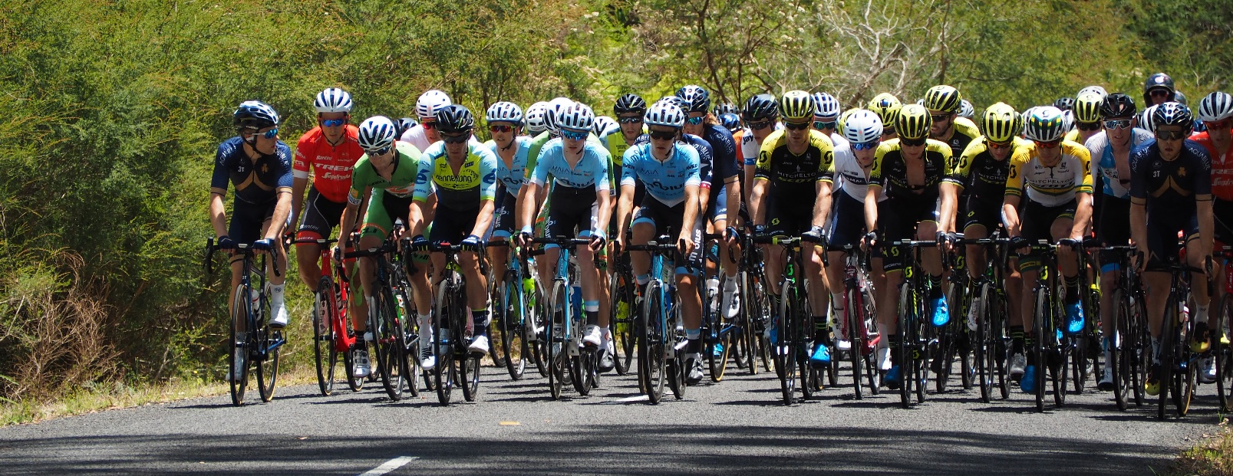

Events of State Significance
The Events of State Significance Grants provide businesses and community groups and organisations with support for events that will attract large numbers of visitation from within Victoria.

Typical event costs
Funding will be allocated to marketing and other associated event costs that attract a large number of state-wide visitors, such as:
- events that are part of a recognised event series (e.g. A Day on the Green)
- marquee events that have a major sponsor/promoter associated with them
- nationally recognised competitive events
- significant State or National trade shows/expos
- multi-day events

Expected outcomes
Events are expected to deliver one or more of the following outcomes:
- projected attendance of 1000 persons or more
- generate additional overnight stays and maximise repeat visitation
- align with Council’s key product/experience or marketing strengths

Supporting documents
Applicants need to submit the following documents with their application:
quotes
marketing plan and products
event management plan
guidelines for other grants if seeking funding for leveraging purposes
evidence of current financial status
other documents relevant to the proposed project or activity
Max project duration | 24 months
Max grant amount | Up to $20,000
Min applicant contribution | 50% of the event cost
Round frequency | Monthly
Eligible applicants | Businesses  Not-for-profit community groups/organisations
Important information | Please contact Council to discuss your project before you apply  May include Fee Reductions as a component of a grant package

Assessment Criteria
Applications will be assessed against the following criteria:
Visitation generated to the town or Shire as a result of the event. Applicants will need to demonstrate how the event will attract visitation from within or outside the Shire.
Potential for growth into a sustainable annual event. Applicants will need to outline their plans to make the event sustainable within 3-5 years.
Capacity to deliver event. Applicants will need to demonstrate they have, or have access to, the skills and experience required to deliver their event.
Potential to attract State or Federal government grant funding. Applicants will need to outline the alignment of their event to State or Federal government grant guidelines. Leveraging opportunities are viewed favourably.
Potential to generate visitor spend, overnight stays or return visitation. Applicants will need to demonstrate projected increases in visitor spend, overnight stays or return visitations.
Benefit to the community. Applicants will need to describe the benefit to the community as a result of this event.

Business and Innovation Grants

The Business and Innovation Grants provide financial support to develop businesses and grow employment within Murrindindi Shire.
There are two levels of Business and Innovation Grants:
- Business Growth or Establishment which support businesses to start or grow
- Industry and Economy Growth which support business, groups of businesses or industry sectors to grow

Business Growth or Establishment
This category provides support to new and established businesses to assist with projects or activities which will allow a business to start or grow.

Typical projects
Projects or activities that support a business to grow or establish, such as:
- development of business plans and marketing plans
- industry level training to fill training/skill gaps
- specialist equipment/skills
- new plant/equipment
- investment in new technology
- new and innovative business ideas
- pop-up businesses in niche markets

Expected outcomes
Projects are expected to deliver one or more of the following outcomes:
- grow employment within Murrindindi Shire
- grow number of viable businesses within Murrindindi Shire
- enhance business capacity to plan, operate and grow
- increase productivity or make production more efficient
- expand existing product/service offer
- fill a local product or service gap
- provide a wider range of employment options and business types (diversity)
- develop more environmentally sustainable businesses

Supporting documents
Applicants need to submit the following documents with their application:
quotes
relevant strategic planning documents - including but not limited to business plans, marketing plan, feasibility studies
evidence of financial solvency
other documents relevant to the proposed project or activity
Max project duration | 24 months
Max grant amount | Up to $20,000
Min applicant contribution | 50% of the project cost
Round frequency | Applications open all year round. Assessed 6 monthly in April and October.
Eligible applicants | Businesses
Important information | Please contact Council to discuss your project before you apply  May include Fee Reductions as a component of a grant package  May include Governance, Skills and Capacity Building activities as a component of a grant package

Assessment Criteria
Applications will be assessed against the following criteria:
Potential for growth. Applicants need to show how the project or activity will establish or improve how the business operates. How will it provide growth opportunities they would not have without the grant, plan for the future and become financially and environmentally sustainable.
Capacity to deliver the project. Applicants will need to demonstrate they have, or have access to, the skills and experience required to deliver their project.
Employment growth and diversity of business types and employment opportunities. Applicants will need to show how the project or activity will grow employment and/or provide a broader range of employment options.
Improvements in productivity and efficiency in operations. Applicants will need to show how the project or activity will improve operational efficiency and improve or expand production.
Creation of new products or service to address local product and service gaps. Applicants will need to provide evidence of the product or service gap and show how they will address the gap.

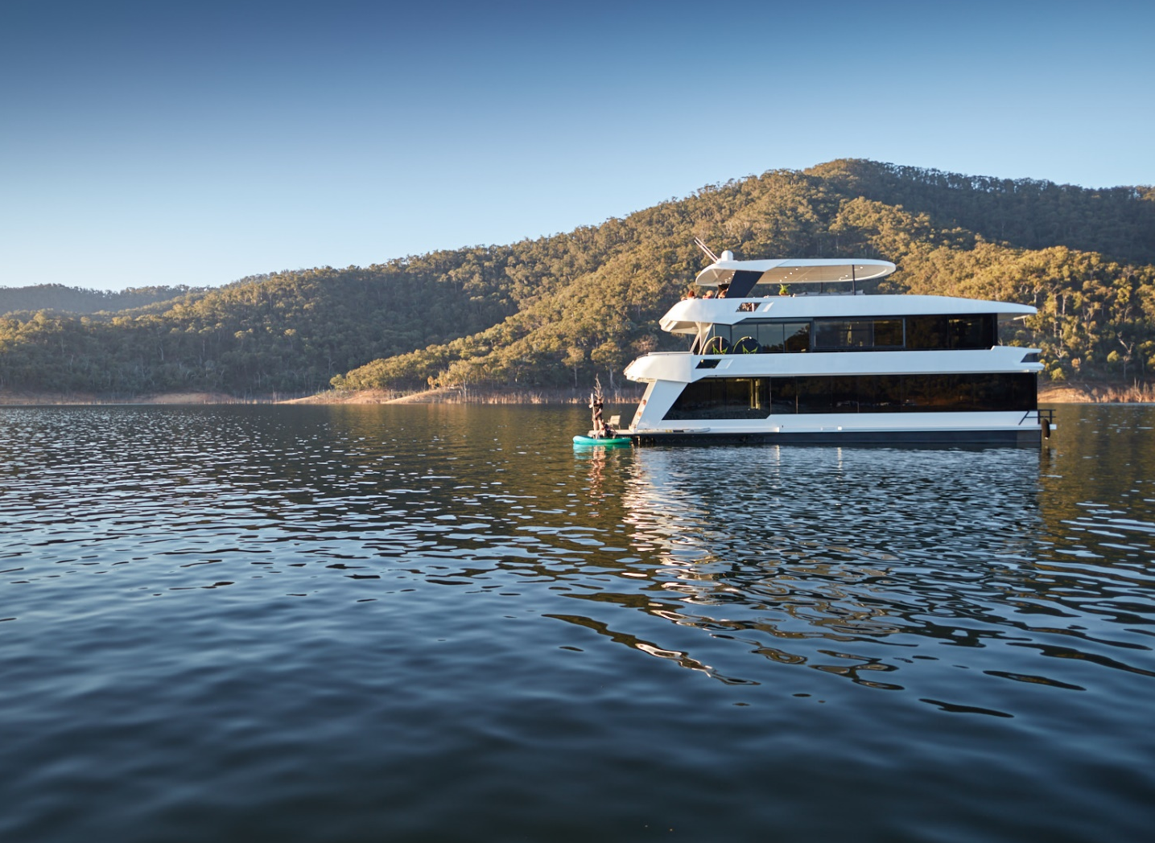

Industry and Economy Growth
This category provides support to assist with projects or activities which will allow a business, group of businesses or industry sector to grow in either value or numbers of employment.

Typical projects
Projects or activities that support businesses and industry sectors to grow, such as:
- industry wide training and skill development programs
- new and specialist plant/equipment
- Investment in new/leading edge technology
- improved infrastructure (e.g. power and water upgrades, irrigation infrastructure, roads and telecommunications)
- new and innovative business ideas impacting the industry sector
- feasibility studies

Expected outcomes
Projects are expected to deliver one or more of the following outcomes:
- growth of the local economy or industry sectors in terms of value of production
- growth in employment
- increased investment in the local economy
- diversified employment opportunities and business types
- expanded employment and skills base

Supporting documents
Applicants need to submit the following documents with their application:
quotes
comprehensive business plan that forecasts jobs growth or new local investment as a result of the project or activity
evidence of financial solvency
guidelines for other grants if seeking funding for leveraging purposes
other documents relevant to the proposed project or activity - including but not limited to business plans, marketing plan, feasibility studies

Max project duration | 24 months
Max grant amount | Up to $50,000
Min applicant contribution | 50% of the project cost
Round frequency | Rounds close on the last Wednesday of March and September
Eligible applicants | Businesses
Important information | Please contact Council to discuss your project before you apply  May include Fee Reductions as a component of a grant package

Assessment Criteria
Applications will be assessed against the following criteria:
Potential for industry sector growth. Applicants need to outline how their project will contribute to growth of the industry sector. They will need to demonstrate strong links to other businesses within the sector, including but not limited to industry partnerships and demonstrate their commitment to industry best practice.
Impact on the local economy and employment within the Shire. Applicants need to outline the impact on the local economy in terms of additional ‘local spend’ and projected job growth as a result of the project. If relevant, they should show how the project will diversify the employment base within the Shire.
Business sustainability and financial status. Applicants need to demonstrate that their business is financially viable and solvent. They will need to provide a business plan that outlines their objectives, financial viability and growth projections.
Capacity to deliver the project. Applicants need to show a well-developed understanding of their industry sector and that they have, or have access to, the skills and experience required to deliver their project.
Potential to attract State or Federal government grant funding of private sector contributions. Applicants need to outline the alignment of the project or activity to State or Federal government grant guidelines. Leveraging opportunities are viewed favourably.

