## 

## Food Premises Design

## and Construction Guide

## FOOD PREMISES DESIGN AND CONSTRUCTION GUIDELINES

CONTENTS

Permits 3

Registration process 4

Design and construction specifications 5

Plumbing fixtures 8

Mechanical ventilation 10

Fixtures, fittings and equipment 11

Waste storage 12

Other storage areas 13

Useful contacts 14

Glossary of terms 15

August 2021

Cover Image: Acheron Cutting Lookout

Disclaimer

While care has been taken to ensure the content in the report is accurate, we cannot guarantee it is without flaw of any kind. There may be errors and omissions or it may not be wholly appropriate for your particular purposes. In addition, the publication is a snapshot in time based on historic information which is liable to change. Murrindindi Shire Council accepts no responsibility and disclaims all liability for any error, loss or other consequence which may arise from you relying on any information contained in this report.

# PERMITS

Starting, altering or growing a food business in Murrindindi Shire may require permits, licenses and registrations from Council and other regulatory organisations.

Council has developed an online assessment tool to help you understand which permits your business requires. You can access the tool [business self-assessment tool](https://www.murrindindi.vic.gov.au/Your-Business/Starting-or-growing-your-business) on our website.

You can also contact our Business Concierge team on 5772 0333, who can help you identify which permits you require and guide you through the permit approval process.

For a full list of contacts, refer to page 14 of this guide.



# REGISTRATION PROCESS

The *Food Act 1984* requires all businesses that handle, prepare, package, store, serve, supply and repackage food to be registered with their local council. The registration process is outlined below.

### **Contact an Environmental Health Officer**

### We love to hear of new businesses opening in Murrindindi Shire! Contact our Environmental Health team on 5772 0333 to discuss your ideas and plans. We can offer you advice and discuss the process of opening your business.

### **Submit your application form and floor plans**

Submit your [application form](https://www.murrindindi.vic.gov.au/Your-Business/Health-Regulations/Food-premises-regulations) and floor plans.

We recommend submitting your floor plans before constructing or altering a food premises. This allows us to provide valuable information to ensure your premises meets the legal requirements, and can prevent costly changes and delays.

The floor plans should

* be drawn to a professional standard and to a scale no less than 1:50
* show the proposed finishes of floors, walls and ceilings
* show the location of cooking equipment, benches, shelving, fixtures, fittings, hand basins, sinks, toilets, mechanical exhaust system, grease trap, on-site bin storage and all other equipment

Council will assess your application form and floor plans and be in contact within 10 working days.

### **First on-site inspection**

Once we have assessed your application form and floor plans, we will contact you to organise an on-site inspection with an Environmental Health Officer. The Environmental Health Officer will advise you of any outstanding works to complete before you schedule the final inspection.

### **Final on-site inspection**

At the final inspection, the Environmental Health Officer will check your food premises meets the specifications listed in this guide. You’ll also need to show copies of your Food Safety Program and Food Safety Supervisor’s Certificate (mandatory requirement for Class 1 and 2 food premises). Upon a successful inspection, you will be issued a certificate of registration to allow you to trade.



# DESIGN AND CONSTRUCTION

# SPECIFICATIONS

### **Design and layout**

Your food premises needs to be designed and constructed according to the type of food activities that will be performed. The correct design and layout can help streamline work practices, reduce cleaning and maintenance, and prevent cross contamination.

To prevent food contamination, your premises must be designed so the flow of food is in one direction from receipt to storage, preparation, packaging, serving and disposal.

You will need to provide adequate storage space for dry goods, fresh fruit and vegetables, cutlery, crockery, cooking utensils, personal belongings and chemicals.

All food preparation areas, cool rooms, freezer rooms and dry food storage areas must be large enough to prevent overcrowding of food, equipment or staff working in these areas.

### **Floors**

Floor finishes need to be appropriate for the activities conducted on the food premises. They must also be

* able to be effectively cleaned
* unable to absorb grease
* laid so there is no ponding of water
* unable to harbor pests.

Where floors are intended to be cleaned using a hose to flush with water, a floor waste drain is required.

The floor finishes table on page 6 can help you decide which flooring is suitable for your business.

### **Walls and Ceilings**

Walls and ceilings must also be appropriate for the activities conducted on the food premises. They must be sealed to prevent the entry of dirt, dust and pests, and be able to be easily and effectively cleaned.

Service pipes, electrical wiring and other services should be concealed in walls and ceilings or fixed on brackets with at least 25 mm clearance between the pipe and vertical surface.

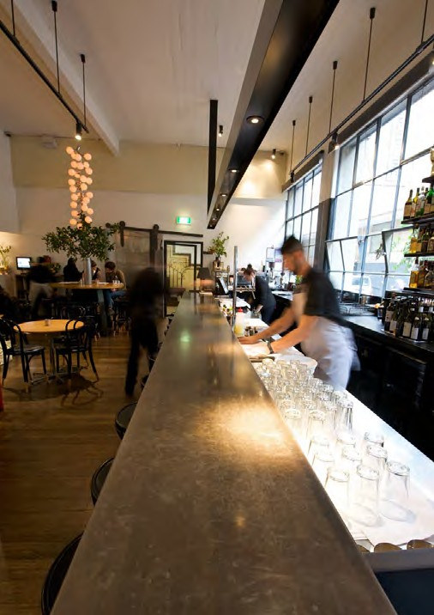The wall finishes table on page 7 lists the suitability of common wall finishes based on their location.

### Suitability of floor finishes

|  |  |  |  |  |  |  |  |  |  |
| --- | --- | --- | --- | --- | --- | --- | --- | --- | --- |
|  |  |  | **Suitable for** | | | | | |  |
| Example |  | Finish | Food preparation area | Servery | Dry store | Refrigerators/freezers | Bin storage area | Eating areas | Comments |
|  |  | Ceramic or porcelain non-slip tiles | ✓ | ✓ | ✓ | ✓ | ✓ | ✓ | Epoxy grout is required to achieve non-porous joins |
|  |  | Quarry tiles | ✓ | ✓ | ✓ | ✓ | ✓ | ✓ |
|  |  | Commercial-grade vinyl | ✓ | ✓ | ✓ | ✓ | ✓ | ✓ | Highly durable, low maintenance |
|  |  | Epoxy | ✓ | ✓ | ✓ | ✓ | ✓ | ✓ | A minimum of three coats of epoxy sealant is required to achieve sufficient durability |
|  |  | Polished, sealed concrete | ✓ | ✓ | ✓ | ▪ | ✓ | ✓ |
|  |  | Timber-look vinyl planks | ✓ | ✓ | ✓ | ✓ | ✓ | ✓ | Unlike other timber and timber look planks, vinyl timber planks are waterproof |
|  |  | Non-slip stainless steel | ▪ | ▪ | ▪ | ✓ | ✓ | ✓ | Some non-slip stainless steel has intricate raised patterns which makes cleaning very difficult. |
|  |  | Natural stone tiles (including marble, granite, slate and travertine) | ▪ | See comments | ▪ | ▪ | ✓ | ✓ | These tiles are porous and require sealing at least every 12 months depending on foot traffic |
|  |  | Cement (encaustic) tiles | ▪ | See comments | ▪ | ▪ | ▪ | ✓ |
|  |  | Timber, engineered timber and timber look laminate | ▪ | ▪ | ▪ | ▪ | ▪ | ✓ | Timber finishes should be sealed |
|  |  | Carpet or carpet tiles | ▪ | ▪ | ▪ | ▪ | ▪ | ✓ |  |

Suitability of wall finishes

|  |  |  |  |  |  |  |  |  |
| --- | --- | --- | --- | --- | --- | --- | --- | --- |
|  |  | **Suitable for** | | | | | |  |
| Example | Finish | Food preparation area | Servery | Dry store | Refrigerators/freezers | Bin storage area | Eating areas | Comments |
|  | Ceramic or porcelain non-slip tiles | ✓ | ✓ | ✓ | ✓ | ✓ | ✓ | Epoxy grout is required to achieve non-porous joins |
|  | Stainless steel | ✓ | ✓ | ✓ | ✓ | ✓ | ✓ | Welded joints and waterproof screw covers must be used |
|  | Vinyl wall sheeting | ✓ | ✓ | ✓ | ✓ | ✓ | ✓ | Highly durable, low maintenance |
|  | Painted plaster | ✓ | ✓ | ✓ | ✓ | ✓ | ✓ | Plaster must be smooth. Paint must be washable. Adequate splashbacks will need to be provided above sinks and basins |
|  | Sealed concrete | ✓ | ✓ | ✓ | ▪ | ✓ | ✓ | A minimum of three coats of epoxy sealant is required to achieve sufficient durability |
|  | Natural stone panels and tiles (including marble, granite, slate, travertine | ▪ | See  comments | ▪ | ▪ | ✓ | ✓ | These tiles are porous and require sealing at least every 12 months depending on foot traffic |
|  | Cement (encaustic) tiles | ▪ | See  comments | ▪ | ▪ | ▪ | ✓ |
|  | Feature brick | ▪ | See  comments | ▪ | ▪ | ▪ | ✓ | Brick is generally unsuitable for food handling areas. In some instances, brick walls with unraked joints and treated with an epoxy sealant have been approved, however, this significantly changes the appearance of the finish |
|  | Concrete bricks | ▪ |  | ▪ | ▪ | ✓ | ✓ |  |
|  | Timber, engineered timber and timber look laminate | ▪ | ✓ | ▪ | ▪ | ▪ | ✓ | Timber finishes must be connected with a 'tongue and groove' joint with a smooth and sealed finish |

PLUMBING FIXTURES

The number and size of sinks required depends on the type and quantity of food being prepared, the number of staff and whether you have a dishwasher for sanitising

equipment. You must be able to easily carry out all washing and cleaning without posing a risk to food safety.

All sinks and hand basins should be permanent fixtures, connected to a continuous supply of hot and cold potable water and drained to sewer.

### **Hand washing facilities**

Hand basins must be

* located where they can be easily accessed by food handlers
* provided within food preparation areas
* provided immediately adjacent to the toilets
* designated for the sole purpose of washing hands, arms and face
* supplied with soap and paper towel

### **Sink for washing utensils and equipment**

Food businesses must have a double or triple bowl sink or a single or double bowl sink and dishwasher for washing and sanitising equipment.

The sink(s) need to be large enough to fit the largest piece of equipment that will be washed.

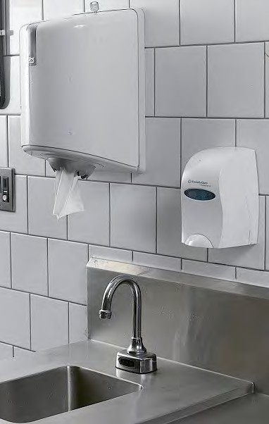 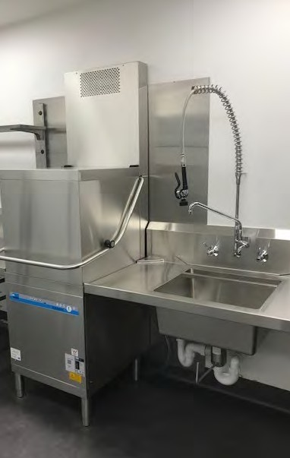

### **Bars**

Bars require a glass washer and a rinsing sink in addition to a separate hand basin. If fresh fruit is frequently used for drinks, such as cocktails, then access to a food preparation sink is also required.

### Sink for food preparation

A separate food preparation sink is required where food handling involves washing fruit, vegetables, fish or other food items.

### **Cleaner’s sink**

All types of food premises will need an on-site cleaner’s sink. This is used solely for floor cleaning activities and disposing of dirty water, such as mop bucket water (example below).

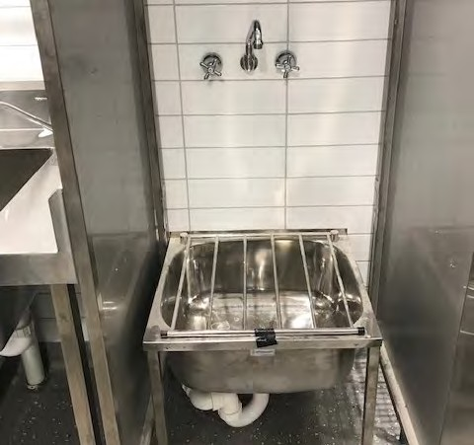

### **Water supply**

You must supply a potable water source with adequate volume, pressure and temperature.

You will need a hot water system with sufficient capacity for peak operating times for cleaning and sanitising the food premises and equipment.

If you plan to use a private water supply, such as tank water, you will be required to install an effective treatment system, such as filtration and ultraviolet irradiation. Private water supplies will require ongoing laboratory testing to ensure that water is being effectively treated to remove harmful microbial pathogens and chemicals.

### **Septic, sewage and wastewater disposal**

Your premises must have an effective septic or sewage and wastewater disposal system for all sewage and waste liquid produced by the business.

For areas not connected to mains sewer it is important to make sure that you have connected to the premises an adequate sized and functioning septic system.

The Environmental Health team can provide further information on septic, sewage and wastewater disposal. The contact details are listed on page 14.

### **Grease traps**

Grease traps or food and oil arrestors should be located outside the food preparation area.

Depending on the type of food premise you are operating, it maybe that a grease interceptor will be required to be installed prior to the septic system.

Goulburn Valley Water can provide further information on grease traps. Their contact details are listed on page 14.

# MECHANICAL VENTILATION

A mechanical exhaust system must be installed above cooking equipment and dishwashers if their total maximum electrical power input is greater than 8kW or total gas input is greater than 29Mj/h and their construction must comply with Australian Standard AS 1668.2.

Murrindindi Shire Council’s Building team can provide further information on mechanical exhausts. Their contact details are listed on page 14.

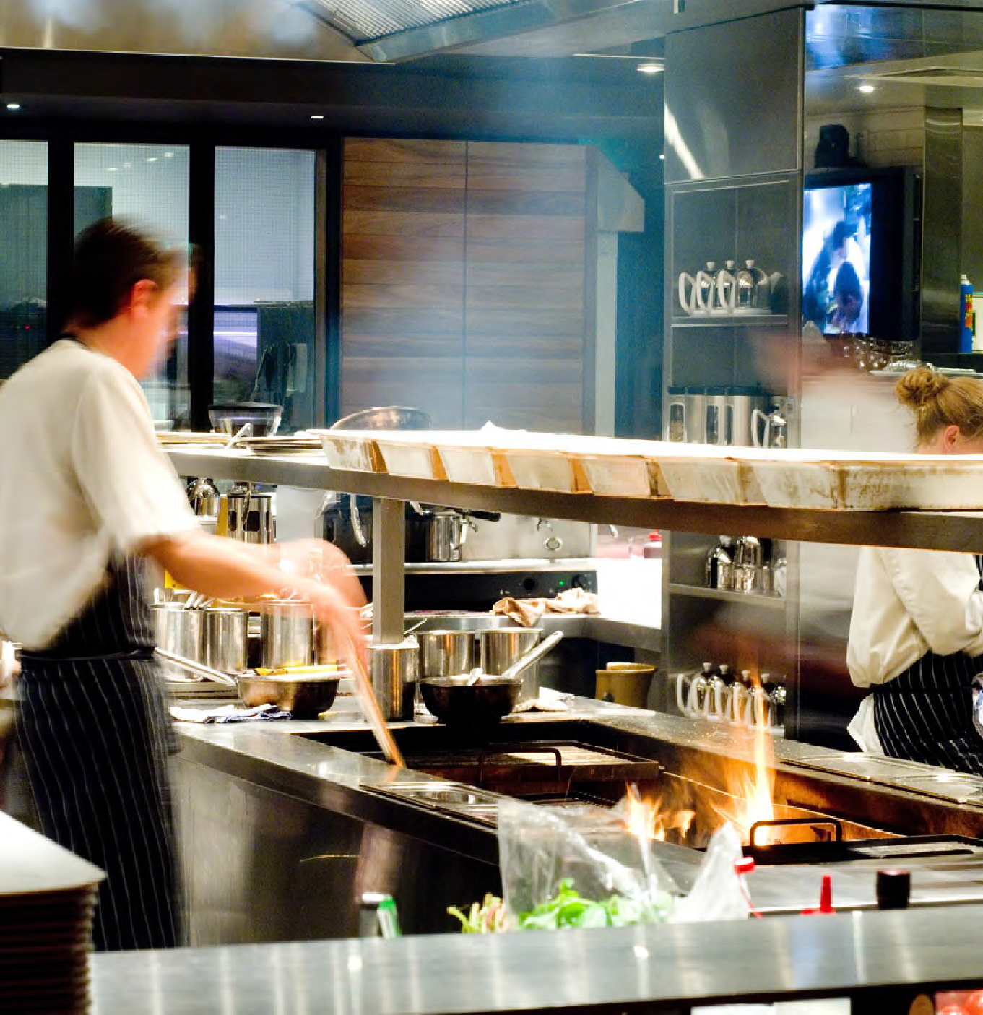

# FIXTURES, FITTINGS AND EQUIPMENT

All surfaces need to be smooth, durable, impervious, and free from gaps and cavities that may allow rodents, insects and other pests to enter, breed and nest.

### **Cooking equipment**

Cooking equipment should either be easily movable, butted against walls or other equipment, have their joints sealed, or placed at least 150 mm from walls.

### **Lighting**

Lighting must be sufficient for food handlers to see whether areas and equipment are clean, to detect signs of pests and to see the food and equipment they handle.

Light fittings, including those in cool rooms and freezer rooms, should be fitted with shatterproof glass or plastic. This facilitates cleaning and prevents food contamination if they break.

### **Cold and Frozen storage**

You will need refrigerators to store all perishable foods at or below 5°C.

Freezers must be able to keep food frozen (usually below

-15ºC) to maintain product quality and shelf life.

Wheels or castors should be fitted to chest freezers and upright refrigerators to allow for easy cleaning underneath.

Cool rooms and freezer rooms must have adequate shelving and must have an external thermometer gauge, you must not store food at ground level.

### **Self-serve hot or cold display**

Self-serve units should have a protective sneeze guard to act as a physical barrier between the customers’ breath and the food. You will need to provide serving utensils such as tongs, serving spoons or forks.

# WASTE STORAGE

### **Waste management and bin storage**

All bins and waste containers must be stored inside your property. When deciding where to store bins, consider your premises’ design and layout to prevent cross contamination. The on-site bin storage location must be indicated on the floor plans you submit.

Bins may only be placed outside on public property the evening before a scheduled kerbside collection.

To learn more about Murrindindi Shire Council’s waste management requirements, visit our website at [murrindindi.vic.gov.au/garbage-and-recycling](https://www.murrindindi.vic.gov.au/Your-Property/Garbage-and-Recycling?BestBetMatch=waste|d13b95b2-5146-4b00-9e3e-a80c73739a64|4f05f368-ecaa-4a93-b749-7ad6c4867c1f|en-AU)

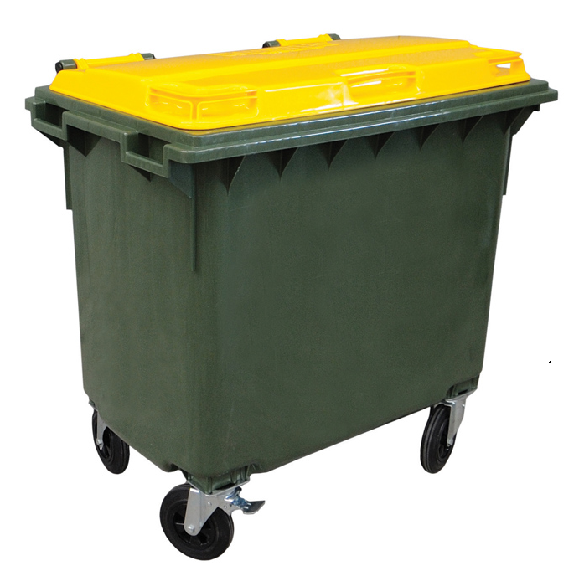

# OTHER STORAGE AREAS

### **Personal belongings storage**

To prevent the contamination of food, you will need to provide a separate room or locker for storing clothing, footwear and other personal belongings.

If storage outside a food preparation area is not possible, provide a designated enclosed cupboard.

### **Cleaning equipment and chemical storage**

You must also provide a cleaner’s cupboard or other clearly designated storage space for storing mops, cleaning chemicals and cleaning equipment.

Chemicals and cleaning equipment must be stored separately to food items and food contact surfaces.

### **Pest control**

Pests include birds, rodents and insects. Your food premises must be constructed and designed to prevent the entry of pests by ensuring

* screens are fitted to doors and openings
* 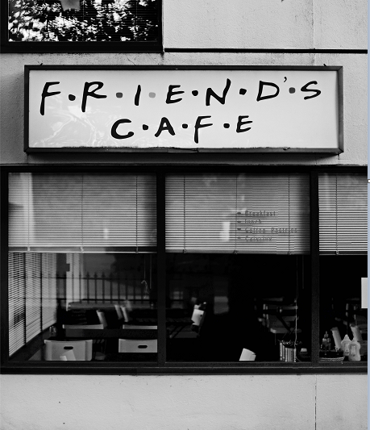self-closing doors, insect traps, fly strips or air curtains are fitted to all door entries
* all holes are sealed, including gaps to all floors, walls, ceilings and service pipes where they pass through floors, walls and ceilings

### **Toilet facilities**

All toilet facilities must be provided with hand basins that supply warm running water and suitable hand-drying facilities.

Toilets should not be entered directly from a food preparation area, but through an air lock. An air lock is a buffer zone between a food area and the toilet that stops contaminated air entering a kitchen.

Your toilet facilities must be kept clean and operating properly whether on-site or off-site.

### **General requirements**

###### Name of proprietor

The name of the proprietor needs to be prominently placed at the front of the premises. This is a specific requirement under the *Food Act 1984*.

**Café Pty Ltd**

# USEFUL CONTACTS

###### Murrindindi Shire Council

Environmental Health

Phone: 5772 0333

Email: [eho@murrindindi.vic.gov.au](mailto:eho@murrindindi.vic.gov.au)

Planning

Phone: 5772 0333

Email: [planning@murrindindi.vic.gov.au](mailto:planning@murrindindi.vic.gov.au)

Building and Construction

Phone: 5772 0333

Email: [building@murrindindi.vic.gov.au](mailto:building@murrindindi.vic.gov.au)

Waste Services

Phone: 5772 0333

Email: [operations@murrindindi.vic.gov.au](mailto:operations@murrindindi.vic.gov.au)

Business Concierge Officer

Phone: 5772 0333

Email: [businesssupport@murrindindi.vic.gov.au](mailto:businesssupport@murrindindi.vic.gov.au)

###### Grease traps

Goulburn Valley Water

Phone: 1800 454 500

Website: [gvwater.vic.gov.au](https://www.gvwater.vic.gov.au/)

###### Liquor license

Victorian Commission for Gambling and Liquor Regulation (Liquor License) Phone: 1300 182 457

Website: [vcglr.vic.gov.au](http://vcglr.vic.gov.au/)

###### Building surveyors, builders and plumbers

Victorian Building Authority (VBA)

Phone: 1300 815 127

Website: [vba.vic.gov.au](http://vba.vic.gov.au/)

# GLOSSARY OF TERMS

|  |  |
| --- | --- |
| **Building surveyor** | A building surveyor ensures building work complies with the legal requirements and issues building permits allowing works to commence. They will conduct inspections of building work and issue a permit upon satisfactory completion. |
| **Environmental Health Officer** | Environmental Health Officers are responsible for carrying out measures to protect public health, including administering and enforcing legislation and providing support to minimise risks to the public. |
| **Equipment** | Examples of equipment include refrigerators, cool rooms, Bain-maries, utensils or appliances used in connection with food handling or cleaning the food premises. |
| **Fixtures and fittings** | Examples of fixtures and fittings include benches, shelves, sinks, hand basins, cupboards and light fittings. |
| **Floor plans** | A drawing that shows the shape, size, and arrangement of rooms in a building as viewed from above. |
| **Food business or food premises** | A business, enterprise or activity (other than primary food production) that involves the   * handling of food intended for sale, or * sale of food, regardless of whether the business enterprise or activity is of a commercial, charitable or community nature |
| **Food contact surfaces** | Any surface that touches food such as knives, pots, chopping boards and plates. |
| **Food preparation area** | A food preparation area is any space where food and/or drinks are washed, prepared, cooked, poured and/or served. |
| **Food storage area** | A food storage area is any place where food is stored. It includes dry stores, cool rooms, freezer rooms and off-site storage areas. |
| **Impervious** | A finish that does not allow water, oil or other fluids to absorb or pass through. |
| **Permanent fixture** | A permanent fixture is equipment that once installed is considered  a permanent addition to the property. Permanent fixtures are structurally anchored to the ground or plumbed for water circulation. |
| **Potable water** | Potable water is safe drinking water that is fit for human consumption. |
| **Proprietor** | The owner of the business. |
| **Sanitising** | Sanitising is the process of killing food poisoning bacteria (that you cannot see) and is achieved by using heat and/or chemicals. You must use both a detergent and a sanitiser. |

##### How to contact us

Online:

[customer@murrindindi.vic.gov.au](mailto:customer@murrindindi.vic.gov.au)

[murrindindi.vic.gov.au](https://www.murrindindi.vic.gov.au/Contact-Us/Contact-Details)

In person:

Alexandra Customer Service

28 Perkins Street

Alexandra

Kinglake Customer Service

19 Whittlesea-Kinglake Road

Kinglake

Yea Customer Service

15 The Semi Circle

Yea

Telephone:

03 5772 0333

In writing:

Murrindindi Shire Council

PO Box 138

Alexandra VIC 3714