Kinglake Memorial Reserve
Draft Master Plan
Information Bulletin No. 2
9 July 2020
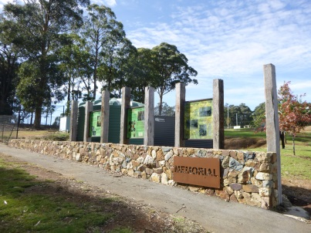
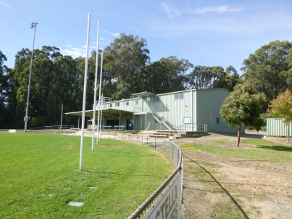

Kinglake Memorial Reserve

Murrindindi Shire Council is pleased to advise that the draft Master Plan for the Kinglake Memorial Reserve is now available for community feedback. The draft Plan has taken into consideration input from representatives of sporting clubs and user groups, alongside 150 survey responses from the wider community.
The Plan details key elements for inclusion and highlights 22 actions (in no particular order of priority) that will help improve and enhance the Kinglake Memorial Reserve.
Council and the consultant team welcome your feedback on the draft Plan. To view the draft Plan, please click here and provide us your feedback via an online survey by 30 July 2020.
For residents wishing to contribute to the planning process, the consultant team for this project are available to discuss any queries about the draft Plan . You can contact Michael Smith of Michael Smith and Associates and Cathy Fyffe of CMF Consulting, via the following means
- Cathy Fyffe of CMF Consulting
- Cathy is available for a 15 minute individual consultation.
- You can book a time with Cathy via the following link - https://go.oncehub.com/CMFConsulting
- Cathy will then call you at the appointed time

- Michael Smith of Michael Smith and Associates
- Michael is available during office hours (M-F) on 9830 0414 or 0418 172 826

For any further information on this project, or if you’d like to receive regular updates about the project, please contact Council on 5772 0333 or email customer@murrindindi.vic.gov.au

