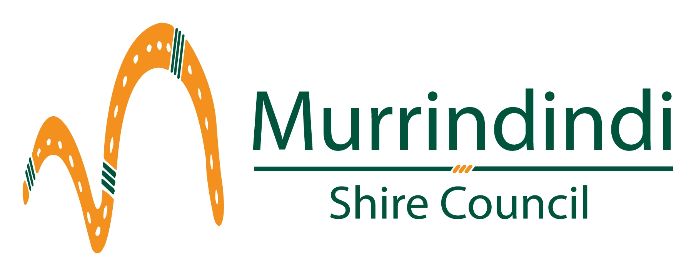
Office Use only:

Receipt # ________________

Staff Initials ______________

Application for Public Liability Insurance

for casual hirers of Council facilities

This is an application form to access public liability insurance cover up to $10 million. In the event of a claim, the hirer will be required to pay the excess, currently $500.00.

The cover is available to individuals and small community organisations hiring Council facilities. The hirer must have a signed Council Hire Agreement and the event must be not-for-profit and involve no more than 1,000 people. More information about the cover is provided on the other side of this form.

If there is any doubt as to the eligibility of a hirer for the cover, please call Council’s insurance officer/s before completing the application and making the payment.

Name of hirer:

Address:

Email address:
(Compulsory – method of contact)

Facility being hired:

Purpose of hire:

Date(s) of hire: ____________________________________________

Signed: ____________________________________________

Insurance Fee (Premium) is $35.00 (incl. GST)

Please return the completed application form to PO Box 138, ALEXANDRA VIC 3714
or e-mail it to msc@murrindindi.vic.gov.au.
The insurance fee can be paid in person at Council Customer Service Centres.
Cheque payments can be posted to PO Box 138, ALEXANDRA VIC 3714.

Murrindindi Shire Council – Hirers of Council Owned or Controlled Facilities
Including Council owned or managed Parks and Gardens

Application process
- Hirers are not automatically covered by the completion of this application form.
- The completed application form will be reviewed by Council to make sure the hirer is eligible before being provided to the insurer. Council and the insurer reserve the right to not approve an application if the hire is deemed ineligible.
- Applications and fees should be processed at least 10 business days prior to the hire, to allow sufficient time for the application to be assessed.
- If an application is not approved, Council will contact the hirer and arrange for the application fee to be refunded.

Who is eligible for the insurance?
- The hirer must have a completed and signed Council Hire Agreement.
- The hirer must not already have public liability insurance.
- The hire event must be not-for-profit.
- The hire event must not involve more than 1,000 people.
- The hire term must not be longer than five (5) consecutive days. Coverage for longer periods may be available at extra cost, subject to negotiation with the insurer. Hirers wanting to explore this should contact Council’s insurance officer before completing the application form and paying the fee.
Who is not eligible for the insurance?
- People who want to use the facility on a regular basis (ie more often than once a week).
- Hirers organising a ticketed event where an admission fee will be charged (excluding gold coin donations).
- Hirers that will derive a monetary gain from the hire activity or commercial hirers (e.g. An Art Show).
- Organisers of festivals, rock concerts or other similar events.
- Sporting activities are not covered

What are my options if I am not eligible?
- You can contact insurance companies directly and get quotes for public liability insurance cover.
- Not-for-profit clubs and community groups may also be able to access public liability insurance through the Local Community Insurance Services (https://www.localcommunityinsurance.com.au/).

Useful Information:
- This is a service provided by Council. The preference is always for hirers to have their own insurance.
- In the event of a claim, the hirer will be responsible for payment of the excess, currently $500.00.
- Insurance is for the hirer and the hirer’s purpose only. Providers of entertainment (e.g. a band), catering or any other service provider associated with the event should have their own insurance cover.
- Any queries should be directed to Councils insurance officer/s.

