**Advertising Events on Township Entry Signs**

**Signs – Community Service Club/Event – Major Structures**

The community service signs have been designed with a bracket support to support a slide in corflute sign (or similar). Sign measurements are mm wide x high.

The community service club/event signs are located at Alexandra, Eildon, Kinglake, Marysville and Yea. Further details of their exact location and size can be found below.

**Alexandra (3 entrances)**

* Goulburn Valley Highway –between Swann Rd and Grant Street
* Goulburn Valley Highway –between UT Creek Road and Wattle Street (in front of Dame Pattie Menzies Centre)
* Maroondah Highway – between Girdwood Court and Alexandra Tourist Park

**Marysville (3 entrances)**

* Buxton-Marysville Road – between Mad Dog Way and Murchison Street
* 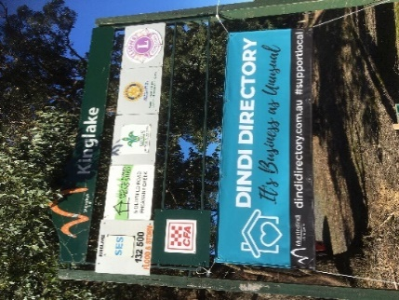Marysville Road – between Fiske Street and Dowdle Road

**Yea (4 entrances)**

* Melba Highway – between Oliver & Miller Street (next to Great Victorian Rail Trail)
* Whittlesea-Yea Road – between Melbourne Road & Flat Lead Road (next to Yea Bushland Reserve)
* Goulburn Valley Highway – junction of Killingworth Road

**Kinglake (3 entrances)**

* Heildleberg- Kinglake Road – between roundabout and Kinglake CFA
* Whittlesea-Kinglake Road – between Parkside Road and Shelly Harris Court (in front of Elimatta Youth Centre)

**Eildon (2 entrances)**

* Goulburn Valley Highway – between Ted Lech Drive and Jerusalem Creek Road

**Size**

Corflute 2700mm wide x 400 high

Canvas Banner 2430mm wide x 900 high

|  |
| --- |
| **Note:**  These service club / event frames have been designed to accommodate a single banner as well as a bracket to support a slide in corflute (or similar) sign below the club insignia.  That enables Alexandra, Eildon, Marysville, Kinglake and Yea to effectively promote three single events at one time. |

**Banner Township Entry Locations – Major Structures**

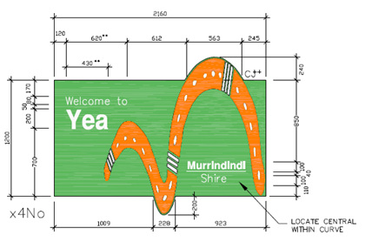The township entry signs have been designed to hold a single banner to promote tourism and community events. Please find their locations and size below.

Alexandra (3), Eildon (1), Kinglake (3), Marysville (3), Yea (4)

**Size:**

Canvas Banner 2430mm wide x 900 high

This will ensure that it is interchangeable and can fit both the township entry signage and service club/ event signage.

|  |
| --- |
| **Remember:**  Service club/ event signage frame is to be used in the first instance and only when this space is occupied is event promotion displayed on the township entry signs. |

**Banner Township Entry Locations – Minor Structures**

The township entry signs have been designed to hold a single banner to promote tourism and community events. Please find their locations and size below. For exact locations please refer to this [interactive map](https://www.google.com/maps/d/edit?mid=1f4UTWhRsmv0-CGGF1psJBwSgSwatoHw2&usp=sharing).

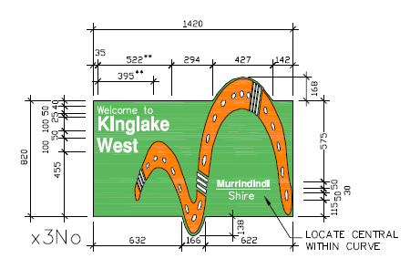

Buxton (3), Flowerdale (3), Glenburn (2), Highlands (3), Kinglake Central, Kinglake West (3), Molesworth (2), Narbethong (3), Pheasant Creek (2), Strath Creek (3), Taggerty (3), Thornton (4), Toolangi (3), Yarck (2)

**Size**

Canvas Banner 1400mm wide x 900 high

|  |
| --- |
| **Note:**  Sponsor logos, not-for-profit groups and Council logos will be permitted on banners.  Dates of the events should be listed on the signs unless the sign shows, for example “First Sunday of each Month” or “Next Sunday” etc. In the event that the words, for example “Next Sunday” are used then only six days advertising is allowed. This means six days prior to the day the event is on. |

**Installation Instructions**

Corflute signs can be easily slid into the Event Community boards with room for only one of these per sign.

Canvas banners can be attached by threading rope through the eyelets of the banner and through several holes at the top and bottom of the board structure.

Please make sure banners are taught when hanging and that rope is strong. This will avoid banners falling down due to strong weather conditions and remove any slack so that signs are easy to read for visitors driving by.

**Township Entrance Signage Guidelines**

1. Event organisers wishing to use promotional event signs must adhere to the township entrance signage guidelines.
2. Space is only available for the promotion of tourism and community events. Priority will be given to tourism events. A tourism event is defined as a short-lived, organised activity designed to attract visitors from outside the region so they may participate, watch, view, learn from and enjoy. Tourism events are organised activities that enhance an existing site, town or attraction and aim to entertain existing tourists, stimulate new visitation and encourage repeat visitation and extend length of stay. This could also be major events carried out on a regular or annual basis attracting large crowds which are conducted over one day or a number of days e.g. race meetings, expos.
3. Banners promoting local not-for-profit, non-commercial educational, cultural, religious, social community or recreational events or services within the Shire may be displayed when tourism event banners are not being displayed.
4. In the event of a dispute over signage suitability or priority of signage placement the Director of Community Engagement will make the final decision, based on the criteria established within this Policy.
5. While Council recognises the costs associated with some signage, refusal and removal of signs will take place if they are not of a “professional” nature.
6. Hand drawn signs on cardboard will not be accepted.
7. Signs that contain offensive language or pictures, commercial advertising or political promotion will not be accepted.
8. There will be no fee to attach banners to the respective signs.
9. Cost associated with the production of signs will be borne by event committees and organisers.
10. It is the responsibility of the organising committee to install and remove their event signs at no cost to Council.
11. Signs may be installed up to 14 days prior to an event, depending on availability. Annually occurring events or those which attract larger visitation numbers may apply for a period of up to 28 days. Event signage must be removed within 24 hours of the event’s completion. Failure to do so may result in the event being ineligible for grants and signage display in subsequent years.
12. Events running longer than three days, (for example, exhibitions), may be eligible to utilise the event board for longer than the prescribed period of 14 consecutive days. These events will only be eligible at the discretion of Council.
13. Organisers of regular/monthly events may apply for a recurring space on the event frames for a designated period for each of their events. However monthly events will only be granted space if a community group/not for profit event or large “short lived” event has not applied for space at the time of the event.
14. Regular markets which operate on a bi-weekly or more frequent basis may maintain a sign for the duration or the annual market period. In the event that other community group/not for profit event or large “short lived” events require this space then the market sign should be removed and can be replaced once space is again available.
15. Event organisers must contact Council at least one month prior to their event to book a signage space.
16. In the service centres, the designated events signage board must be the priority to place banners/ signs in the first instance.