Murrindindi Shire Council Funding Advocacy
Funding Options Fact Sheet
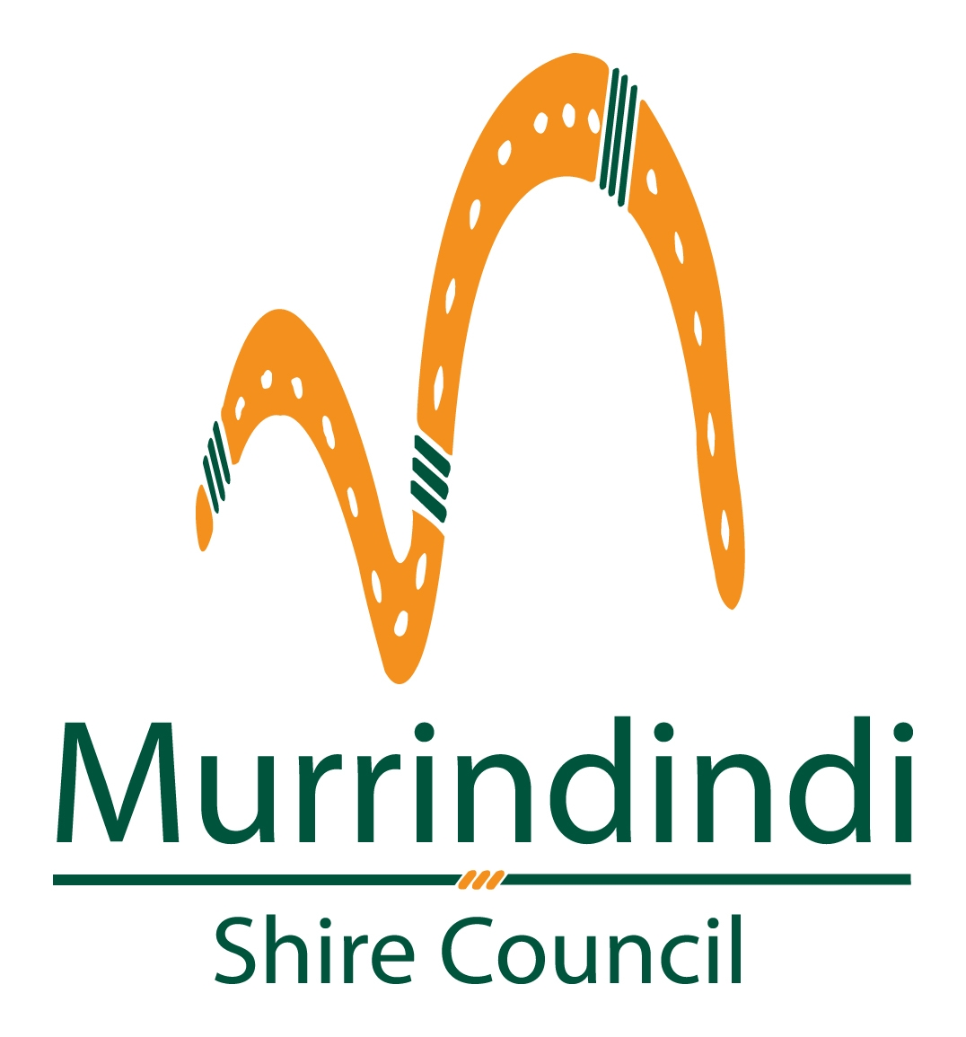

These proposals can be considered individually or in any combination to assist in achieving the necessary outcome of raising revenue and/or cutting costs.

Option 1 – Rate rises
As detailed in Council’s 2014/15 budget, it will be necessary in the coming months to evaluate a range of potential measures that might be applied in the absence of additional financial support from the State Government. Rate rises are one option that Council has to increase revenue growth that is required to cover the shortfall in costs that are required to manage the new and gifted assets.

Council’s current Long Term Financial Plan is based on an annual 6% rate rise for the next 10 years, and clearly shows that the additional costs of the new and gifted assets mean that Council will operate at a deficit until at least 2020/2021 before returning to a small operating surplus.

At current levels, Council’s renewal gap is forecast to reach more than $25 million, which is a measure that highlights the amount of capital works Council anticipates would need to be undertaken to ensure that all assets currently owned and maintained by Council are kept to their current standard of operation as a minimum. A $25 million renewal gap represents the amount of works that will not be done, which will ultimately mean a lower level of service of many of Council’s assets.

Raising rates by 8% per annum for the next 10 years would generate enough additional revenue over this 10 year period to fund the total costs of the new & gifted assets in this decade, whilst spreading the cost burden equally over each year.
Raising rates by 18% in 2015/16, before reducing the increase back to 6% per annum from 2016/17 through 2024/25, would generate a similar amount of total revenue, but would alter the timeframe in which Council receives it.

An example of how these scenarios would be represented for an average residential property in the Shire is shown below. The average rate for a residential property in 2014/15 is approximately $1,500.

 | Current - 6% annual rate rise | Option - 8% annual rate rise | Option - 18% in 2015/16 then 6% annually
2014/15 | $ 1,500.00 | $1,500.00 | $1,500.00
2015/16 | $ 1,590.00 | $ 1,620.00 | $ 1,770.00
2016/17 | $ 1,685.40 | $ 1,749.60 | $ 1,876.20
2017/18 | $ 1,786.52 | $ 1,889.57 | $ 1,988.77
2018/19 | $ 1,893.72 | $ 2,040.73 | $ 2,108.10
2019/20 | $ 2,007.34 | $ 2,203.99 | $ 2,234.58
2020/21 | $ 2,127.78 | $ 2,380.31 | $ 2,368.66
2021/22 | $ 2,255.45 | $ 2,570.74 | $ 2,510.78
2022/23 | $ 2,390.77 | $ 2,776.40 | $ 2,661.43
2023/24 | $ 2,534.22 | $ 2,998.51 | $ 2,821.11
2024/25 | $ 2,686.27 | $ 3,238.39 | $ 2,990.38

Option 2 – Differential Rating Categories
Council’s current rating structure comprises three key elements. These are:
- Property values, which form the central basis of rating under the Local Government Act 1989
- A ‘user pays’ component to reflect usage of certain services provided by Council
- A fixed municipal charge per property to cover some other Council administrative costs

The existing rating structure comprises a general rate and a differential rate (Rural 1). These rates are structured in accordance with the requirements of Section 161 ‘Differential Rates’ of the Act. The Rural 1 rate is set at 75% of the general rate and is applied to any land that is not less than 40ha. Council also levies a municipal charge, kerbside collection charge and recycling charge as allowed under the Act.

The following table summarises the key rating information relevant to the 2014/15 year.
Type or class of land | Number of Assessments | Cents per $CIV | Rate  Revenue
General rate for rateable residential properties | 5,988 | 0.3222 | 5,323,184
General rate for rateable commercial properties | 471 | 0.3222 | 565,451
Differential rate for rateable Rural 1 properties | 1,316 | 0.2416 | 3,015,033
General rate for rateable Rural 2 properties | 1,727 | 0.3222 | 2,542,854
Totals | 9,502 |  | 11,446,522

Council is looking at a range of options which may include the following:
Commercial / Industrial differential rate
Under Council’s current rateable property classifications, 471 properties are rated as commercial or industrial properties across the Shire, representing less than 5% of total assessments and rate revenue. The total value of additional rate revenue generated through this area is dependent on the increase proposed. For example, a 50% additional rate differential for these properties would generate $270,000 in additional rate revenue per annum.
Differential rates for undeveloped land
Council’s preliminary analysis of undeveloped land within the Shire has indicated a moderate number of properties could be affected. This strategy proposes a rating increase for undeveloped land to act as an incentive to develop land across the Shire which will contribute to growth in the rate base. For example, applying a 50% additional rate differential for these properties would generate $190,000 in additional rate revenue per annum.
Restructure of current differential rating categories
Council’s current differential rating structure (with regard to Rural 1 properties) has been in place for a long time. Rural 1 land is any rateable land, which is not less than 40 hectares in area and includes non-contiguous assessments (that is, those separate land holdings which are considered as a single farming enterprise for ratings purposes). Reviewing the level of this differential rate is another option available to Council.

Option 3 – Asset Sales
Council has already committed to the sale of $1.95 million worth of Council-owned land and buildings which have been considered surplus to Council’s needs. These have included the former Alexandra saleyards site, the Alexandra Butter Factory, vacant industrial land in Yea, vacant residential land in Eildon and retirement village units in Marysville. It is anticipated that this sales target will be realised in the 2014/15 financial year, with the sale of additional vacant land in Marysville and Alexandra. It is noted that asset sales primarily provide a once-off financial gain, although ongoing costs associated with operation and maintenance of an asset cease once the asset is sold.
Any additional sale of Council-owned land or buildings would most likely involve the reduction or loss of services provided by the use of that asset, whether provided by Council or another organisation or community body. For example Council could consider the sale of the recently gifted former Rebuilding Advisory Centre in Kinglake (currently leased to a not-for-profit organisation).Council could consider the sale of under-utilised assets; these could include some recycling and recovery centre sites, or open space and park lands. Council could also consider consolidating its works depots in one location and selling either the Alexandra or Yea depot sites.
Many Council-managed assets are not owned outright by Council as they are either owned by the Crown or are located on land owned by the Crown, and therefore are not saleable. For this reason, and with the potential for unacceptable reduction of services to the community (for example with the sale of the Alexandra or Kinglake Council offices which are located on Council-owned land), it is unlikely that asset sales alone will be a major source of revenue to offset the costs of new and gifted assets. At best, asset sales would be part of a broader solution.

Option 4 - Transfer of support for community assets
State Government-owned assets:
Council has, over time, taken on the responsibility of operating, maintaining, renewing and/or insuring many community assets. Most of these assets are on Crown land and are the ultimate responsibility of the State Government.
Due to the costs associated with the new and expanded assets gifted to Council after the 2009 Bushfires, Council will review the option of transferring responsibility for assets located on Crown land back to the State Government.
Assets owned and/or managed by Council:
Many of these assets are managed by the community through committees of management, incorporated associations or not-for-profit groups. Each of these groups across the Shire has demonstrated varying capacity to raise revenue.
Council will be encouraging those groups that currently manage Council-owned facilities to consider their capacity to further contribute to the ongoing costs of managing these assets. Without such support, Council may need to consider other options such as offloading or leasing assets to assist in meeting the financial demands Council now faces.

Council is also encouraging community groups to develop viable business plans to generate sufficient revenue to provide for the annual recurrent and maintenance costs of managing assets.
Assets leased from Council:
Wherever possible, Council will also look to recover the full cost of managing assets from those organisations which use or lease facilities from Council. This could be achieved by including rent arrangements which cover the running costs of the asset within existing formal agreements.
A list of assets categorised according to ownership can be found in the following appendices:
- Appendix 1: State Government Owned Reserves
- Appendix 2: Murrindindi Shire Council Owned Land

Option 5 – Review of Capital Expenditure
Council undertakes a range of capital works each year that could be reduced and the allocation of resources to capital works needs to be rigorously reviewed. This could have a positive effect in a given year by reducing the level of expenditure; however, there is also the potential for a negative effect of reduced quality when more costly renewal becomes necessary because of the deferral of works.
The long term capital works program of funding is focussed on renewal as priority over new and upgrade works and this is reviewed annually to ensure priority expenditure only.

Option 6 – Review of Council Services
Council provides a range of services to the community that could be reduced or ceased entirely. These services were extensively examined in the Services Review in 2012/13, which resulted in annual operational savings of approximately $1.6 million. However, further service level reductions to reduce costs are now limited and have the potential to significantly impact the community.

